Document Control:

Document Version: | 3.0
Document Date:

Revision History:

Date | Revision | Description | Author | Reviewer | Approver
29-04-2020 | 1.0 | System Understanding Document | Swathi Vellanki | Siripuram Sridher | Burri Sambasivarao
16-02-2021 | 2.0 | System Unerstanding Document | Swathi Vellanki,  Sudireddy Madhu
12-07-2024 | 3.0 | System Unerstanding Document | Dhanalakshmi

References:
Document Name | Capital Project Product Documentation
 | Documentum Administrator Product Documentation

Table of Contents

1. Architecture 3
2. Logging into Application 3
3. Preferences 4
4. Search 5
5. Export to Excel 6
6. PVA Task 7
7. Documents 12
8. Transmittals 20
9. Distribution Matrix 33
8.1 Importing Template 33
8.2 Validating the Template 34
8.3 Publishing the Matix 35
10. Distribution process 36
10.1 General Distribution Process 36
10.2 Review Distribution Process 42
10.2.1 Parallel Distribution Process 42
10.2.2 Serial Distribution Process 51
10.3 PAGE Review Distribution Process 52
11. Structures 52
12. Virtual Binders 54

Architecture
The below screenshot is architecture diagram of xCPage application.

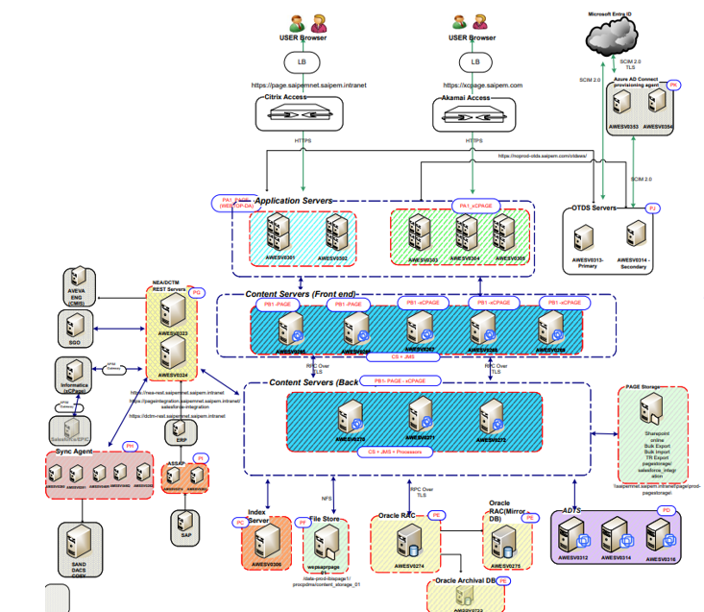

Logging into Application

xCPage is a Read only application that connects to the same repository as PAGE. It is more user friendly. This application works both in Google Chrome and EDGE, enabled the SSO login.
https://xcpage.saipem.com/ once you click on the URL it will automatically redirect to application if you are already part of the xcpage repository as per below screenshot.
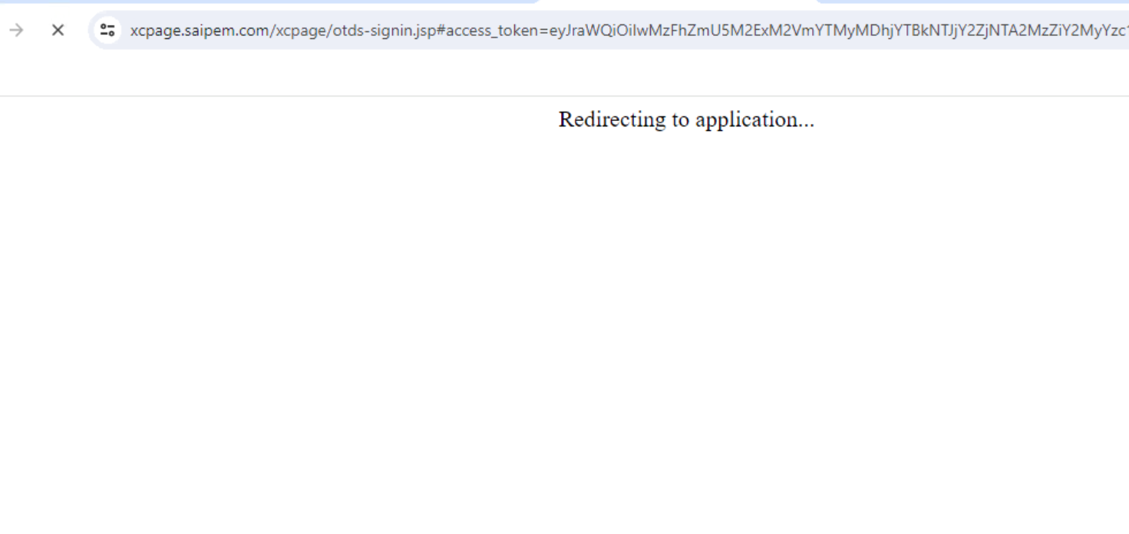
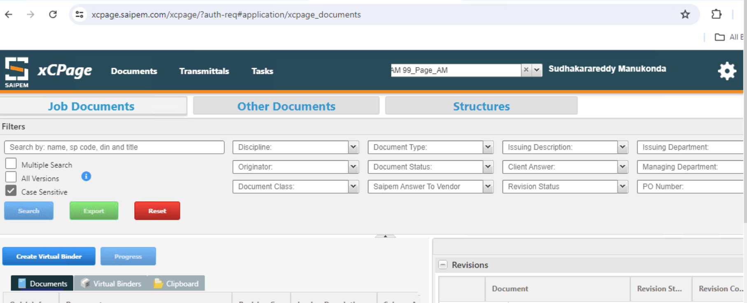

Preferences

We can also set preferences like default project or default Page after login to the Application. This defines what the user will be able to see after login to the application. Click on settings icon  to change the preferences
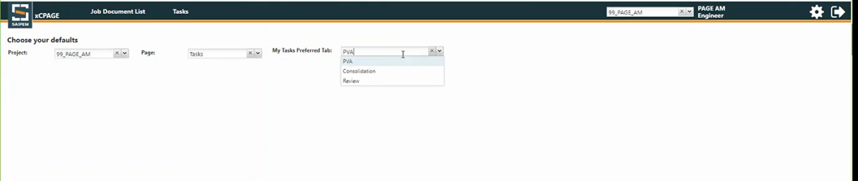

Search
Users can perform Search operation by typing the name of the document in the search bar or select the attributes from the dropdown like Document type, Document status etc.
Also there is an option to perform multiple search by selecting a Multiple search check box, search action can be performed by providing a DIN or the name separated with commas
One can search job documents, correspondence documents. The search query in xCPage uses ‘like’ whereas PAGE Application uses ‘Beginning with’ clause for searching the documents. For the documents to appear they must be already ‘Approved’.
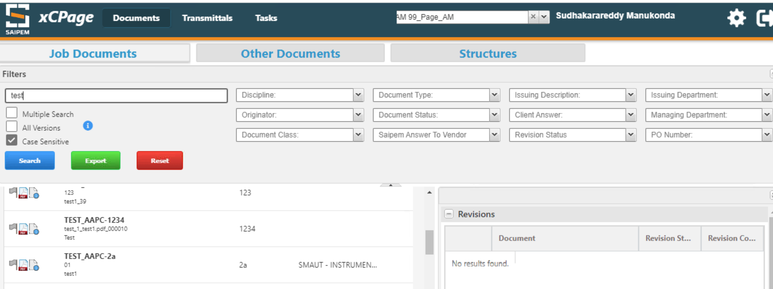
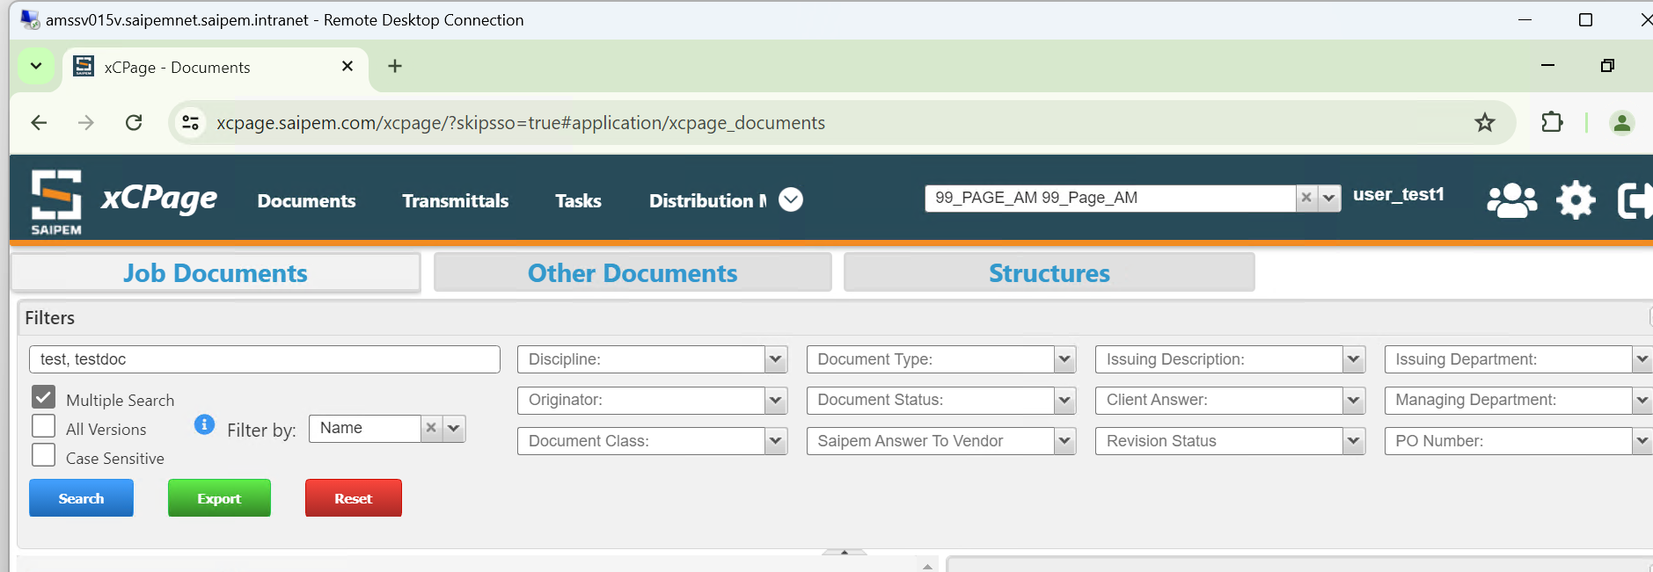

Provided better filters for searching Job Documents in existing Search Screen. Added few more Attributes – example Issuing Department, Managing Department and other attributes
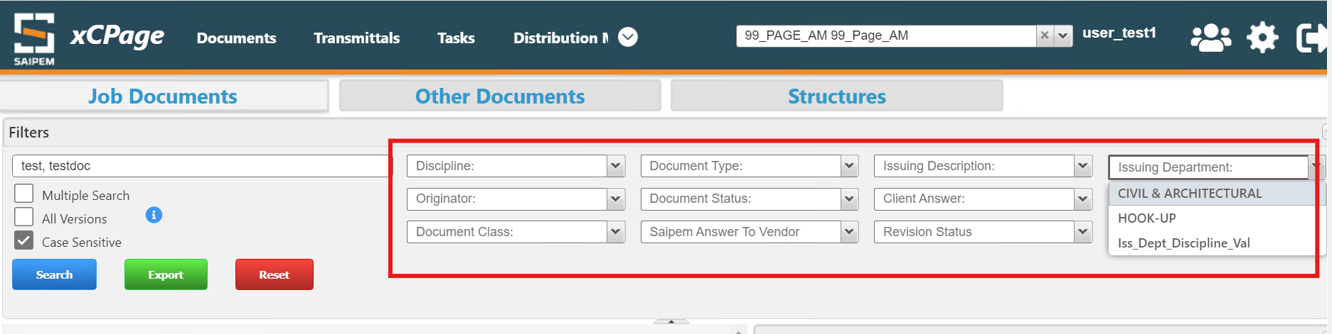

Export to Excel
The search results obtained can be exported to Excel and it looks like below.
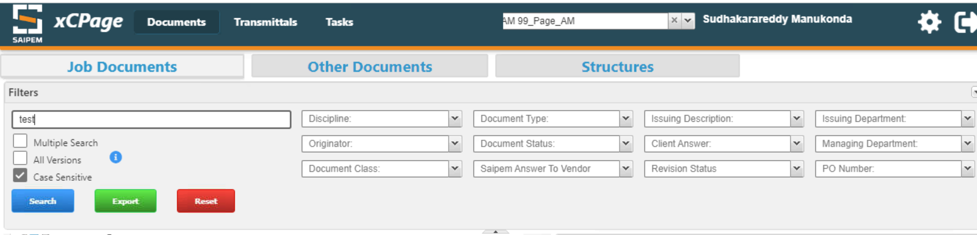

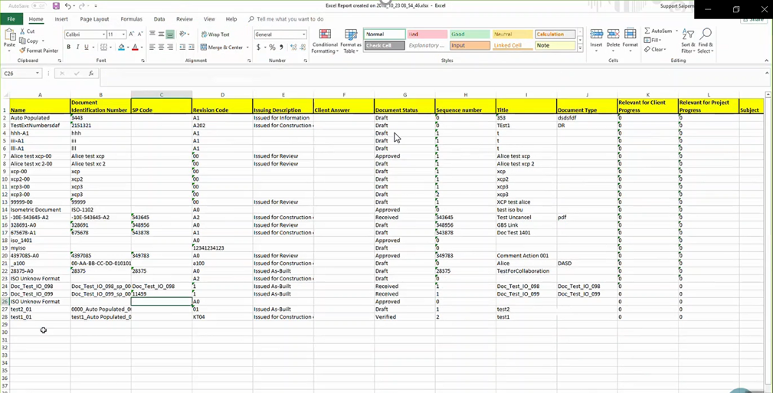
Added a column inside "Export to excel" report showing hyperlink to document content. The user shall be able to open the document itself by clicking on this hyperlink
“Name” column in Excel Sheet show the hyperlink to navigate to selected Job document in the xCPAGE, as shown in below screenshot
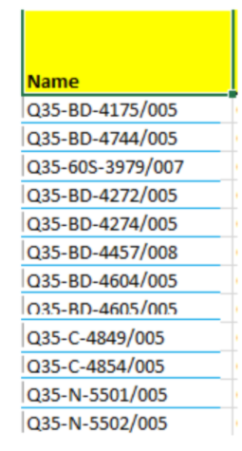
Provided feasibility to download last exported Excel sheet, with using View Report option, highlighted in below screenshot:

PVA Task
The user will create a new PVA Process (full) in PAGE Application and add the recipients who would be performing the PVA Tasks.
In the below screen we can find 1 PVA Task to be performed under the Tasks tab in xcPage. We can select the Task and click on Approve/Reject.
Click on Accept.
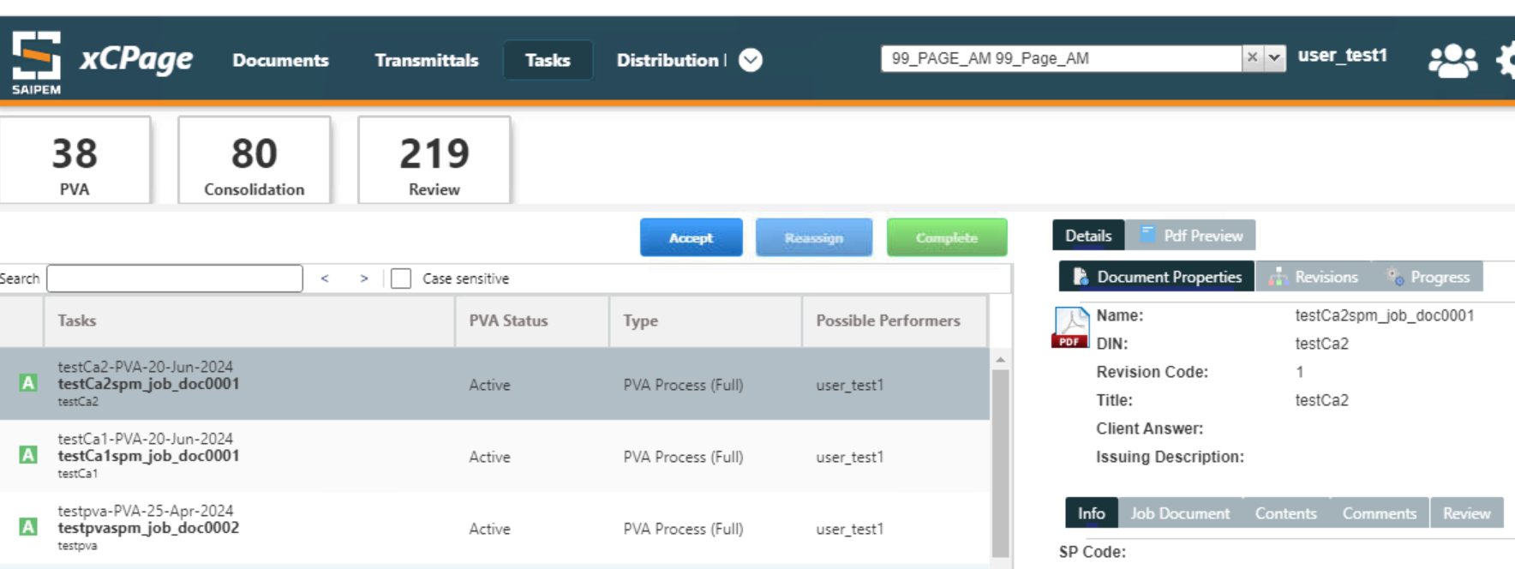
We can see other information such as Document Properties, Revisions, Progress, Comments, Content like below.
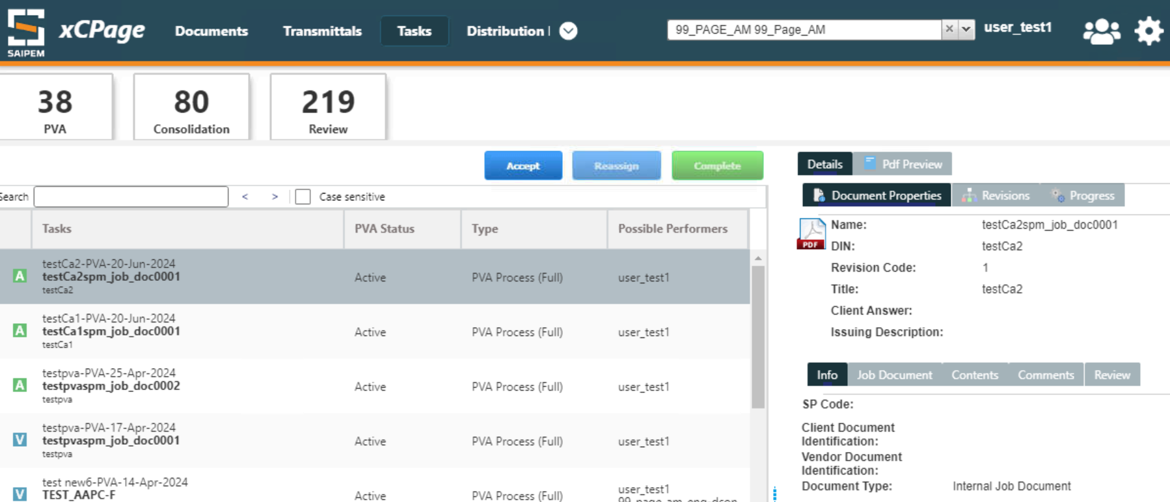

After clicking on Accept, again select the Task, and click on complete, so that we can forward the process to the next recipient.
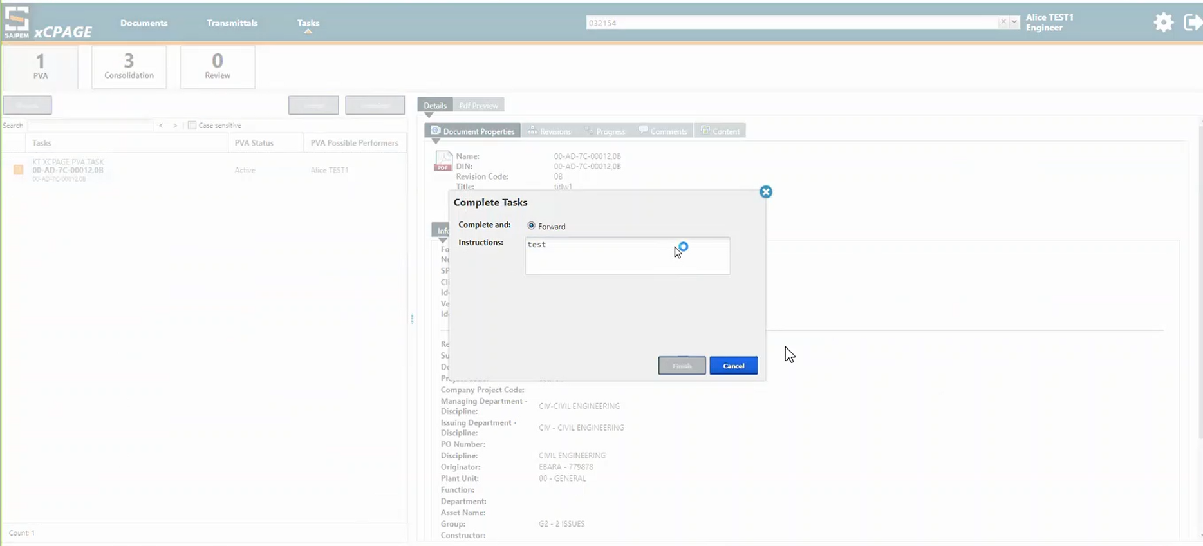
The Document will now be in ‘Prepared’ State. Please note that the State will change to ‘Prepared’ only after we click on complete and not after we accept it. The PVA Process in will be next moved to Active state.
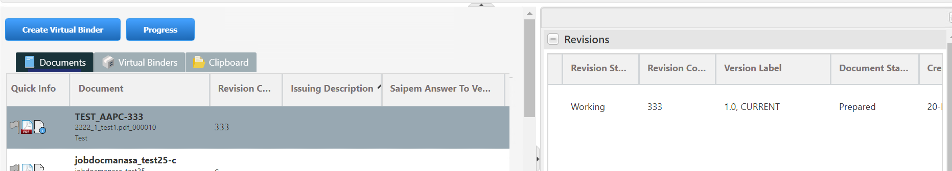
The Next Recipient will be able to see the Task now and performs the same steps- Accept and Complete. If we click on Backward in the Complete task window(below image) it goes back to the 1st recipient or the previous recipient.
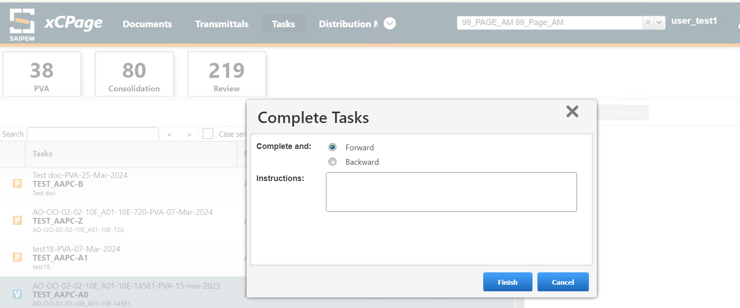
After we click on Finish in the Complete task, the PVA task in PAGE application will be changed to ‘Promoting’ State if it is processing the queue. If there are many queue items to be processed, it takes a while, otherwise it gets changed to ‘Active’ State. The Document state will be changed to ‘Verified’ state like below.
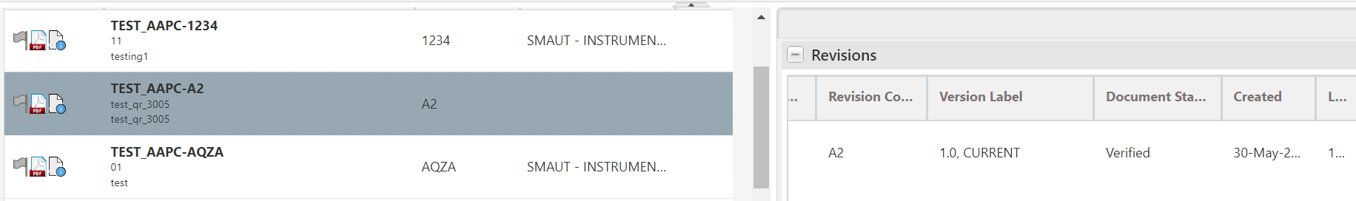
Email notifications will also be sent to the approvers while performing each step in the PVA like below. After clicking on the link it will redirect to the below url
http://xcpage.saipemnet.saipem.intranet/xcpage/#application/xcpage_dp_task_list_land_p

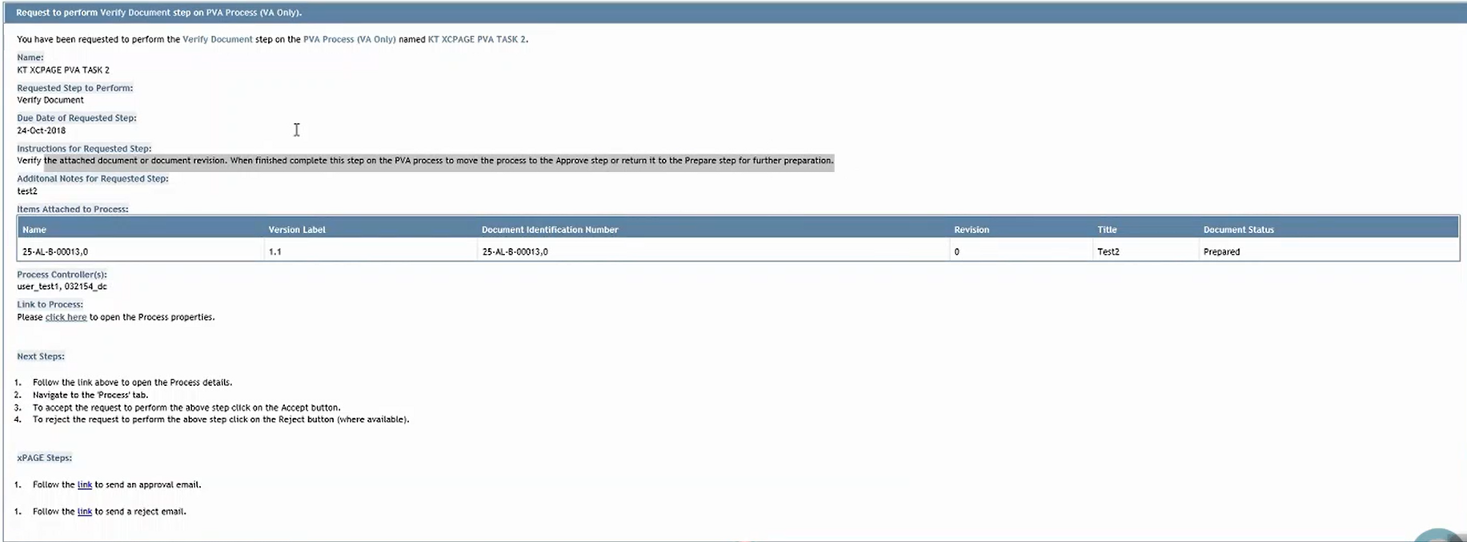
The Task will now be forwared to the Third recipient for Approval. The Approver Accepts and completes the Task. The PVA Process will now be in ‘Complete’ state and the Document will be in ‘Approved’ state like below.
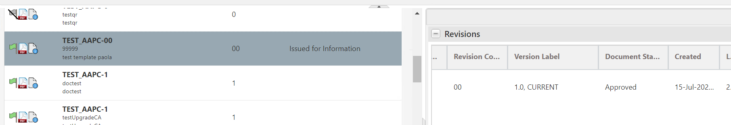

Provide ability to initiate for Single as well as Multiple Job Documents (NF – RITM0159463)
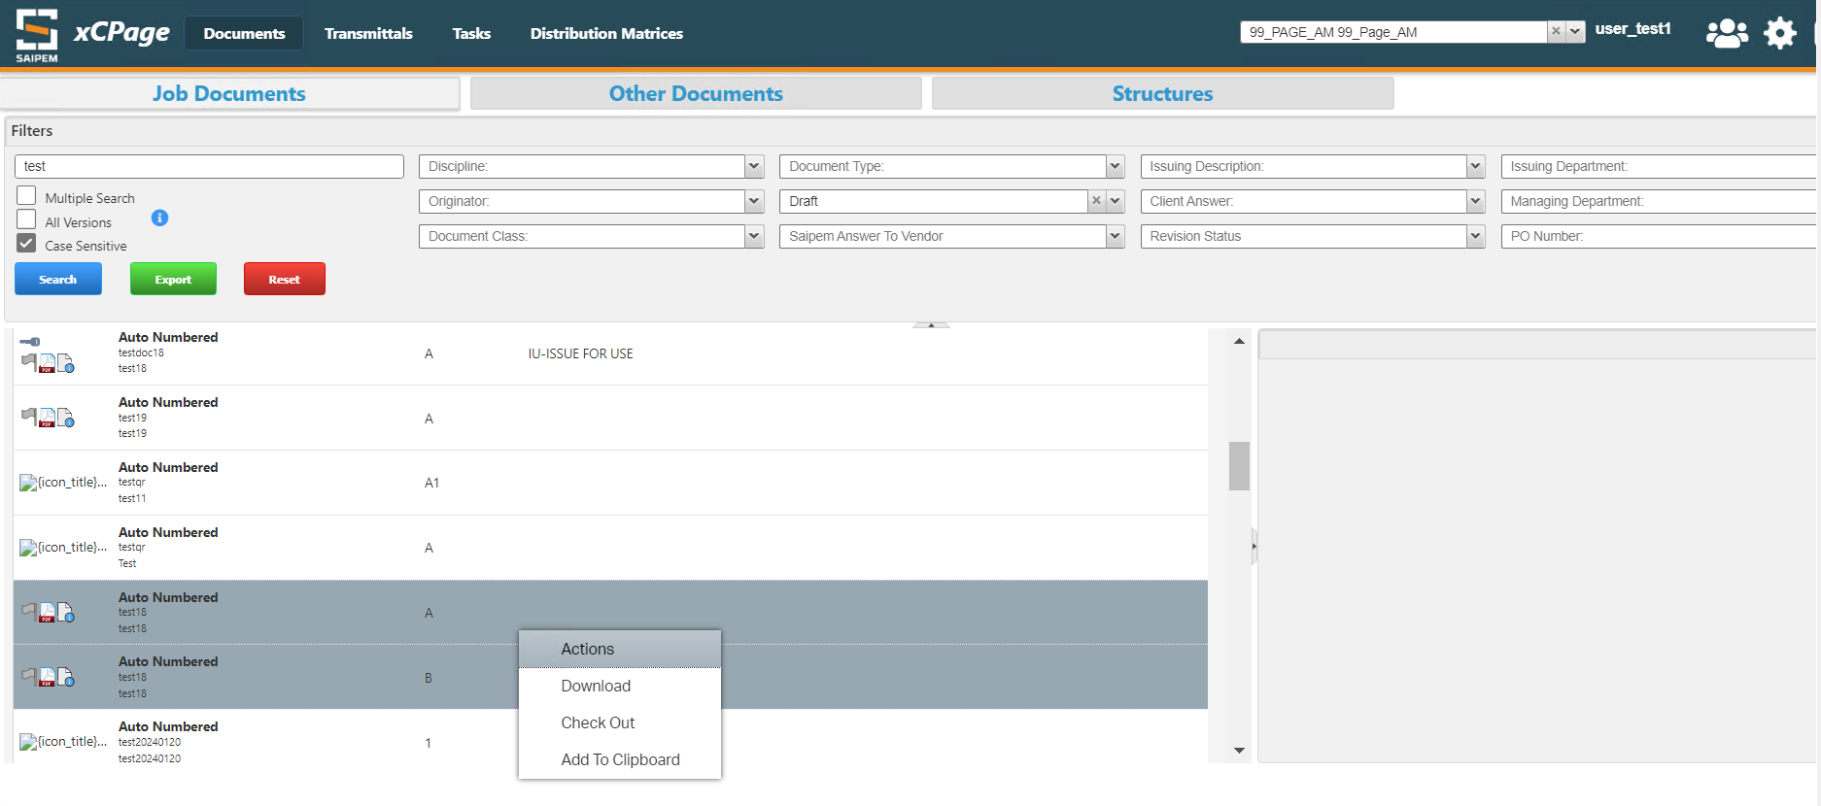
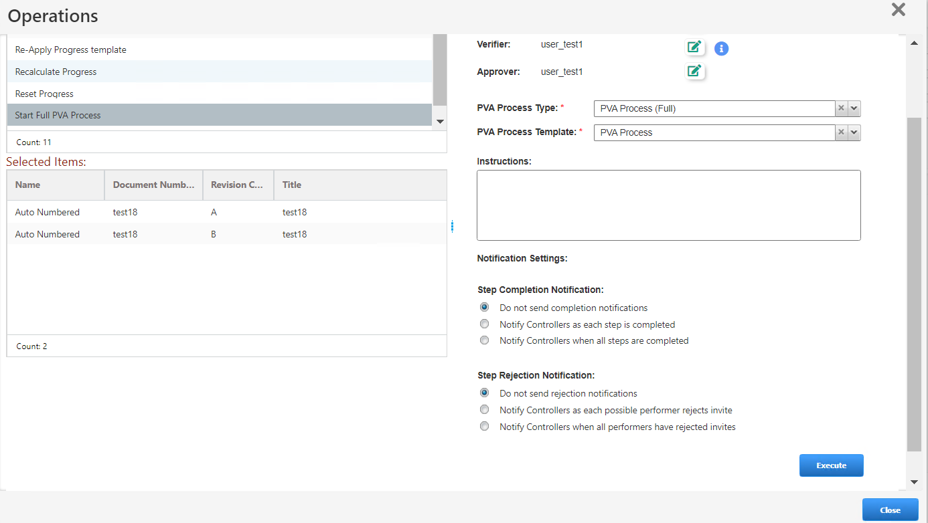

Documents
Under Documents Tab, we have Job Documents and Other Documents which includes reference document, correspondence document and certificate document
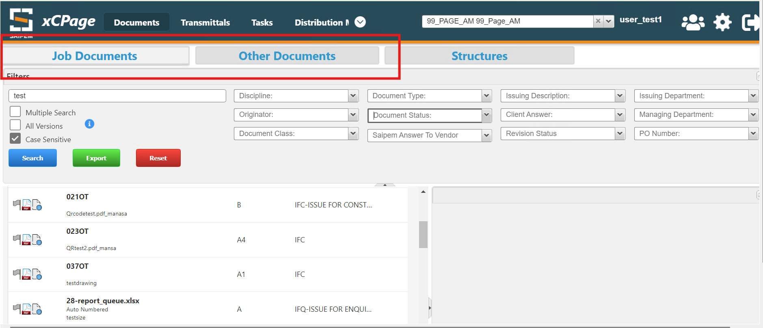
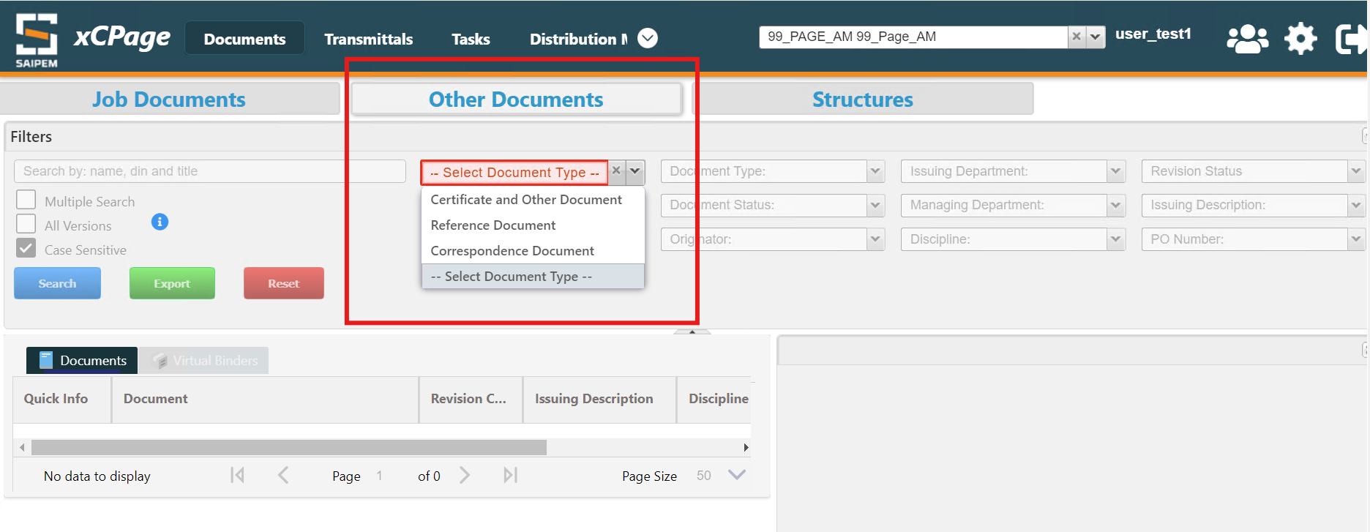
The Job Documents and other Documents are the same that are in PAGE as the Repository is same. For Users, this is a better interface for viewing the results because PAGE takes long time to load display and for Navigation as well.
In xcPage if we click on the document, in the right side windowpane, we will be able to see
- Revisions of the documents: The revisions of the document will be displayed on the right side panel of the application like below.
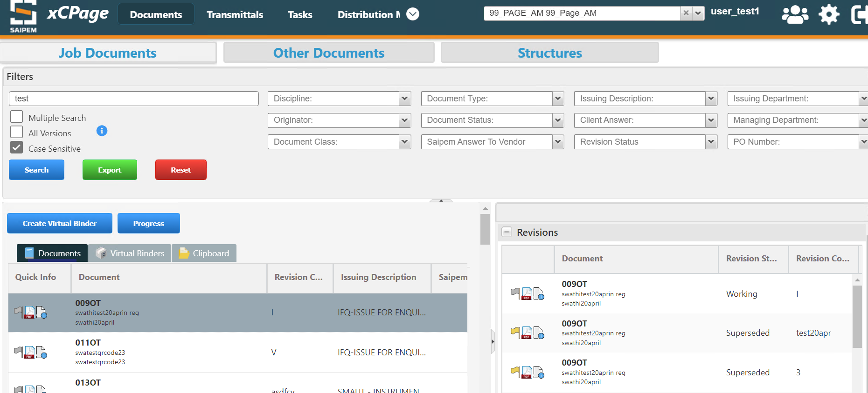
- Transmittals/ Distribution process: If any transmittals/ distribution process have been associated with the document those will be able to see on the right side panel
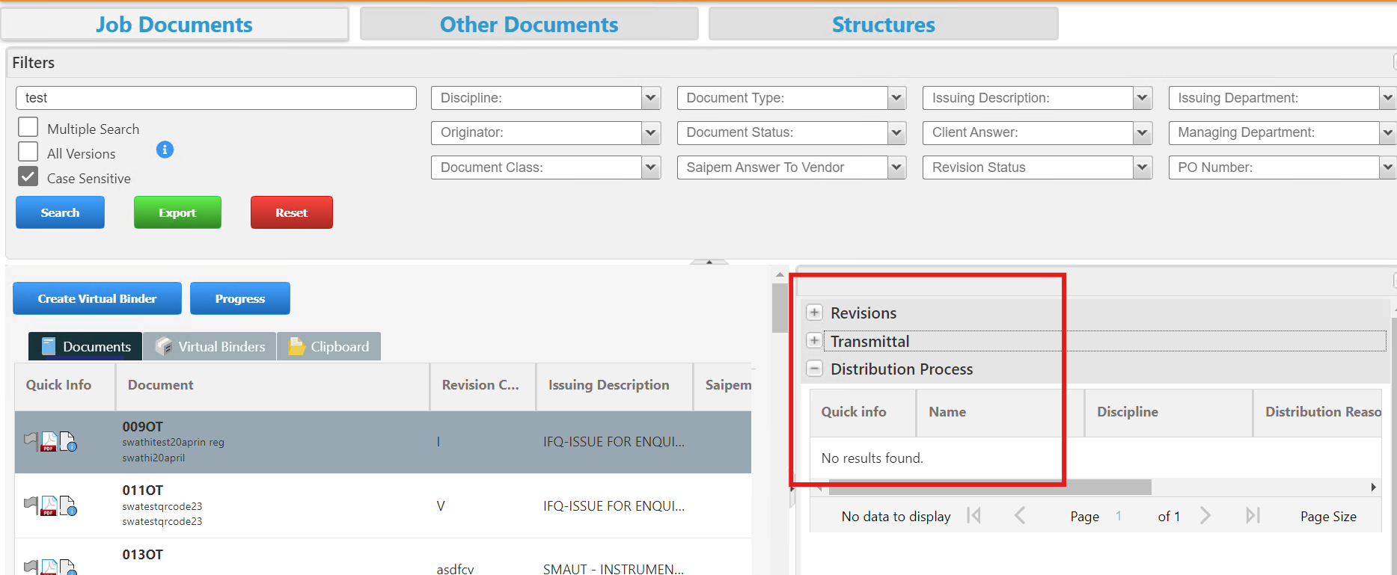

- Document contents like PDF Preview (below screen)
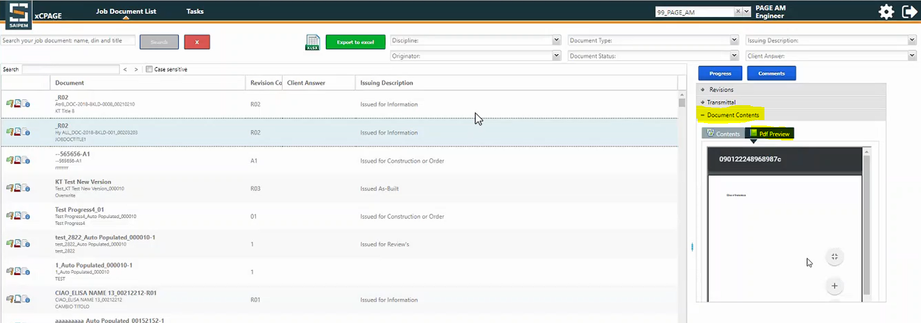

Properties:
We can view the properties of the Document by clicking on the Document Property button as shown below
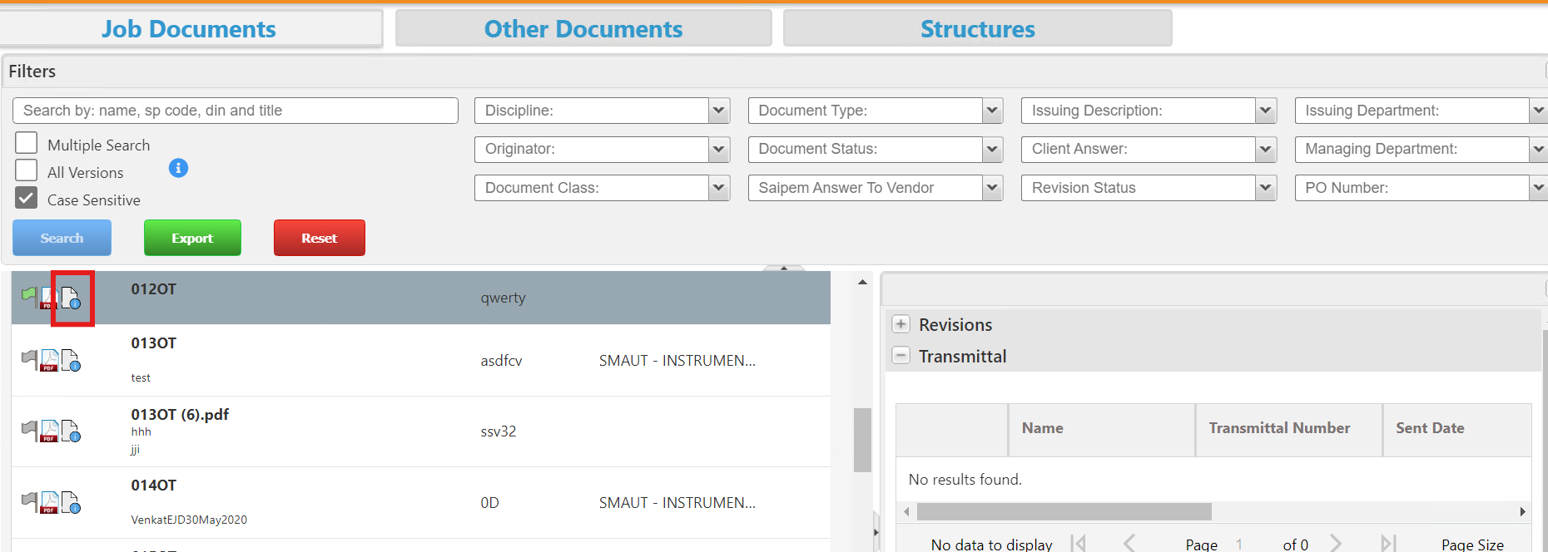

The Properties Tab will appear like below.
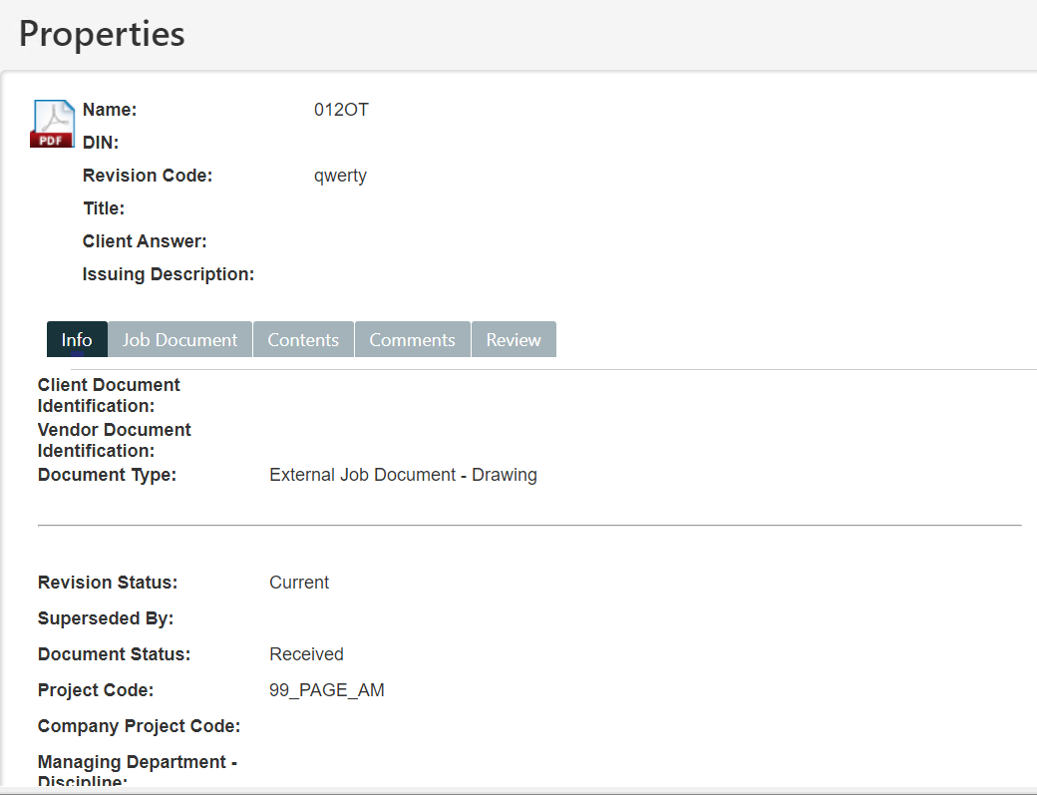
If you the properties of a document needs to be edited, click on the edit action like below
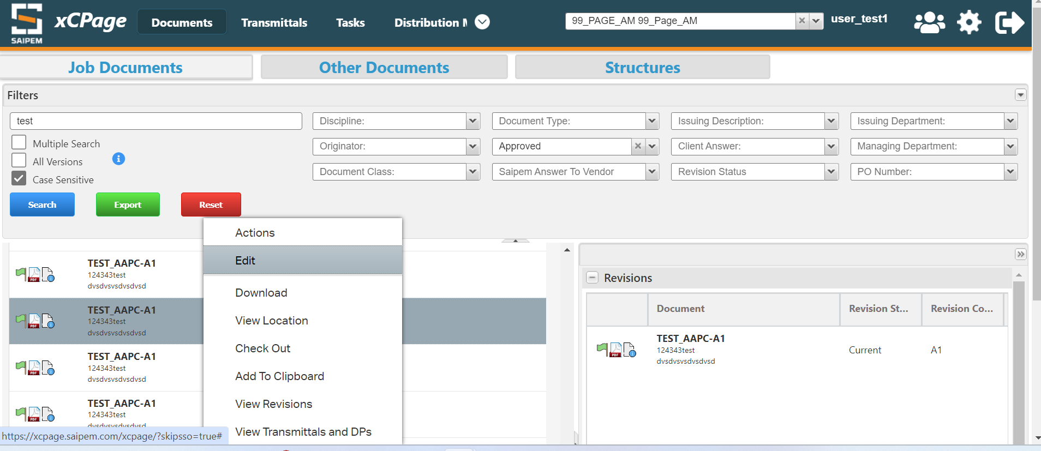
Edit the properties and click on finish
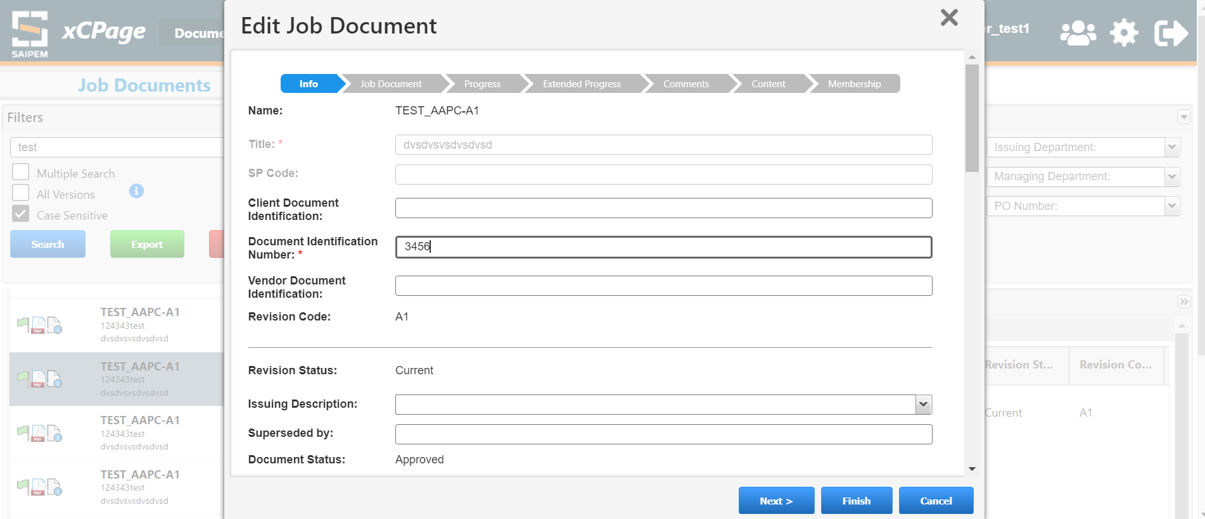
Provide Emergency Approval feature for Internal Job Documents on action window
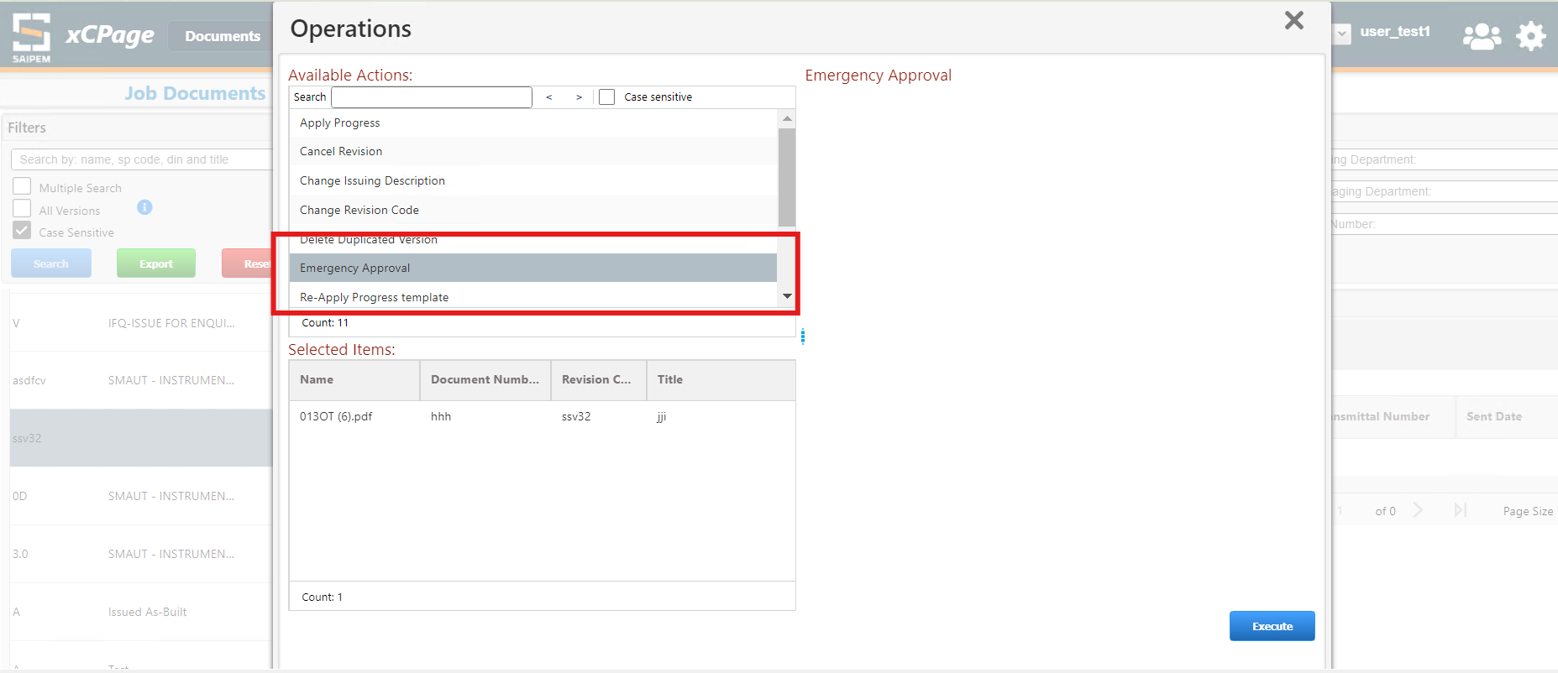

Provide Sign As Received feature for External Job Documents on action window.

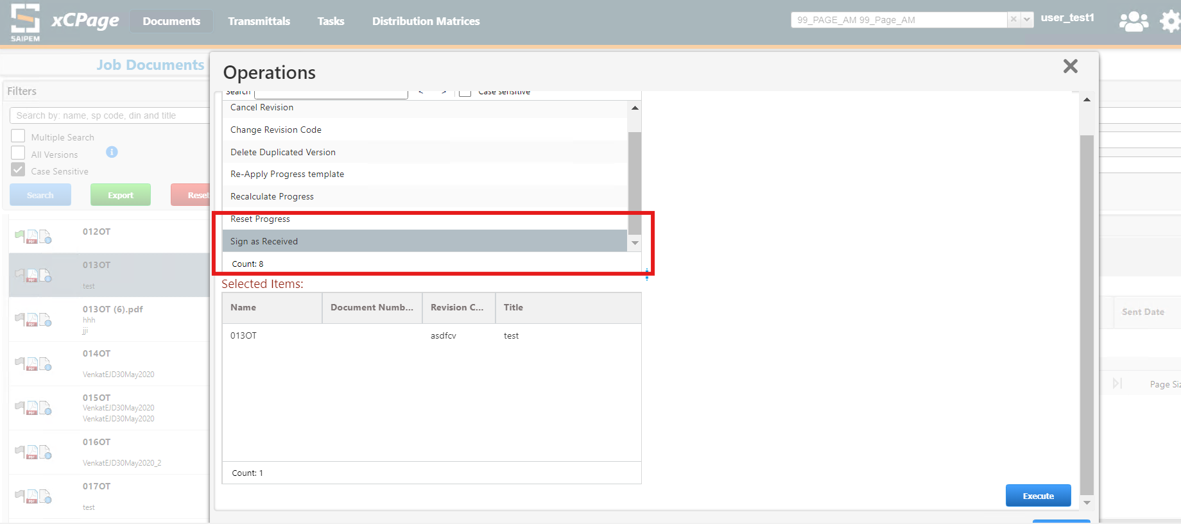

Provide "View Locations" feature on right click on document

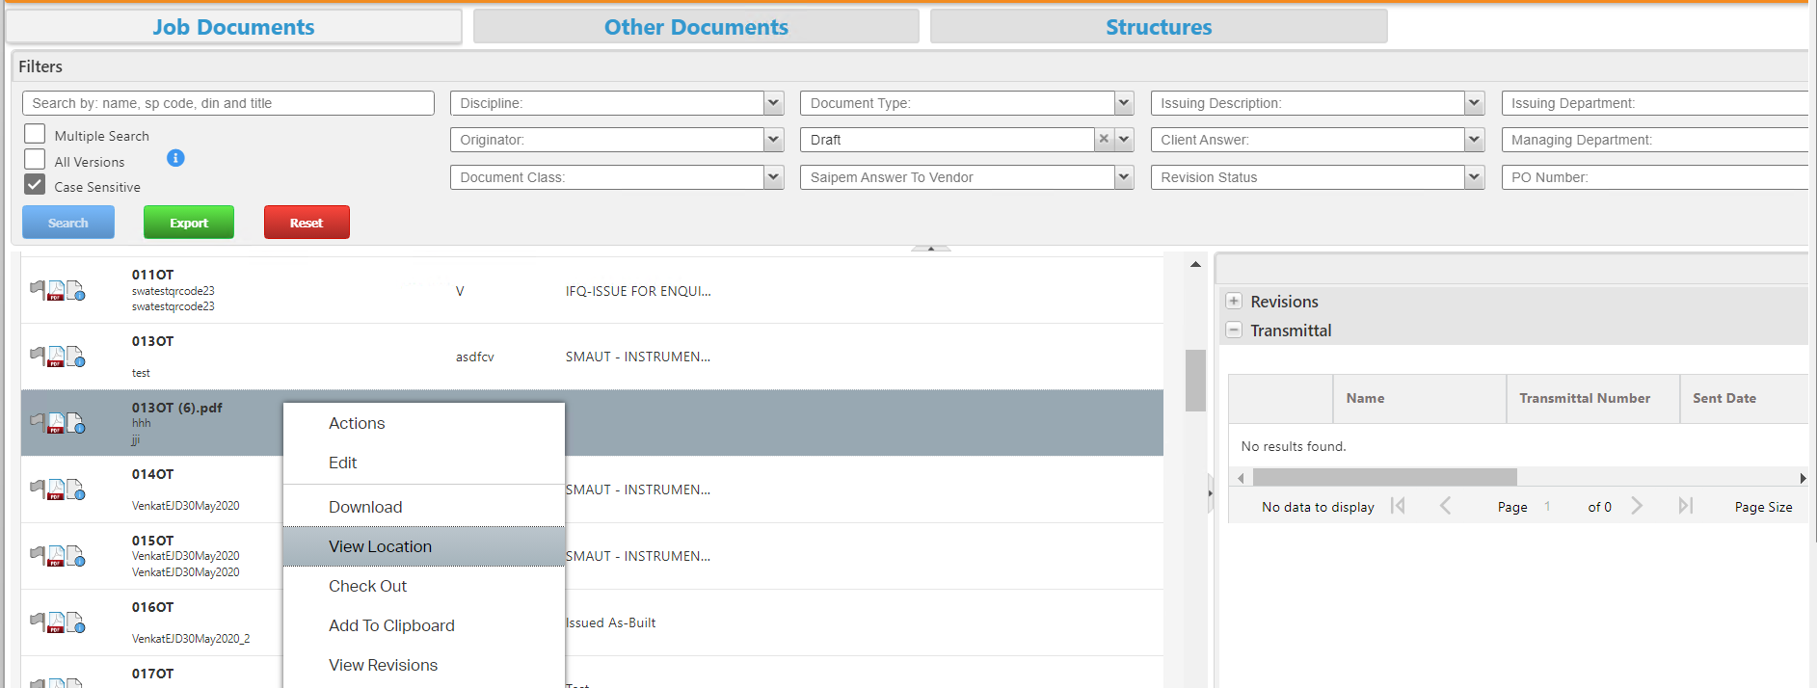
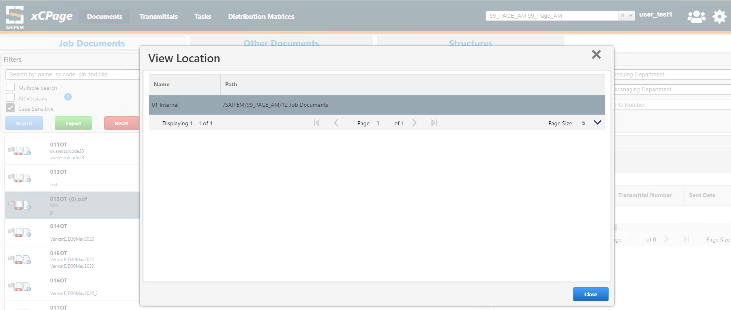

Add to Clipboard: Remove "add to clipboard" button and add this possibility into context menu for both main table and right hand one.
If selected element has been already added to clipboard, Context menu must show ‘Remove from Clipboard’ option.
This solution must be applied for both tables (main table and right-side one).
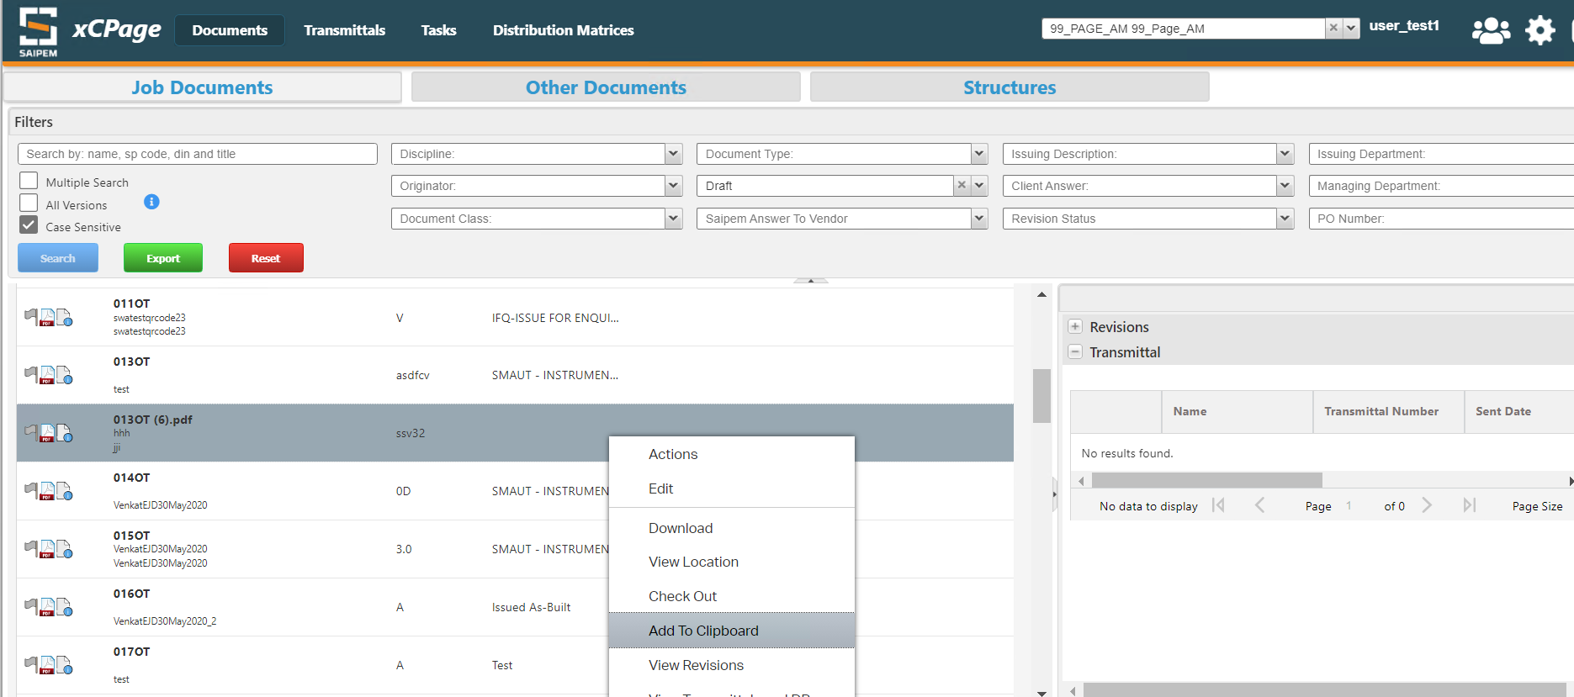

The document added to clipboard can be viewed by clicking on the clipboard action
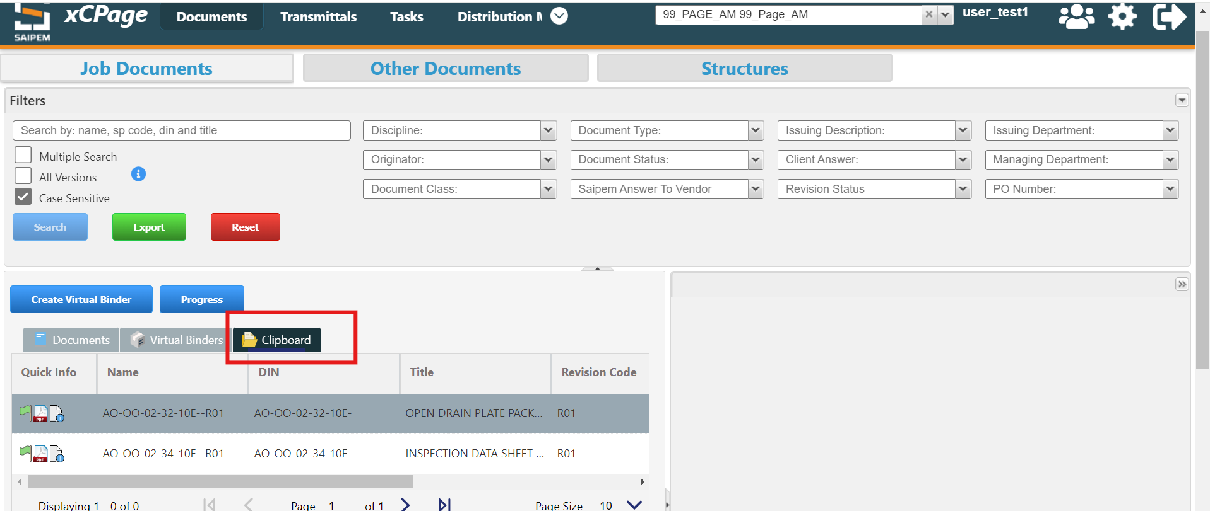

Provide to show the relationship of Job Documents with DP

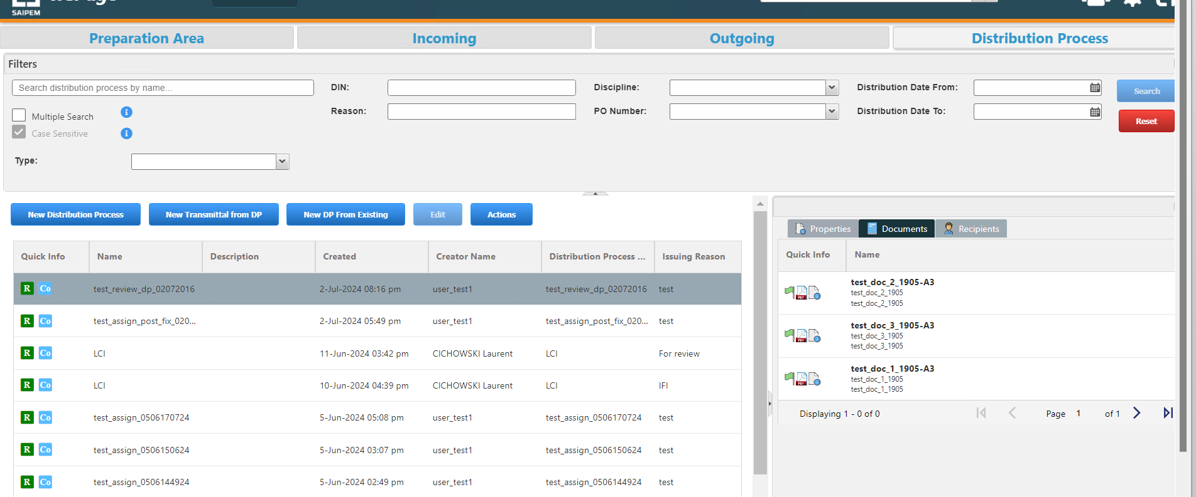

Checkin, Checkout :
Checkout and Checkin feature in XCPAGE. When checkin the versioning by default should point to same version rather than minor version.

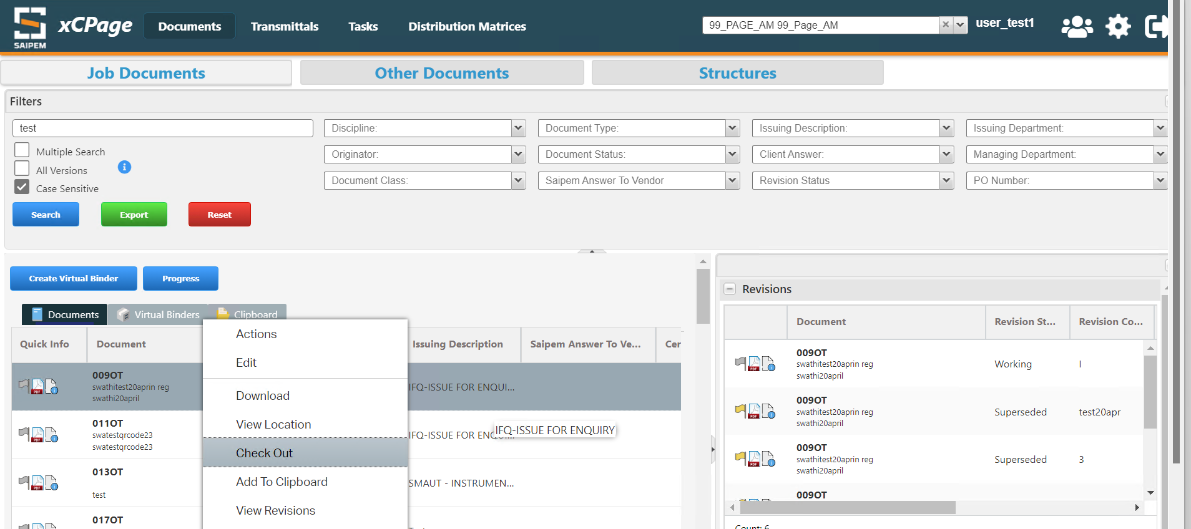
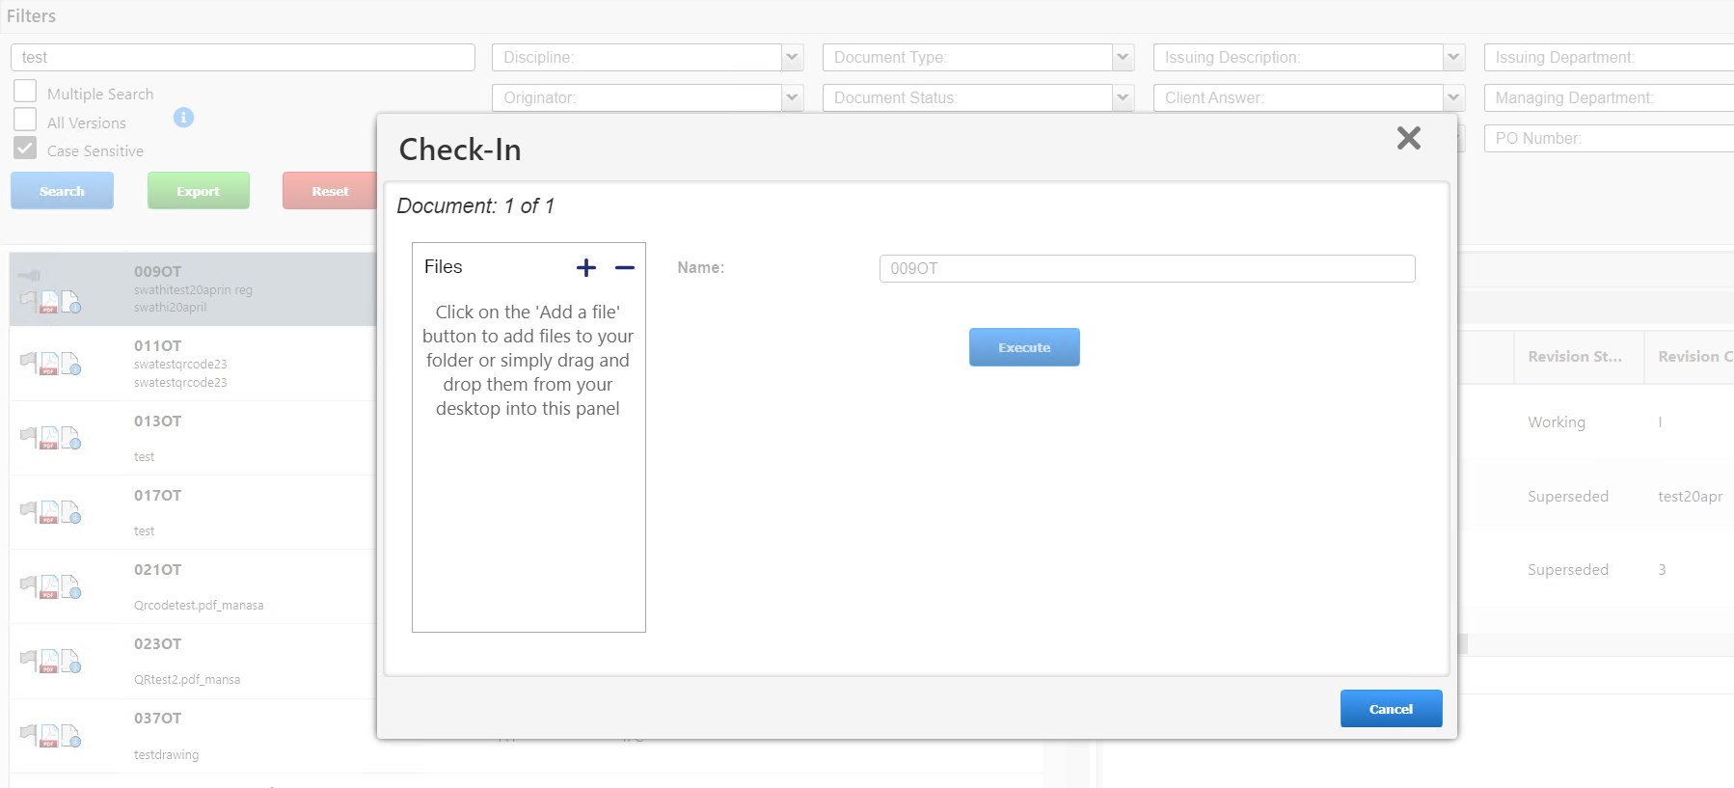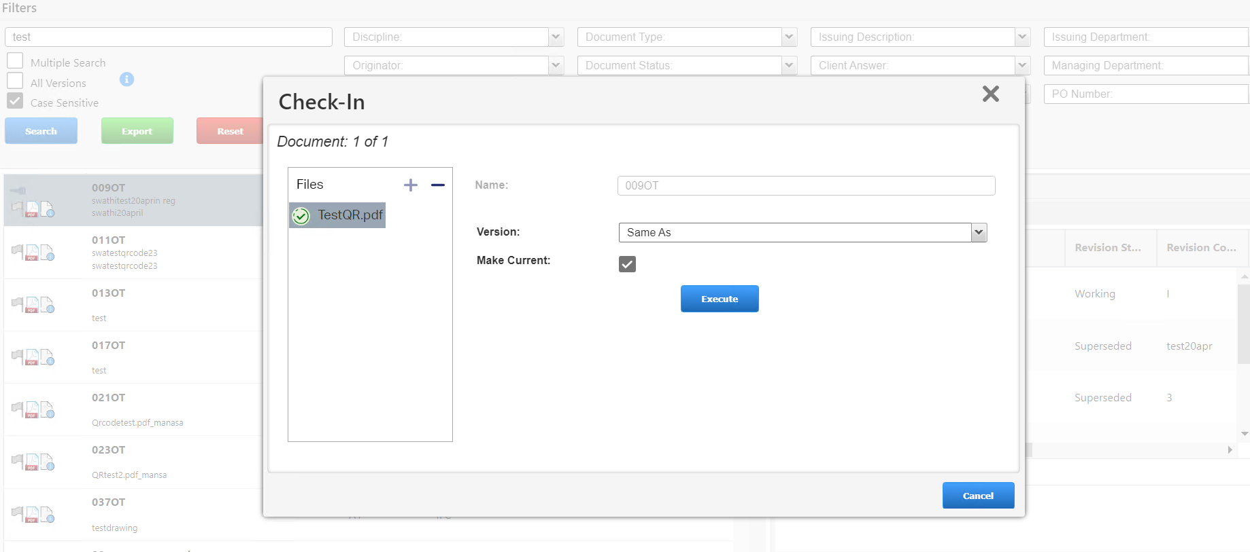

Transmittals
Click on the Transmittals tab beside Documents tab
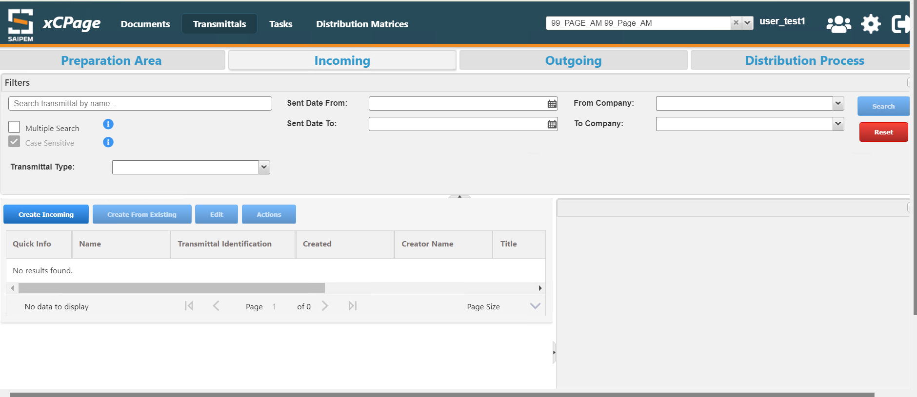
Click on create Incoming. A Create new Transmittal Window will open like below. Fill all the mandatory fields and click on Next
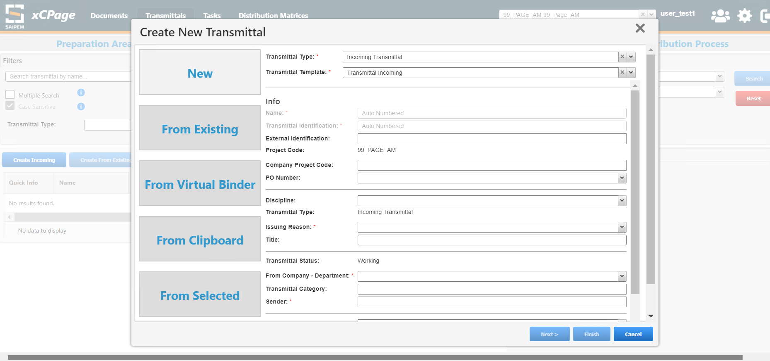
In the Next window we can relate the Transmittal to Job Documents like below. Select the Documents and click on Finish
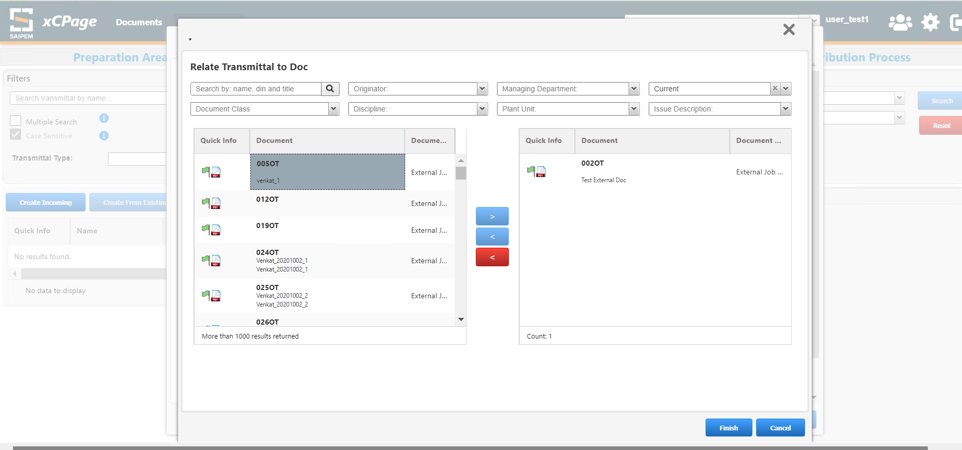
After adding the Documents, click on Next

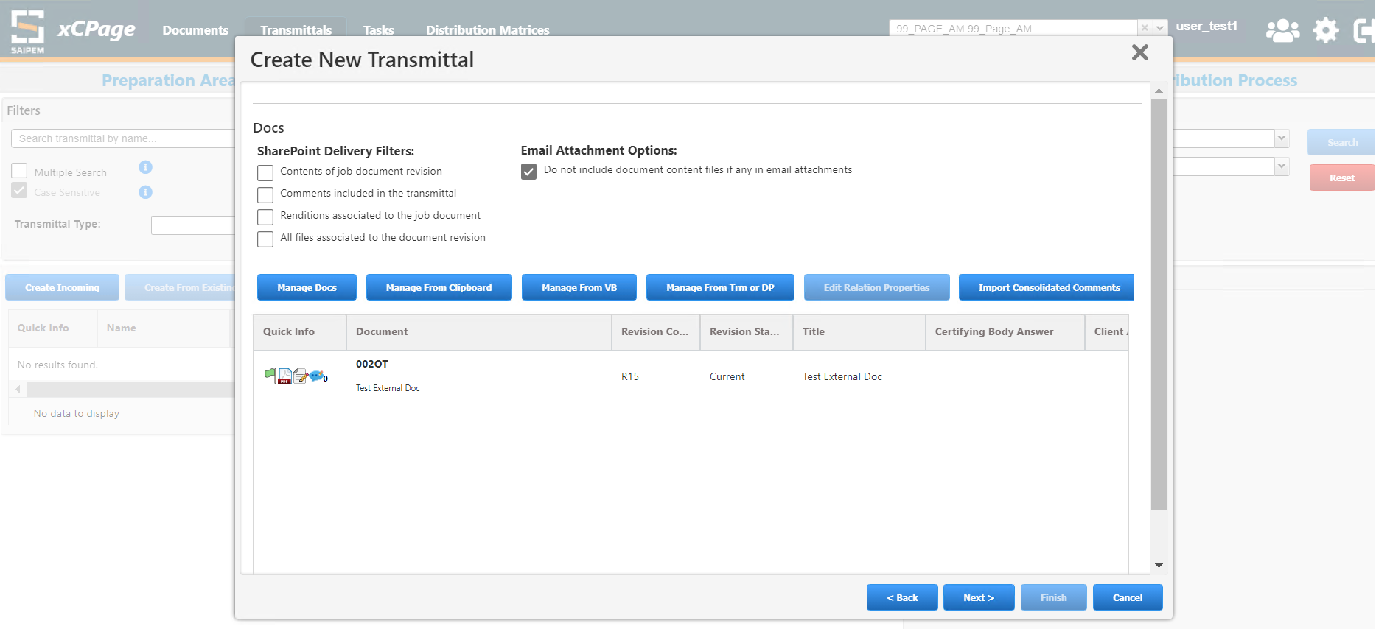
Click on Next after performing the steps in each tab
Select the user, Reason and Delivery Method in the recipients window like below
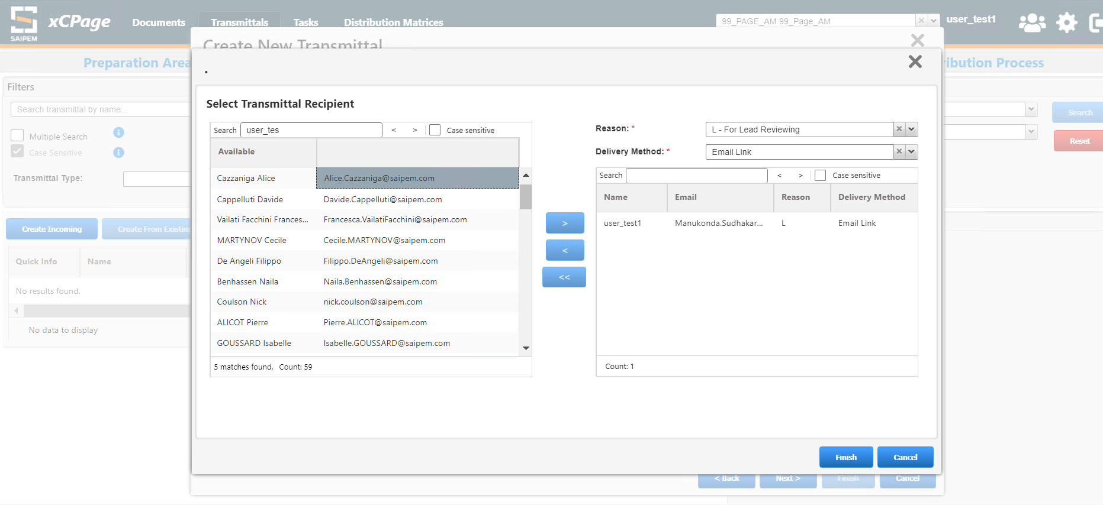

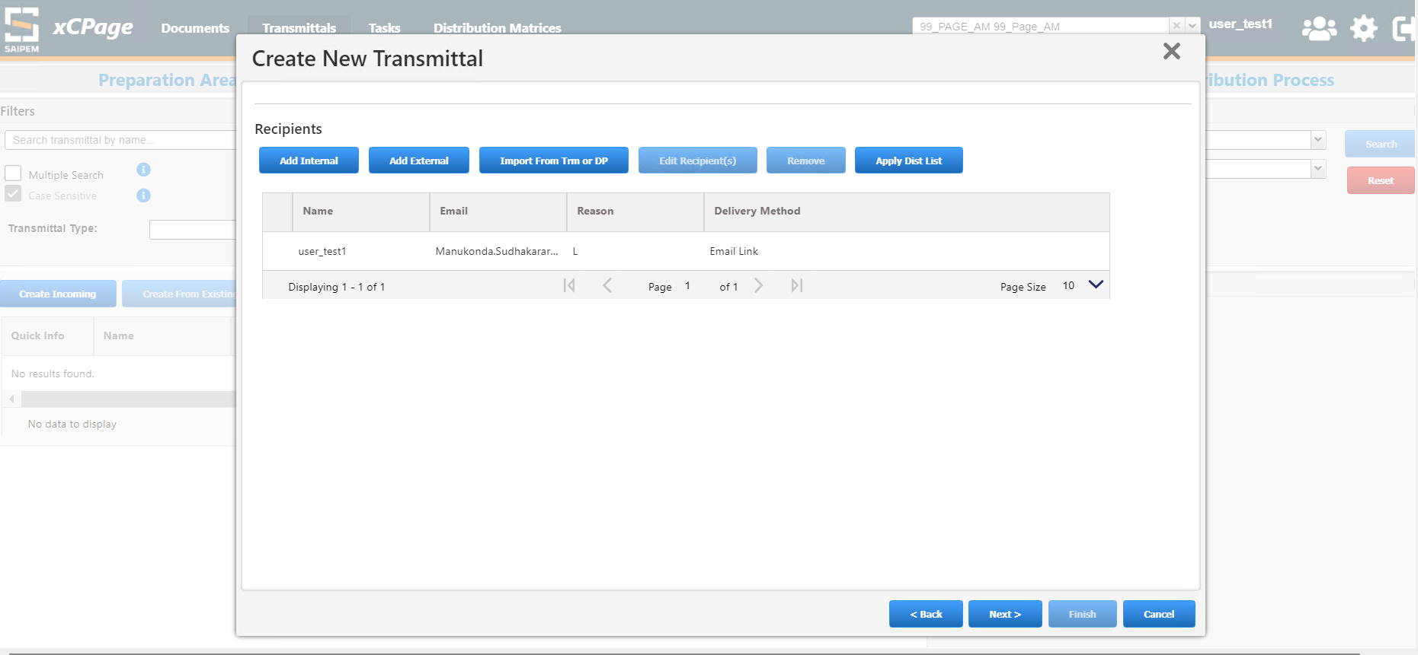
Click on Finish in the Final window
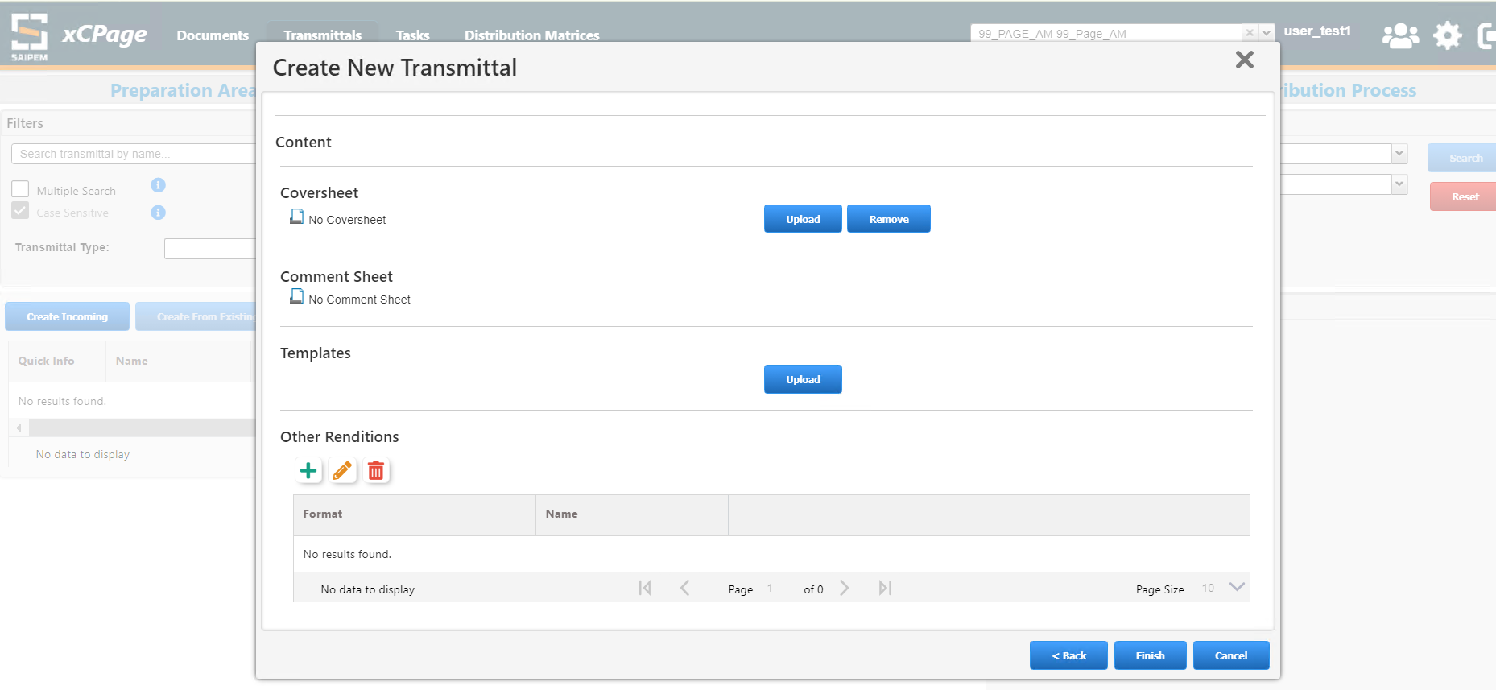
Transmittal will be created like below and will be in working state.
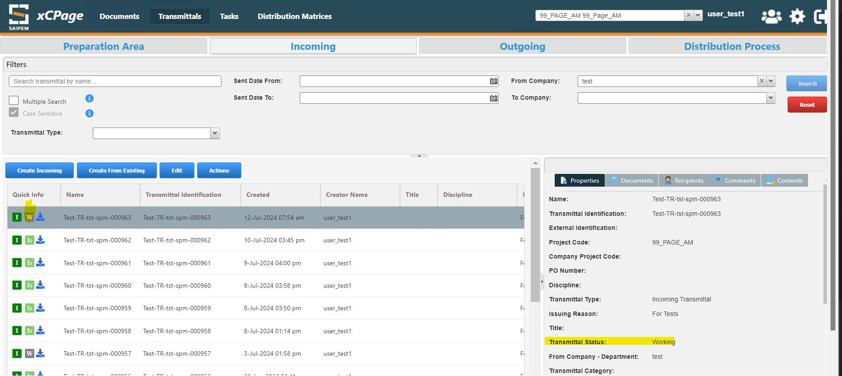
Select the Transmittal and right click to see the available Actions.
In the Actions window select Mark Transmittal as Ready
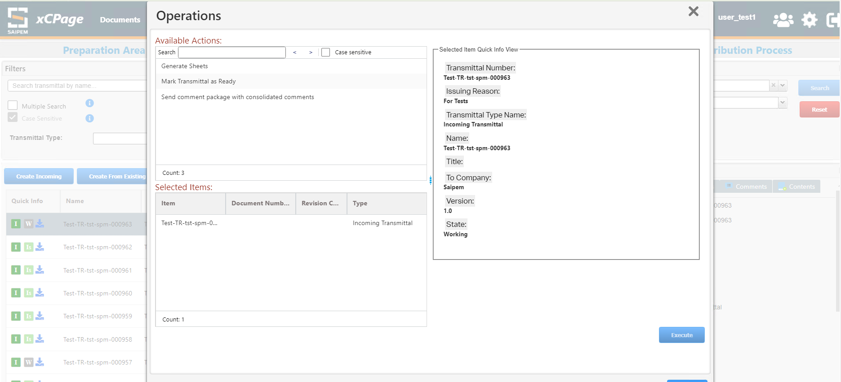
Action will be executed and the Transmittal will be marked as Ready.
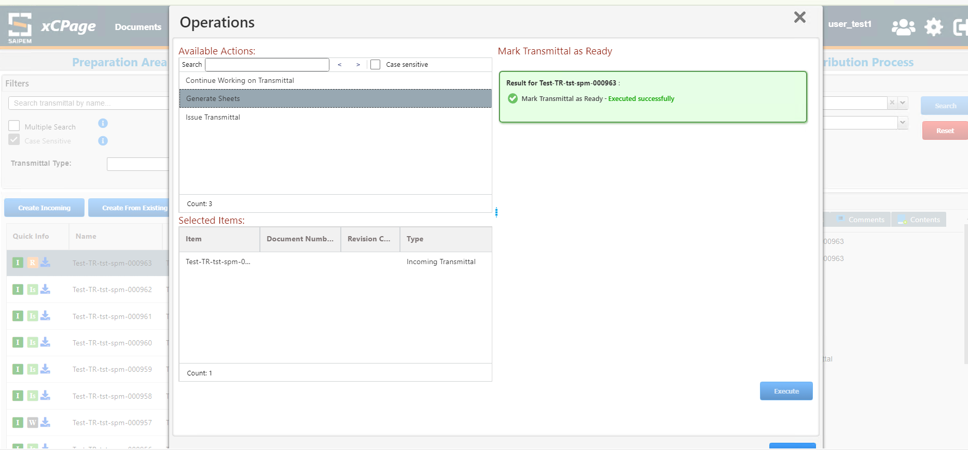
Again in the Actions window click on Issue Transmittal in order to issue the Transmittal
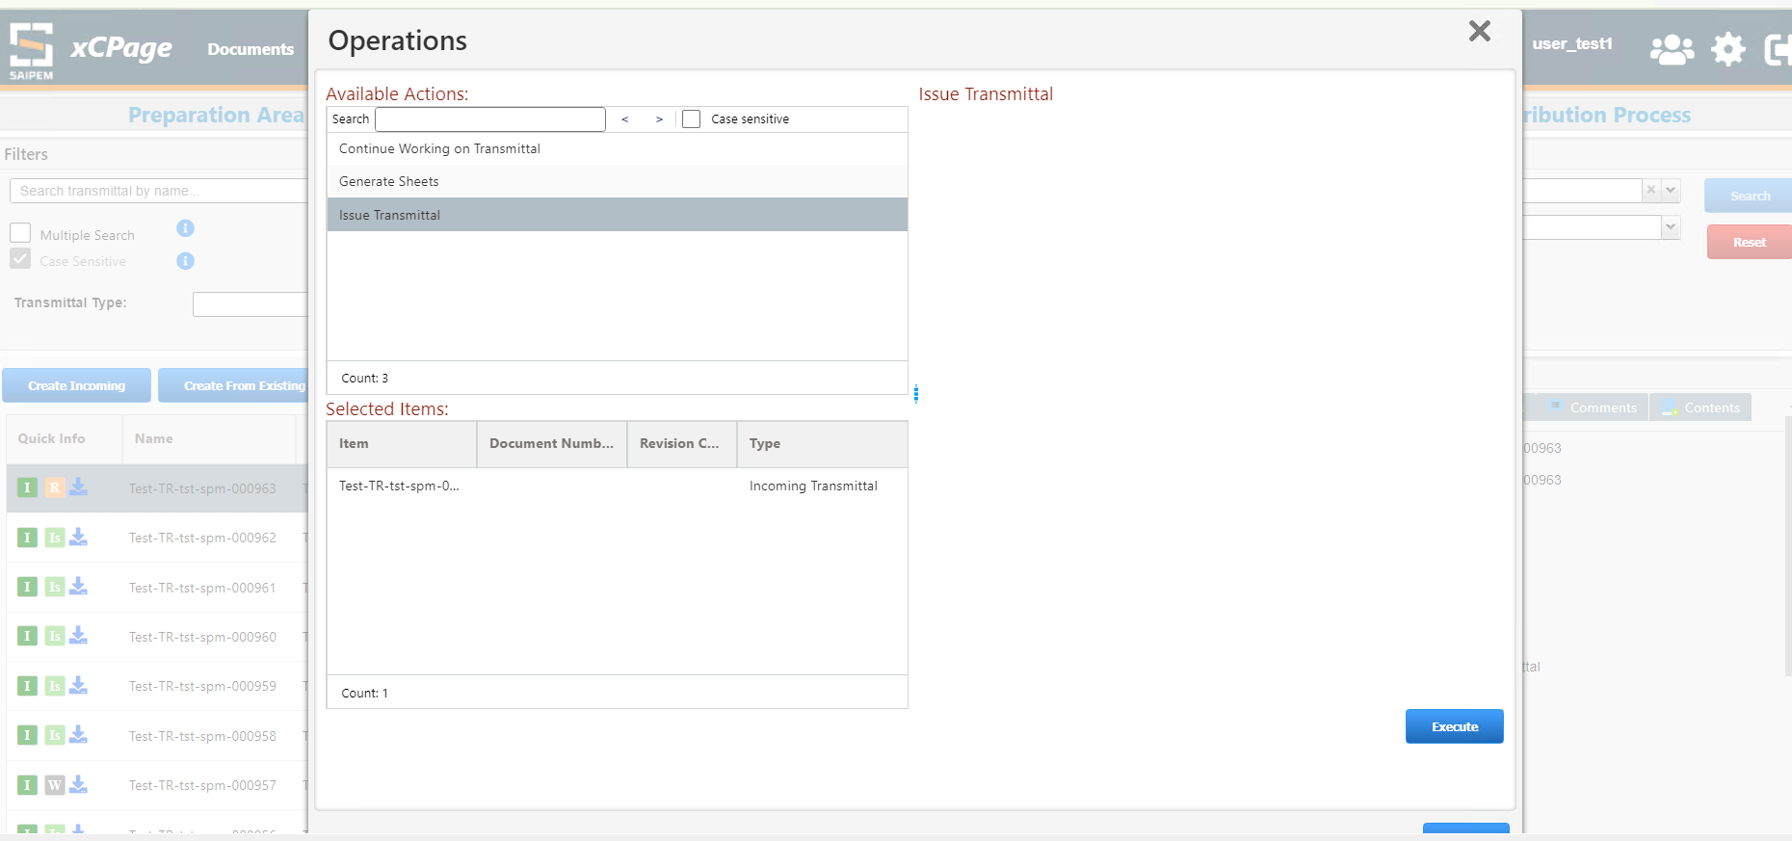
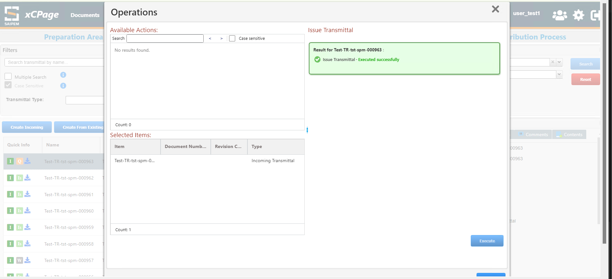
The Transmittal Status will now be changed to ‘issued’
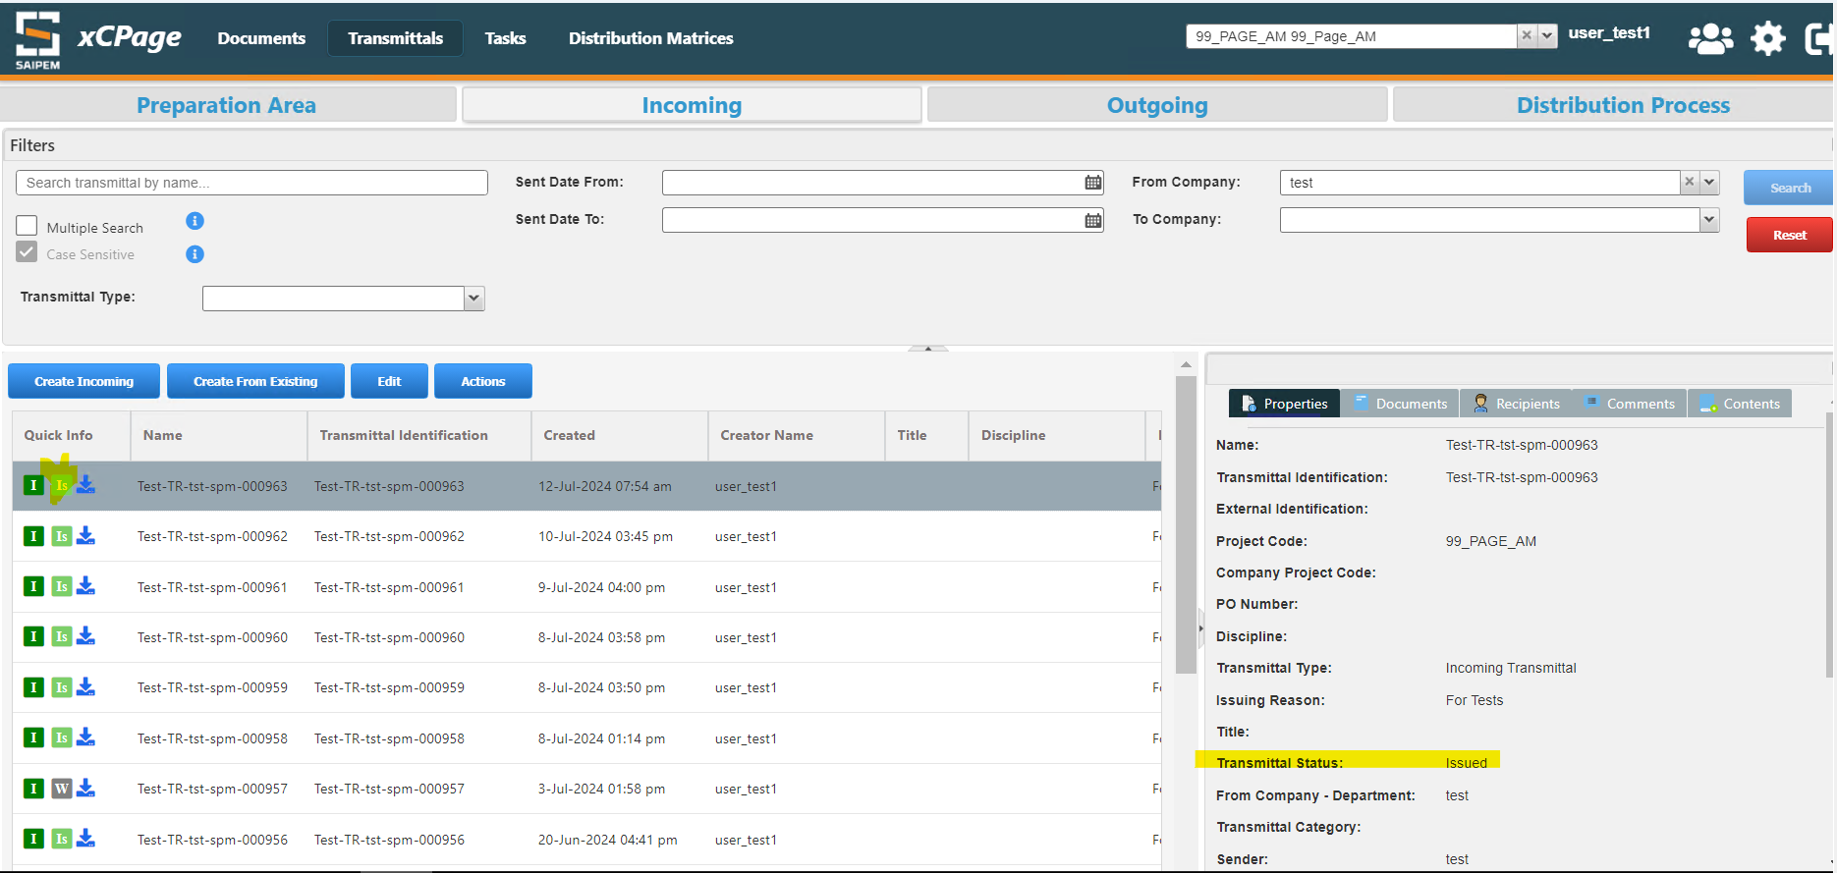

While Creating/Editing the transmittal and Distribution Process, Job documents step page should allow to import the documents from virtual binder and clipboard
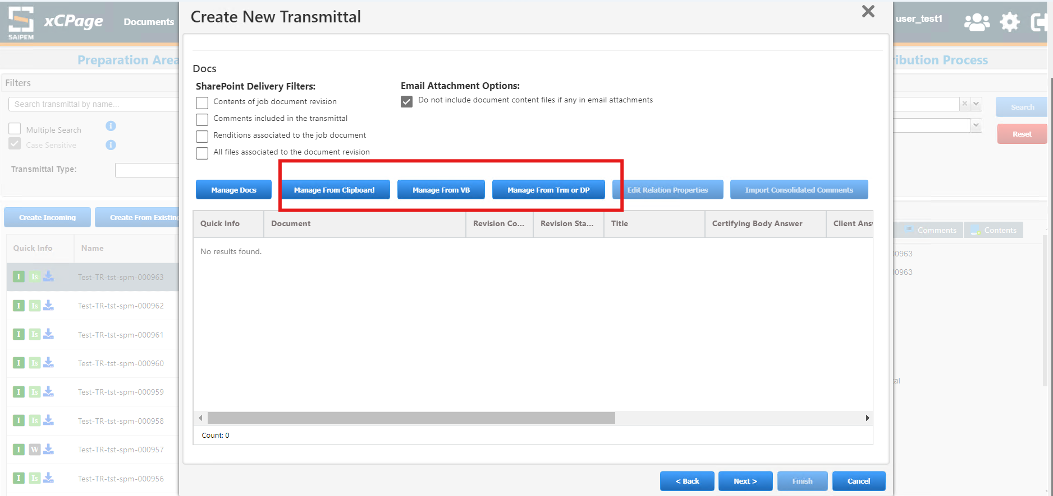

Import From Virtual Binder button will display the popup to select the virtual binder and select the job documents to be imported for Transmittal/Distribution process
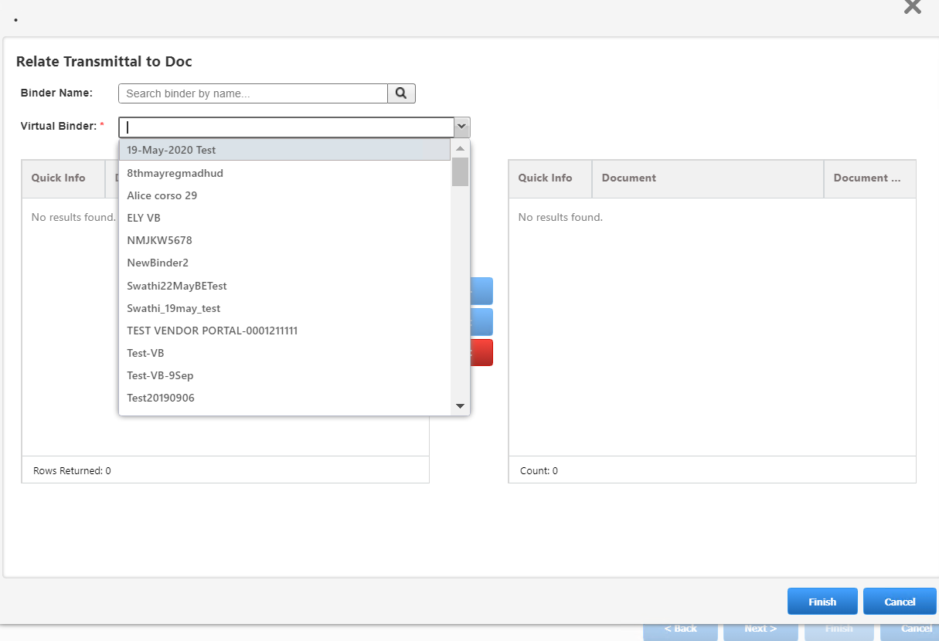
The comments can be added on the document attached to a transmittal by clicking on the below icon
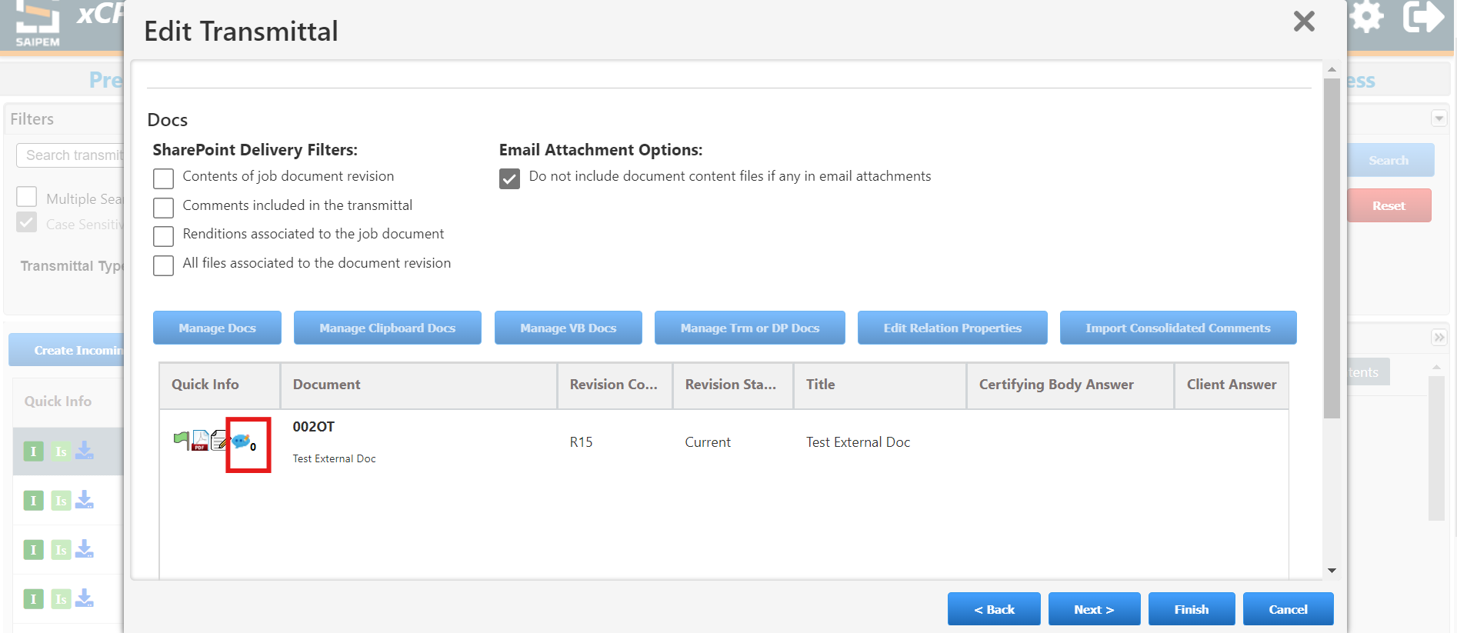
Click on the + icon to add the comment file
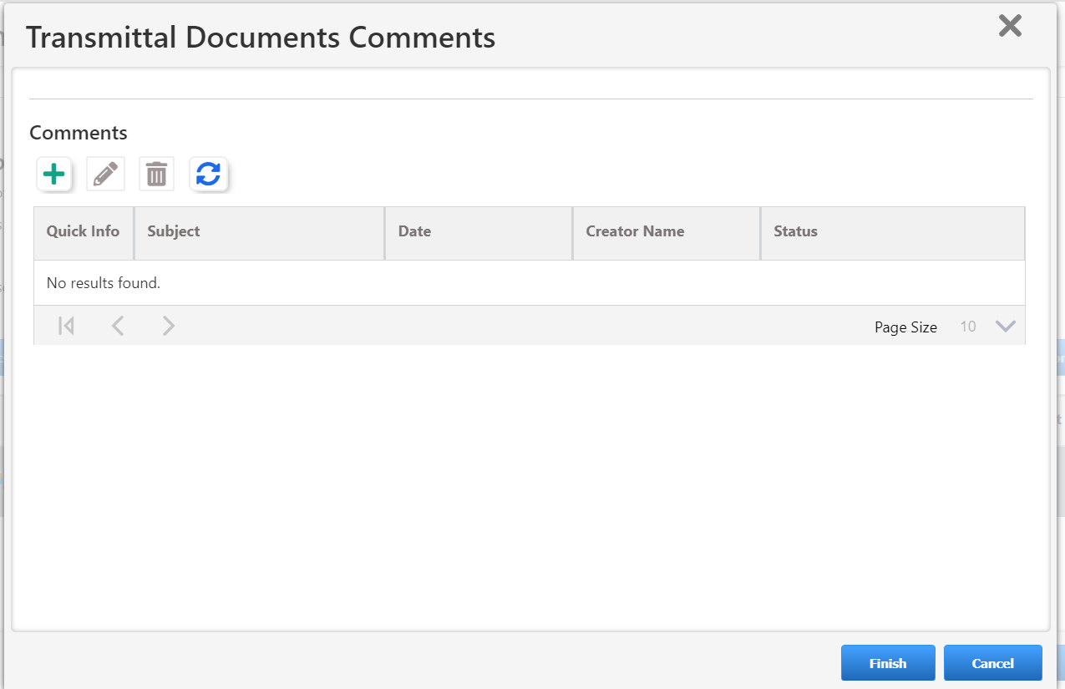
The format will be automatically gets selected based on the file which have been uploaded and click on finish
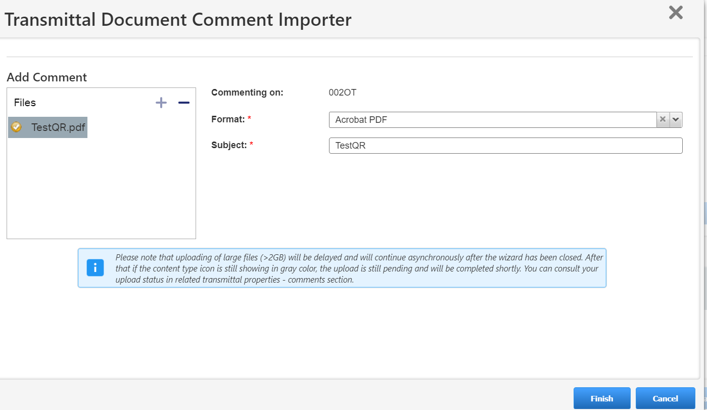
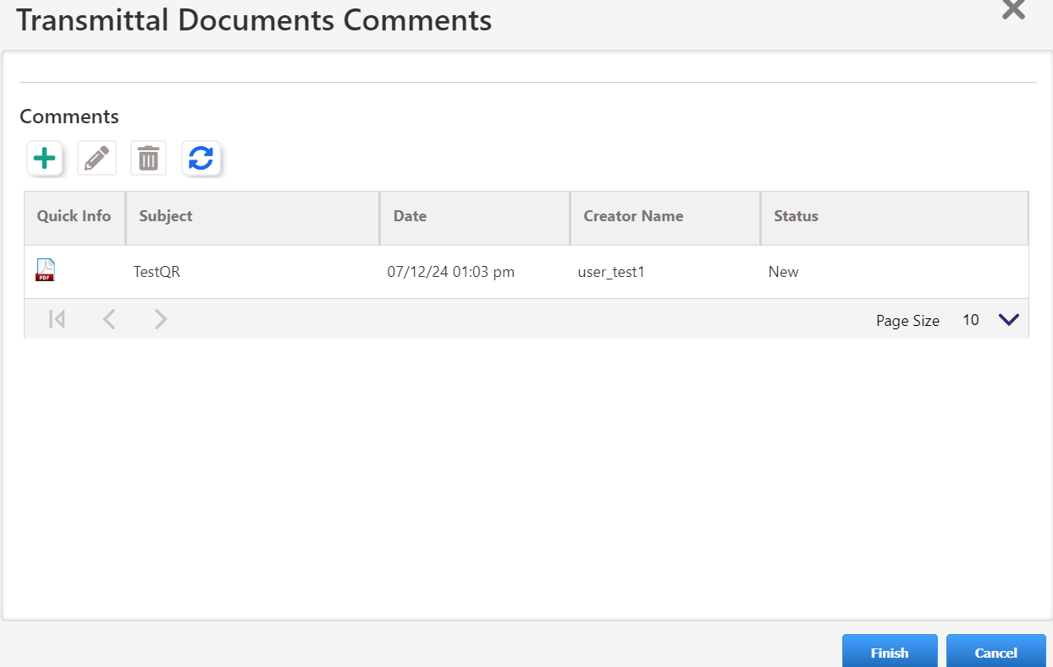
The attached comment can be edited by clicking on the below icon
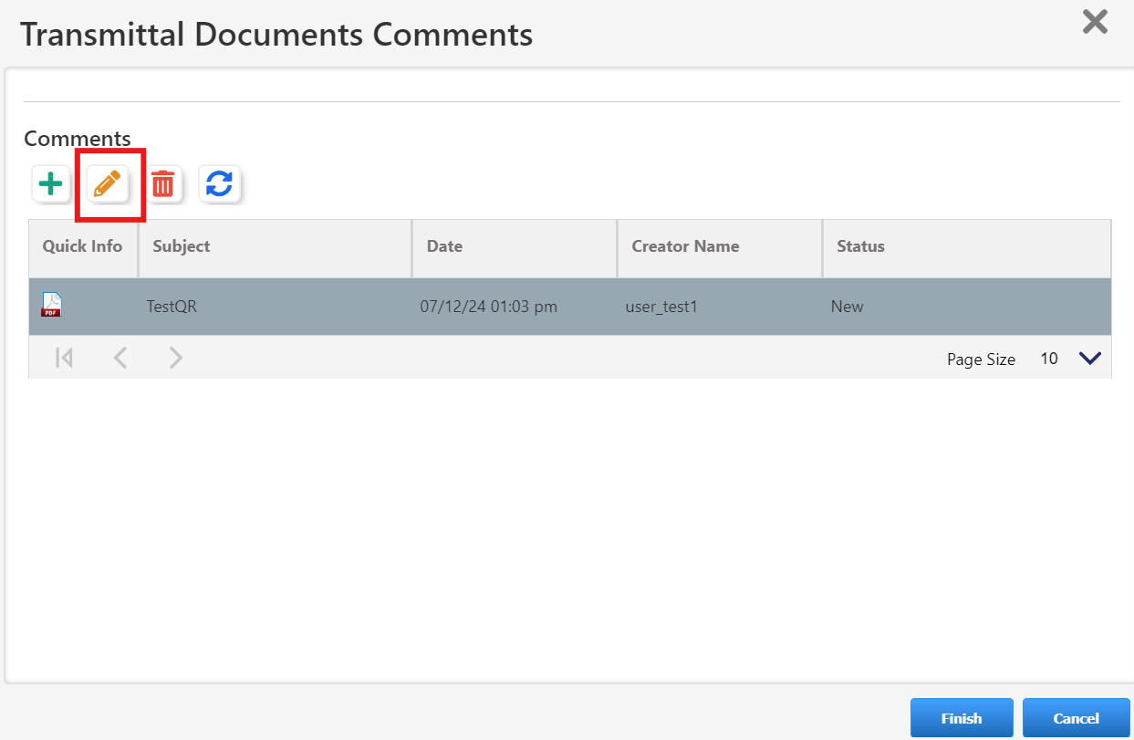

Export to Sharepoint: The transmittal can be exported to a Sharepoint by adding any one of the recipients with Export to Sharepoint delivery reason. Also the below sharepoint filters needs to be selected based on what contents has to be exported to Sharepoint location. Once the transmittal has been issued, it will be available in the sharepoint location
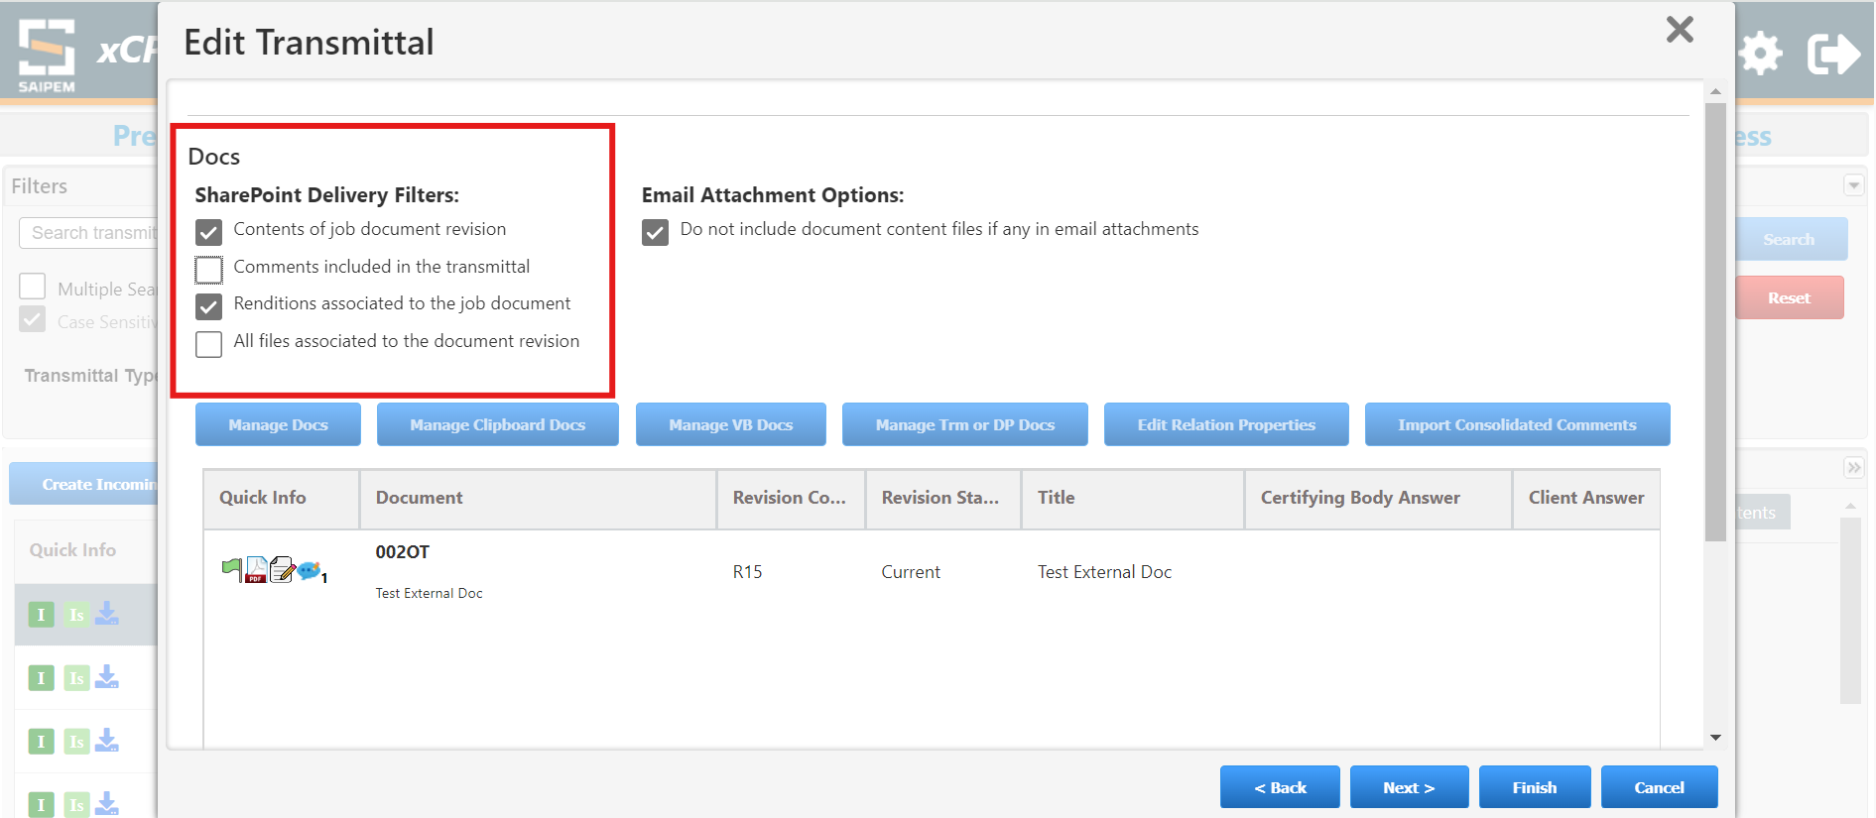
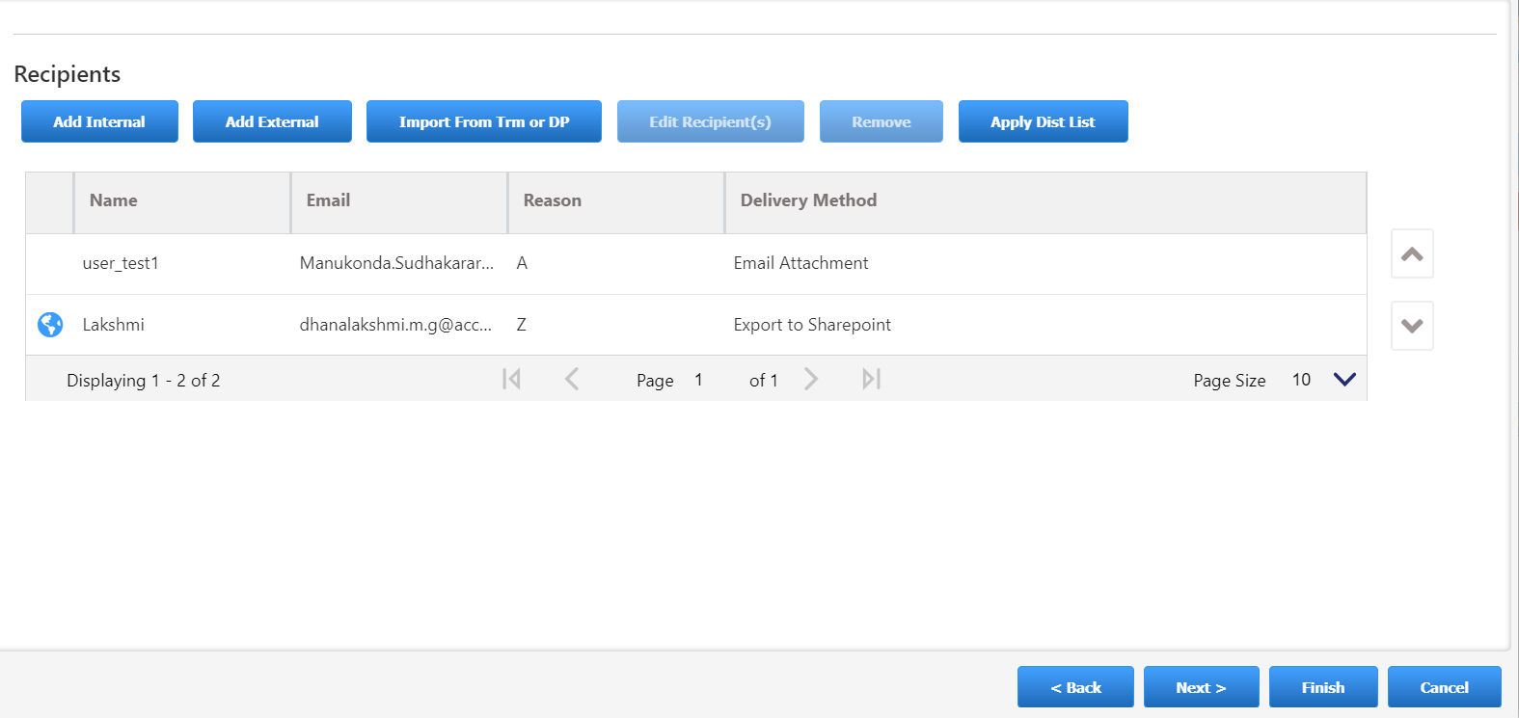
Create a Transmittal starting from a Distribution Process. Select a distribution process and select an option “New Transmittal from DP”
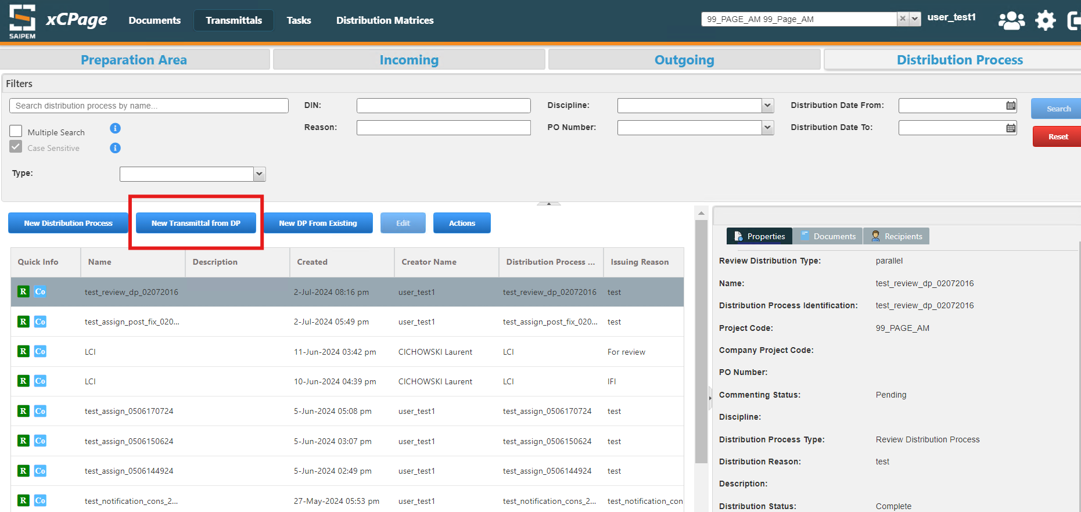

Select a Transmittal type and the options which needs to be copied to a newly created transmittal
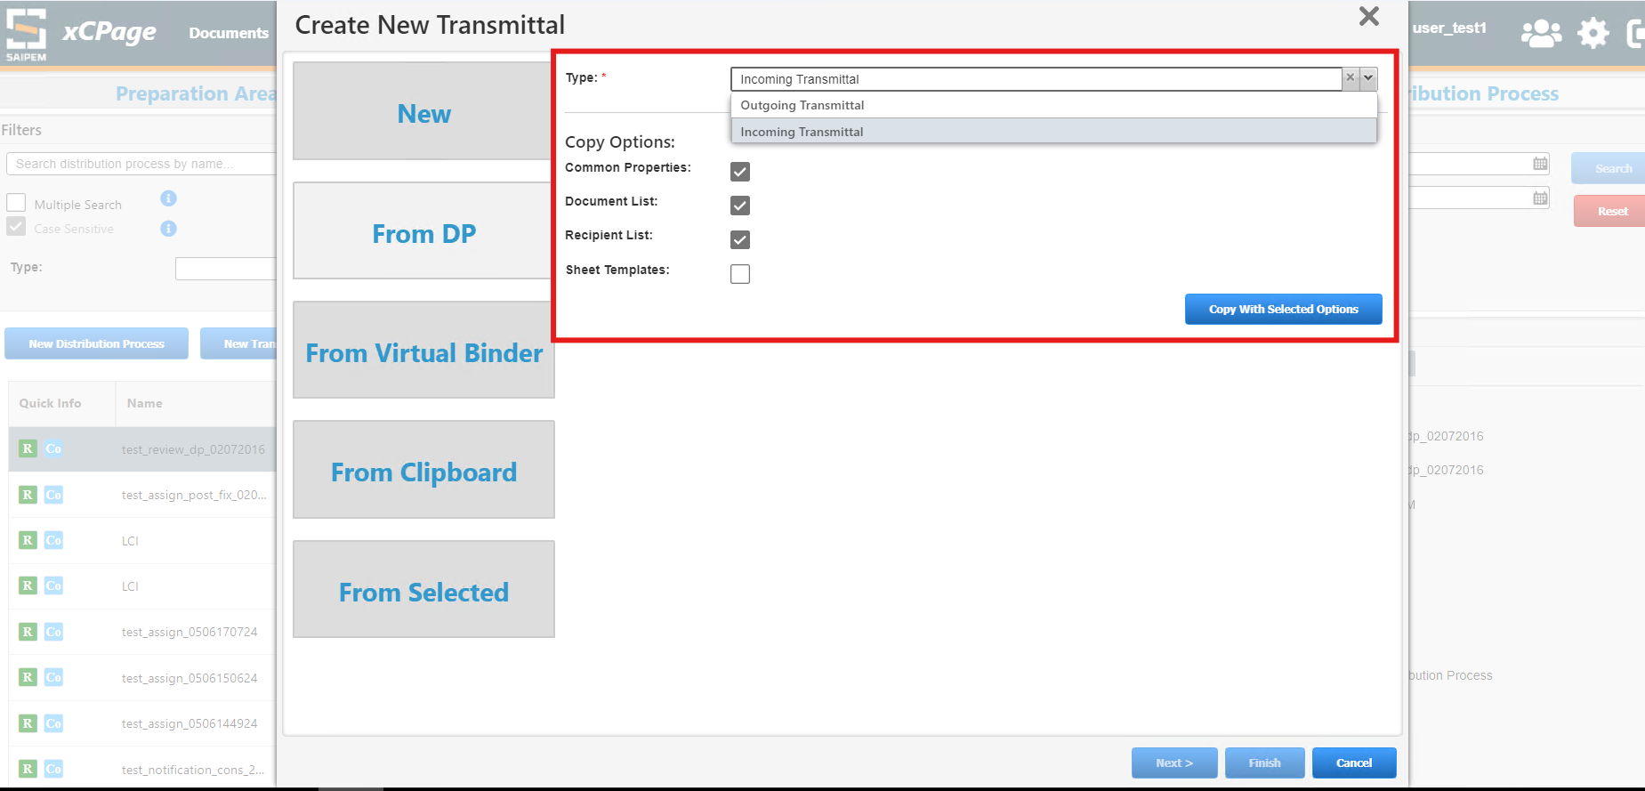

Create a new Distribution Process from an existing one. As shown below:
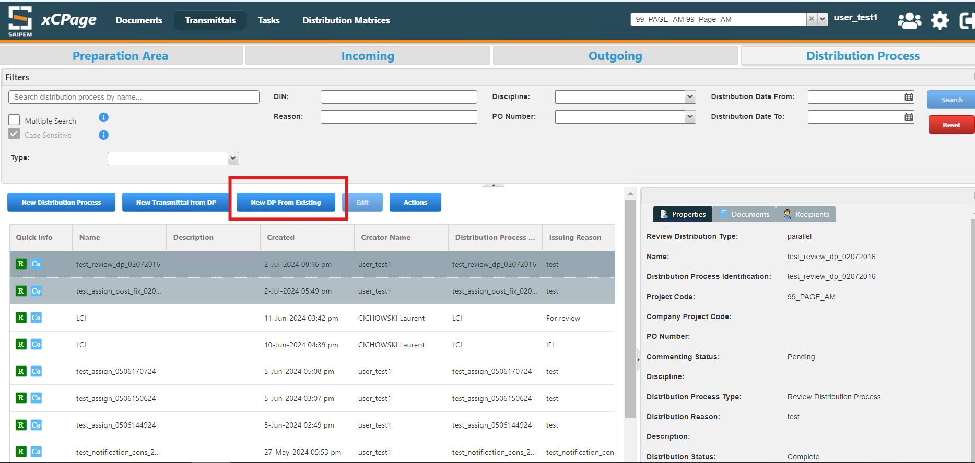
Select a DP type and the options which needs to be copied to a newly created DP
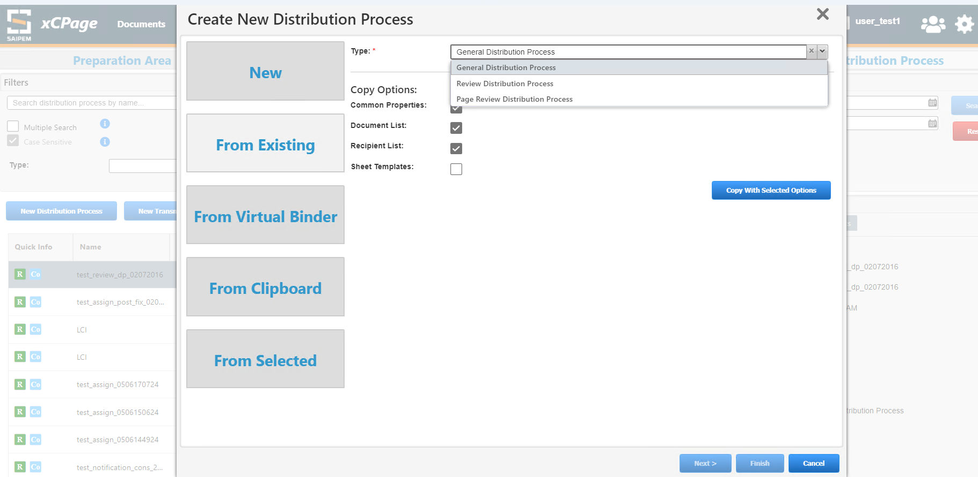

Distribution Matrix

8.1 Importing Template
Click on Import Template to import the Distribution Matrix template.
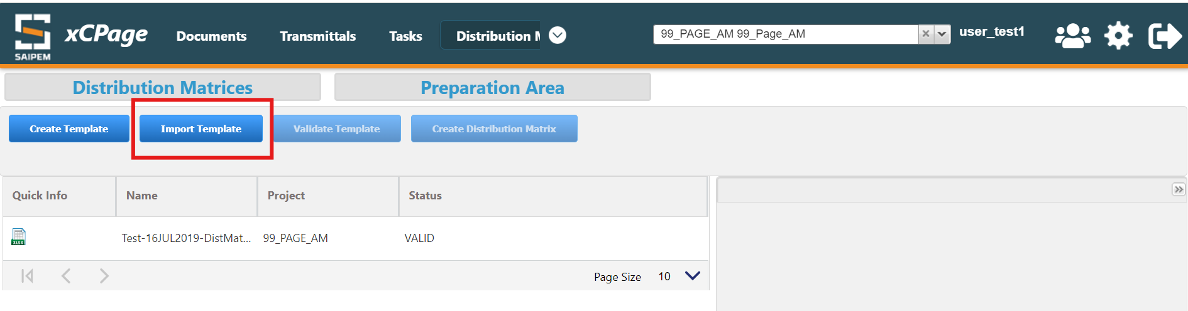
Click on + icon to browse and add the spreadsheet.
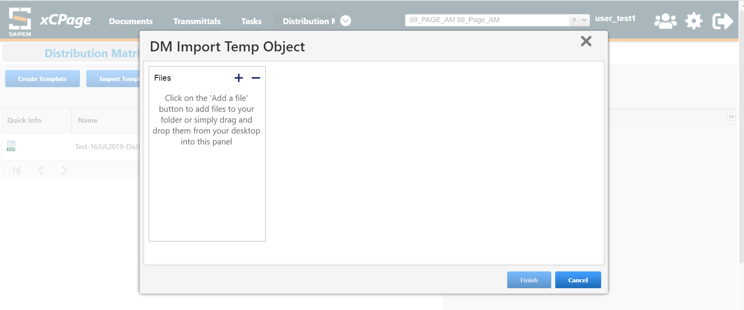
- Select the Format from the dropdown.
- Please fill the Name
- Select the Document Type
- Choose the Document Template
- Add the Valid Type Selected and click on Finish
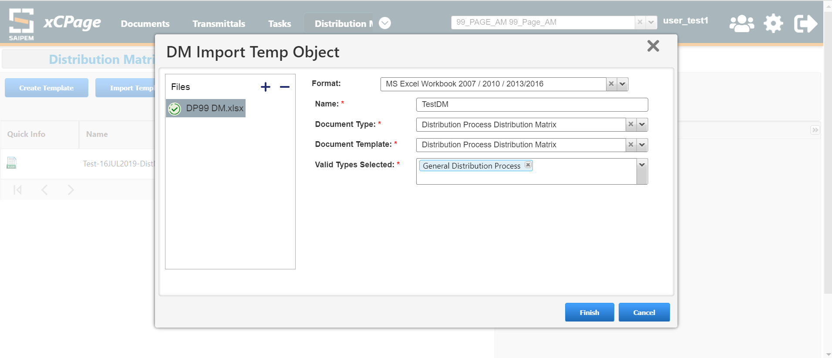

8.2 Validating the Template
Navigate to Preparation Area Tab, Select the Imported Template and Click on Validate Template
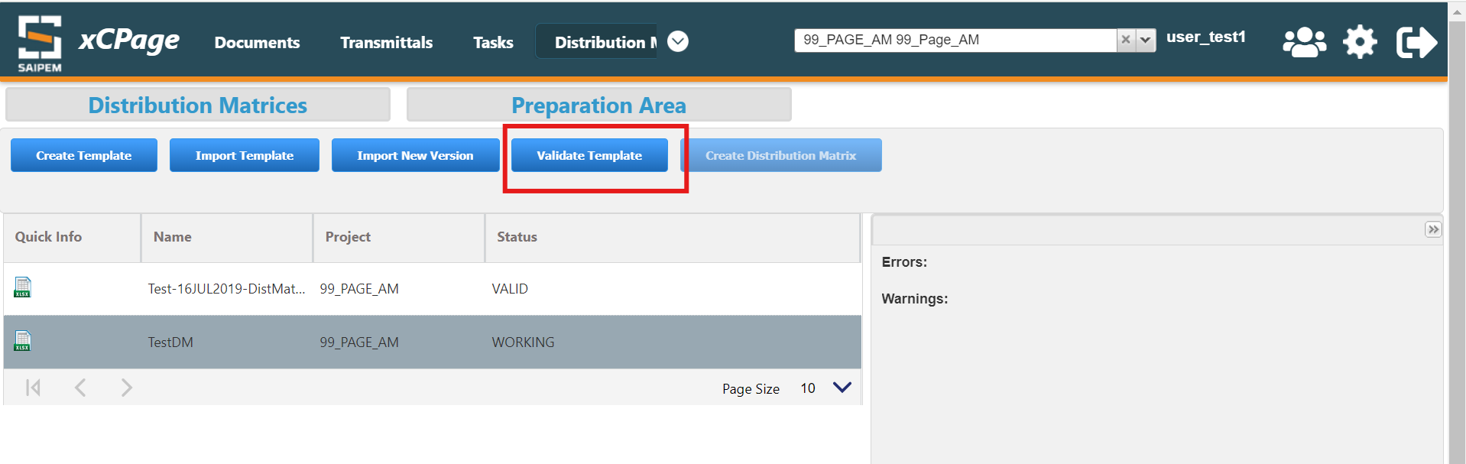
Once it is successfully Validated, select the template and click on Create distribution matrix
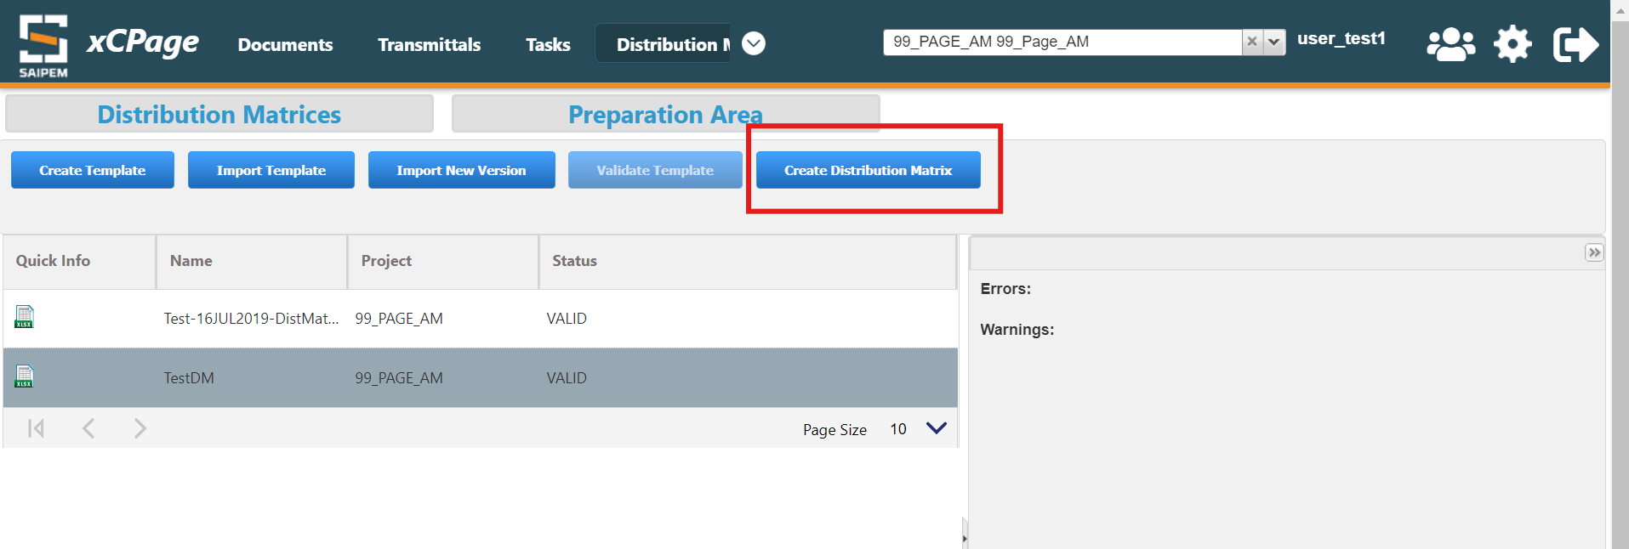

8.3 Publishing the Matix
Navigate to Distribution Matrices Tab and select the imported Template and Click on Publish button.
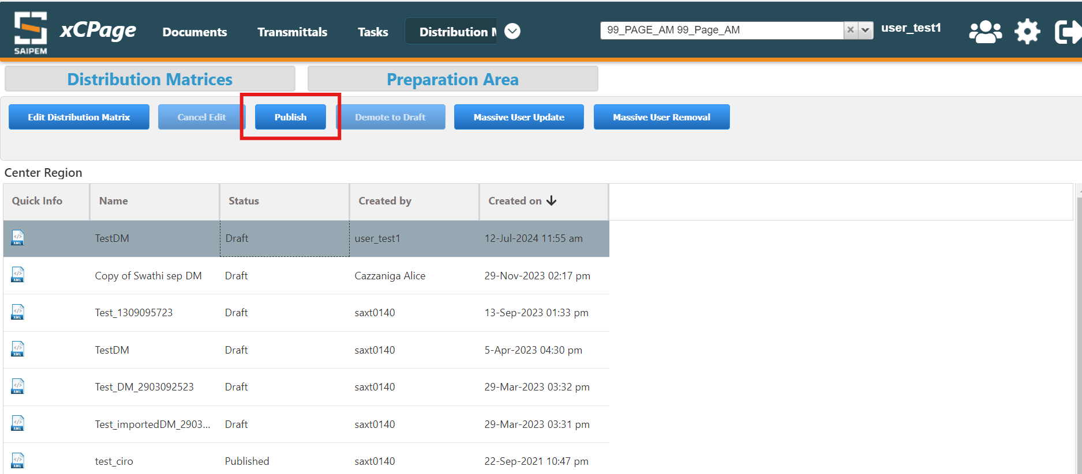

Distribution process

10.1 General Distribution Process
Click on new distribution process
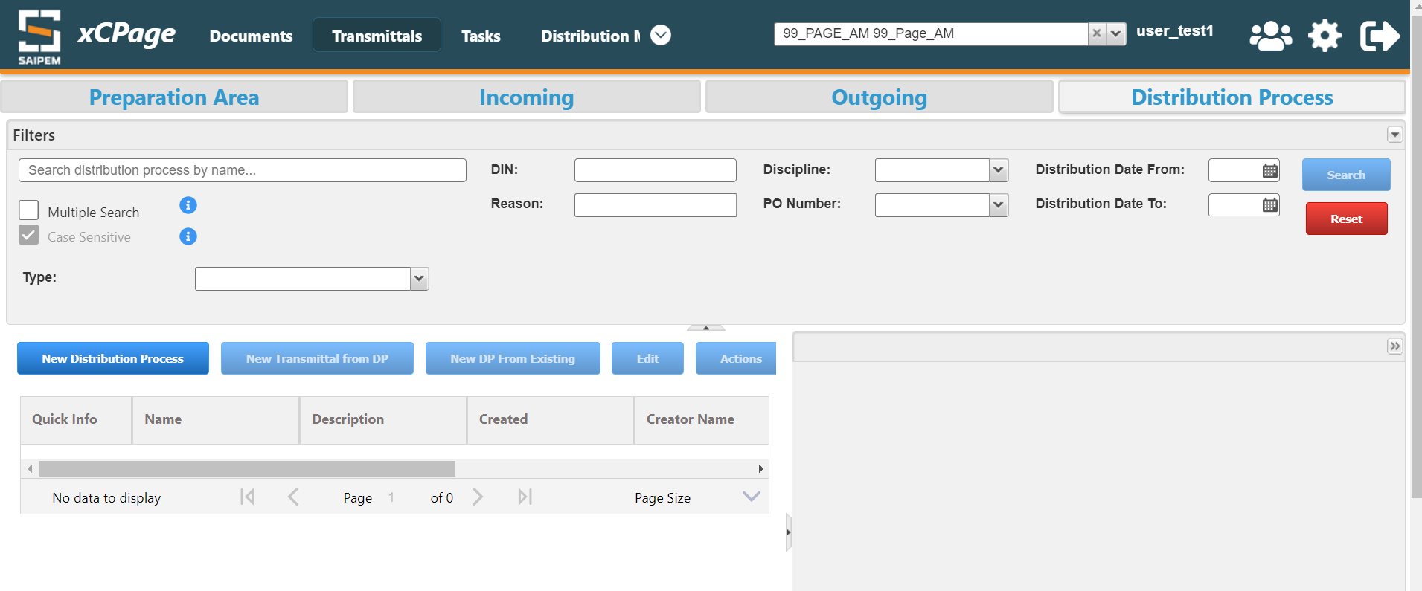
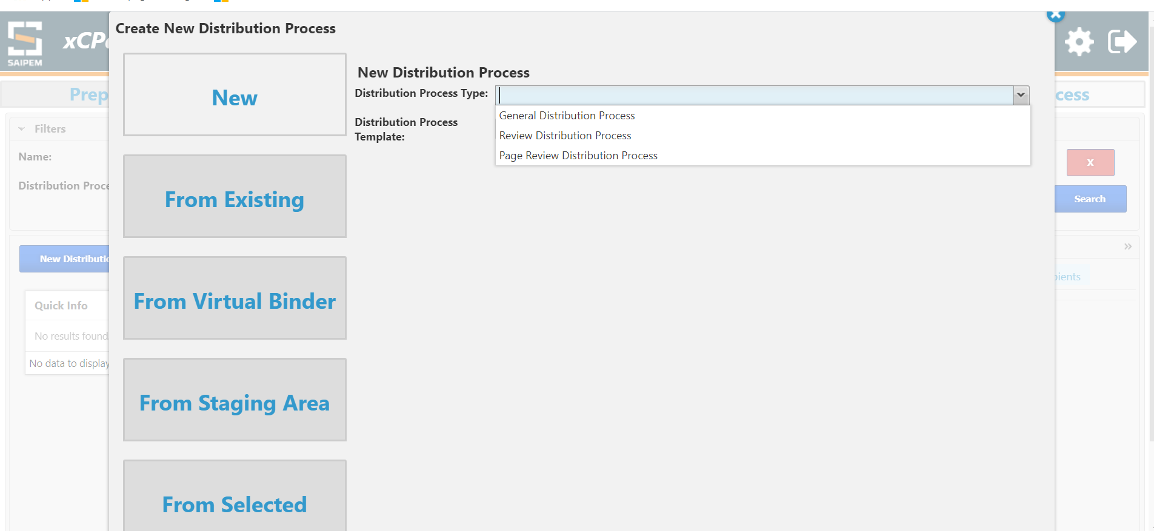
Fill the fields like below
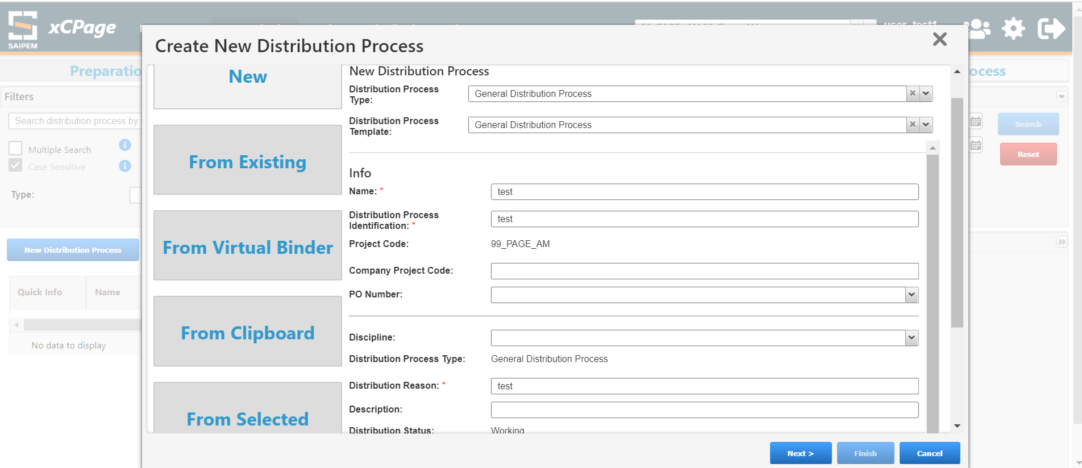
Select the documents
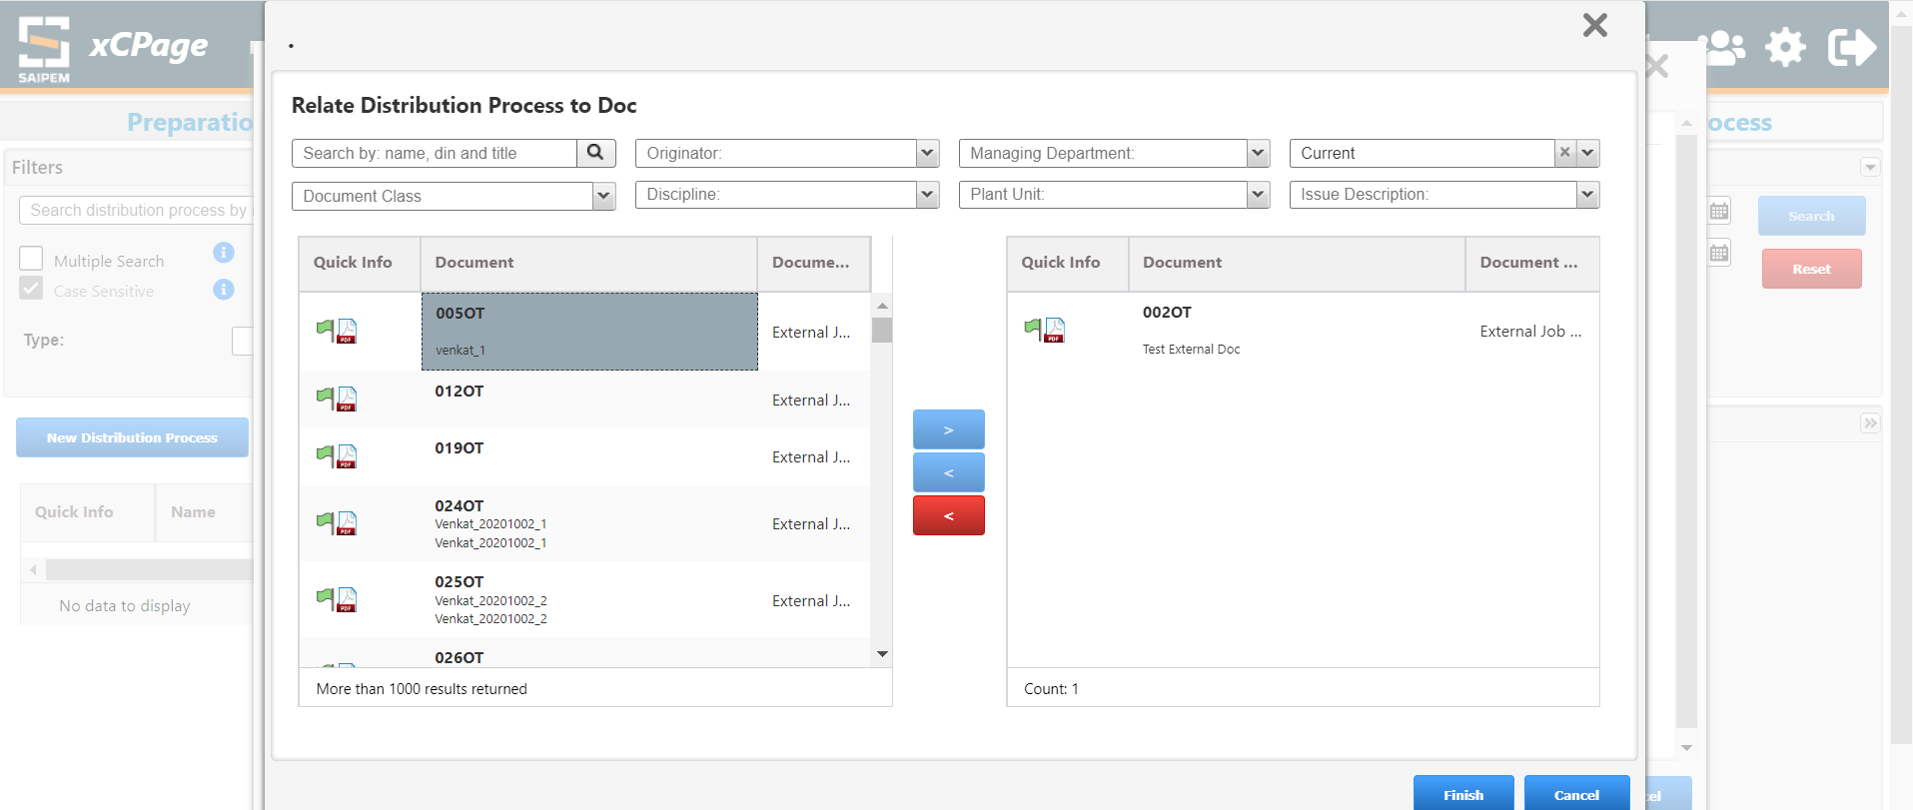
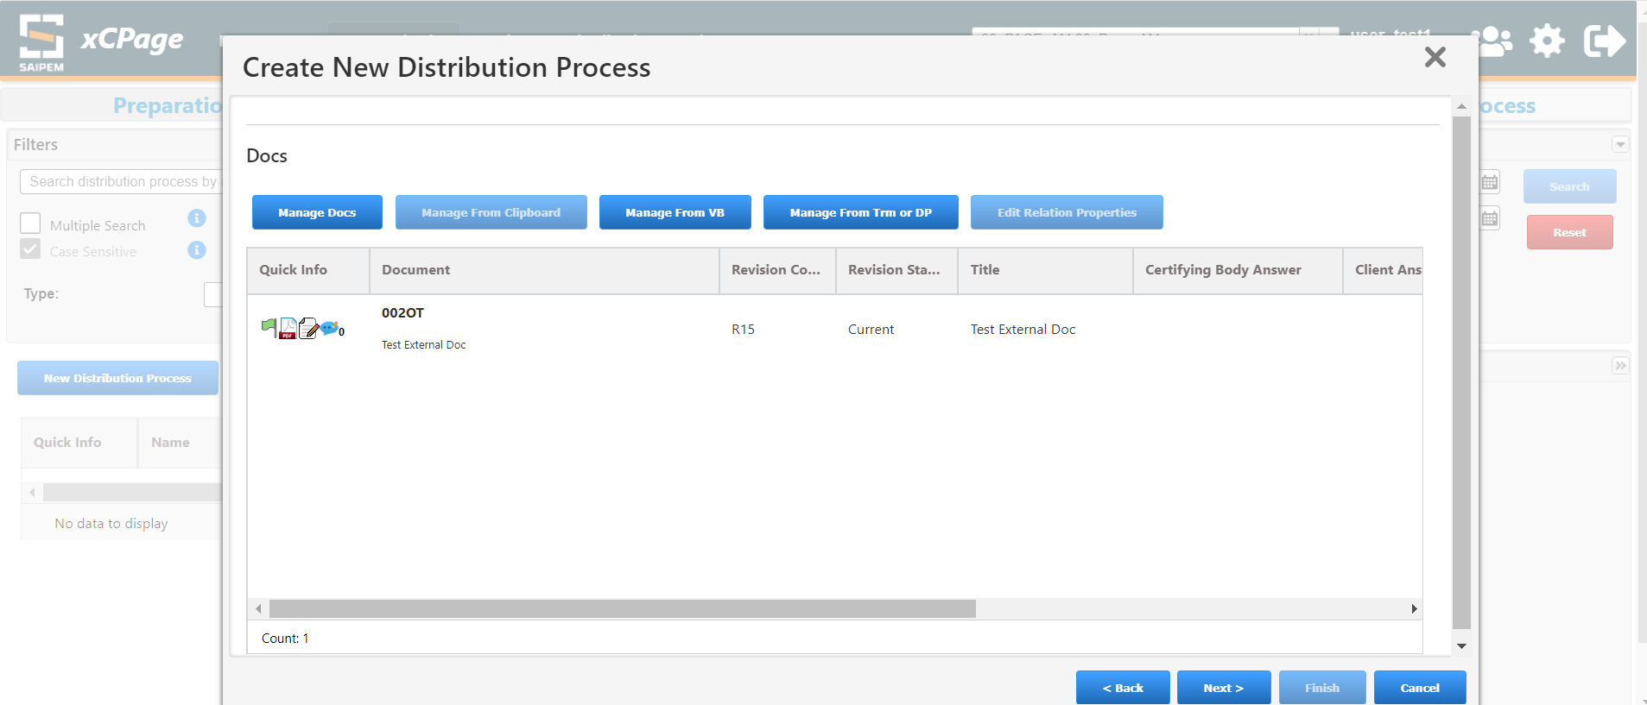
Enter recipients
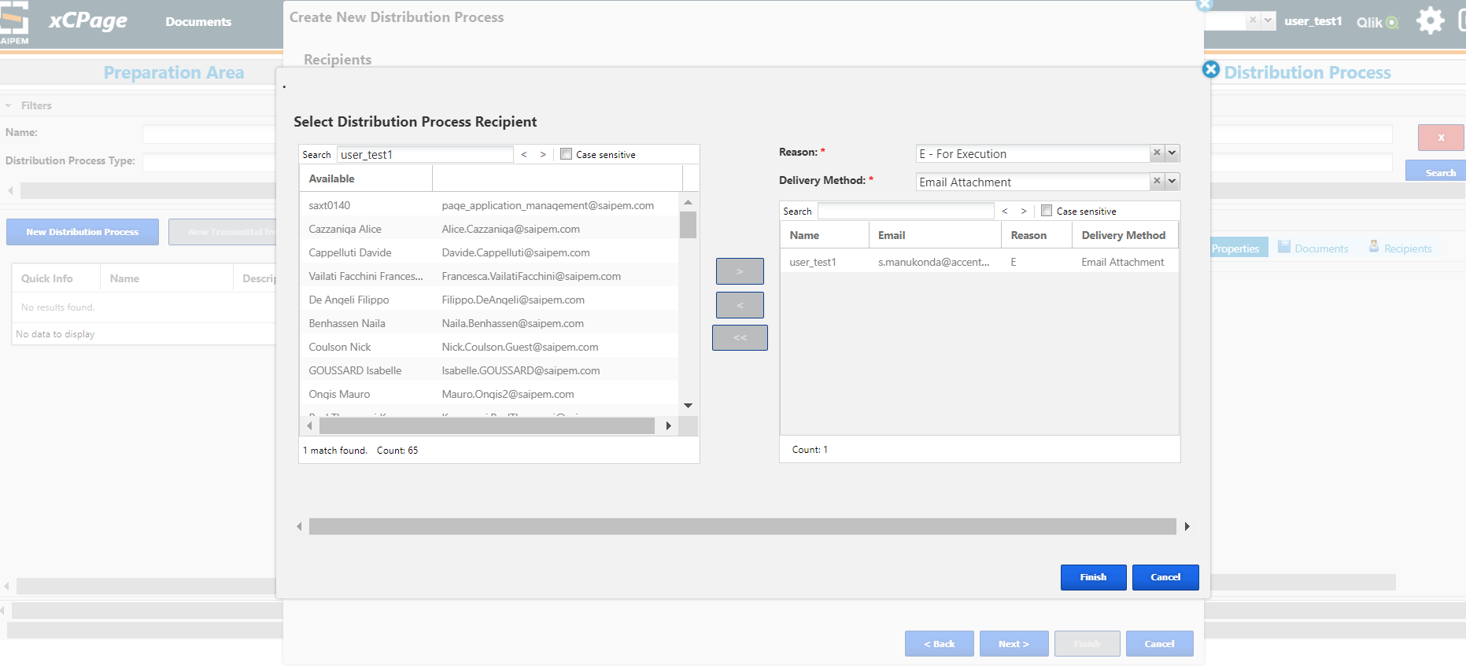
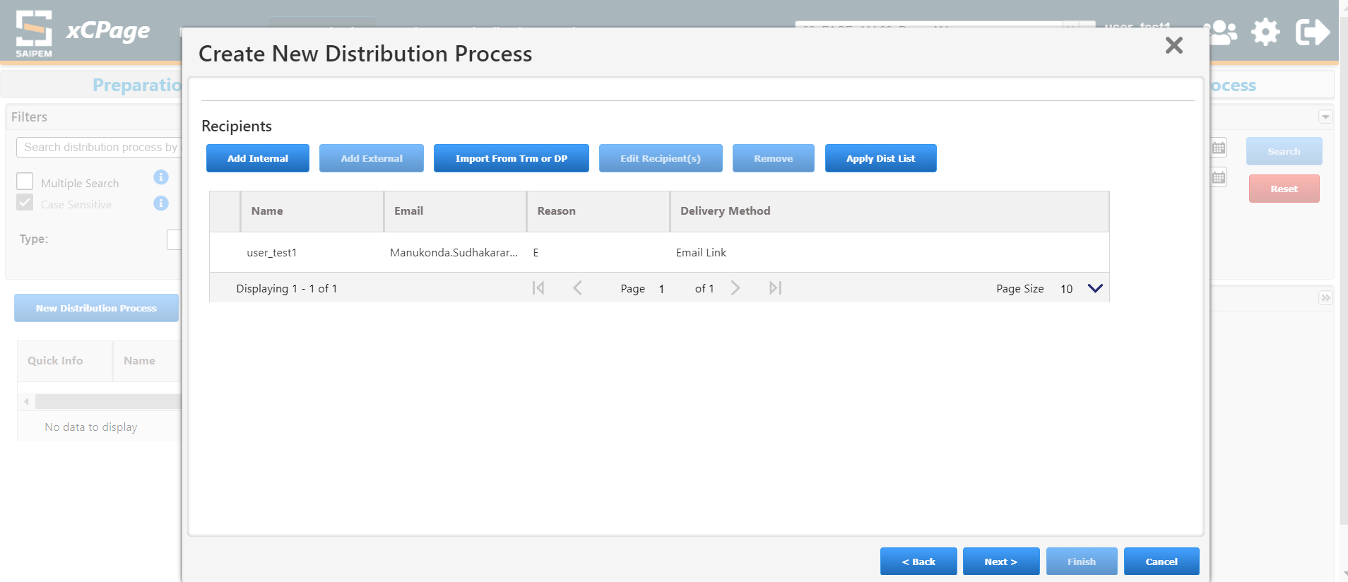
Click on Finish
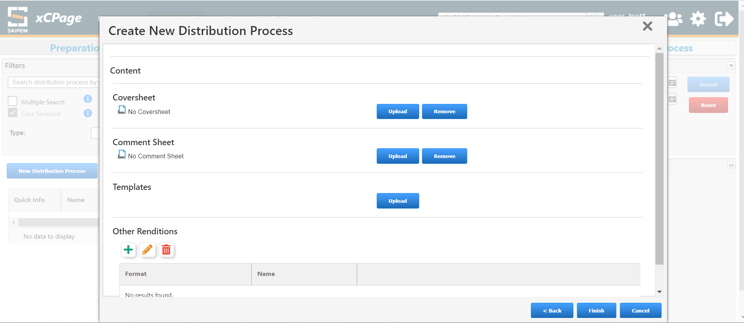
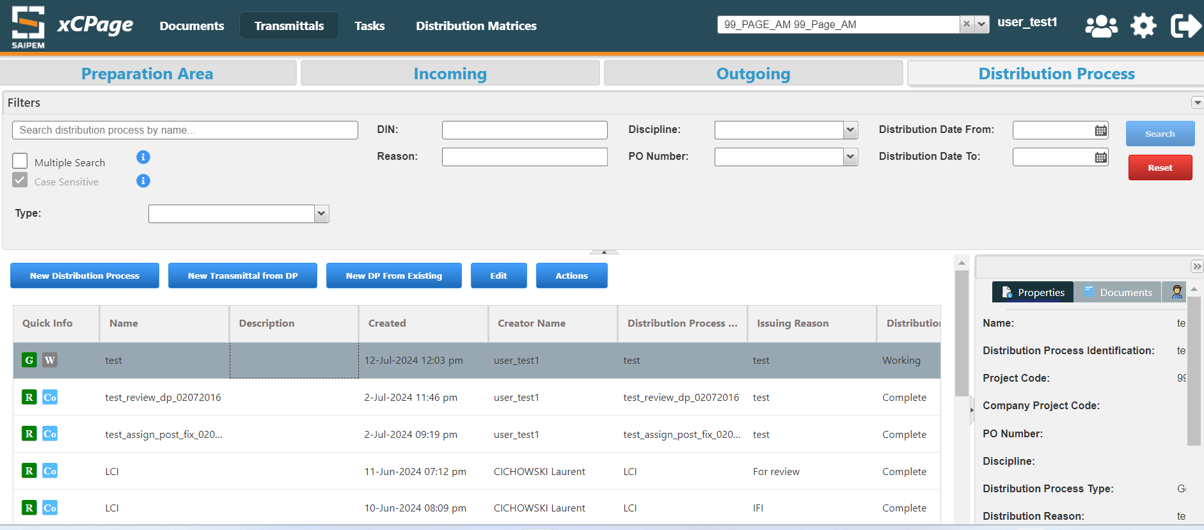
Issue the Distribution process
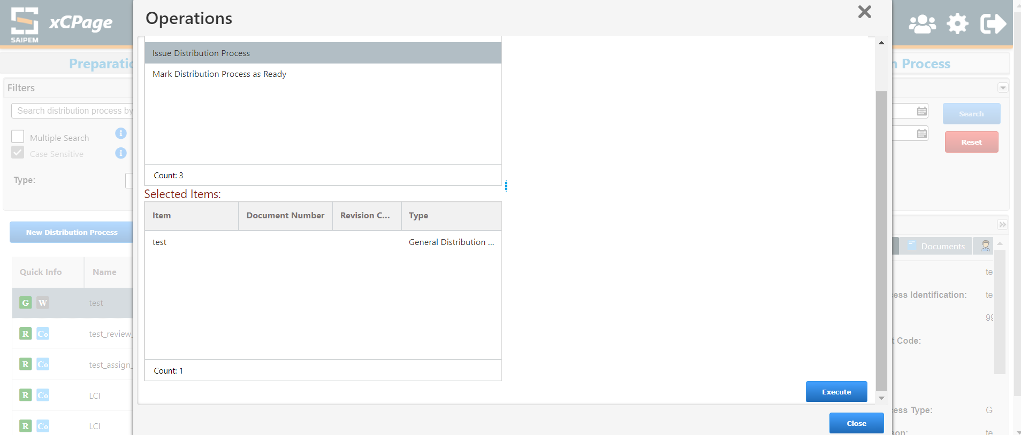
State becomes complete
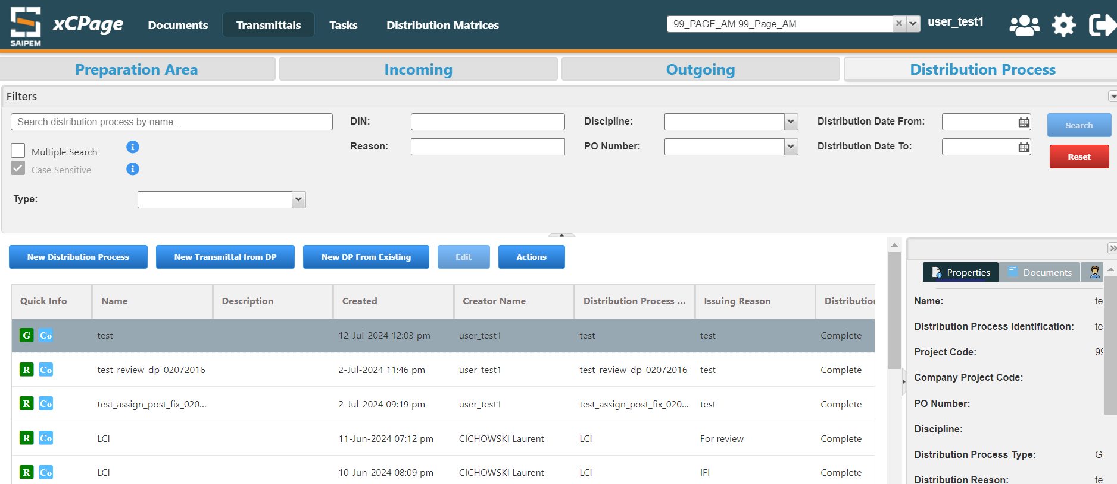

10.2 Review Distribution Process

10.2.1 Parallel Distribution Process

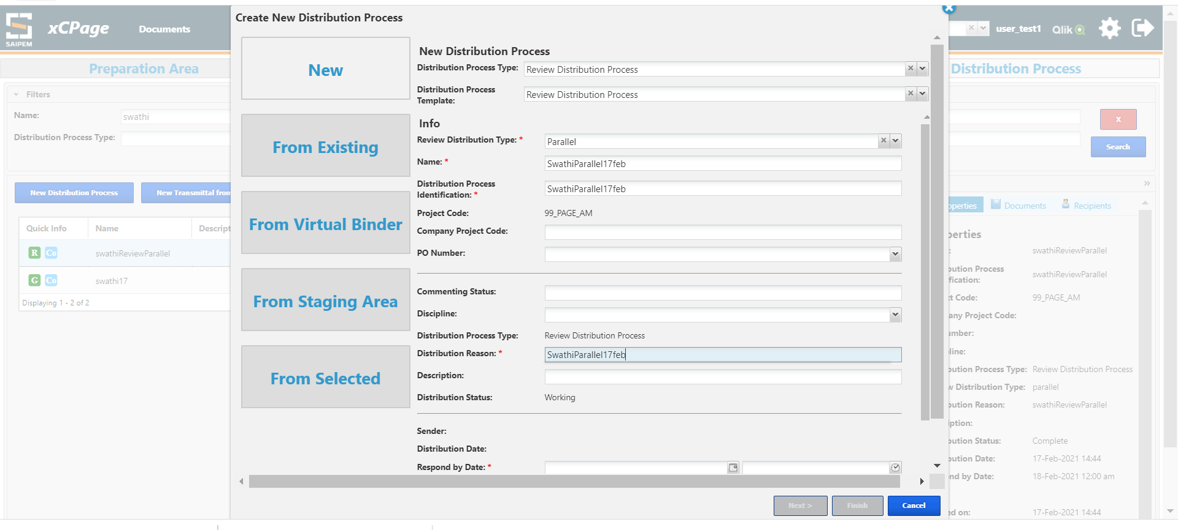
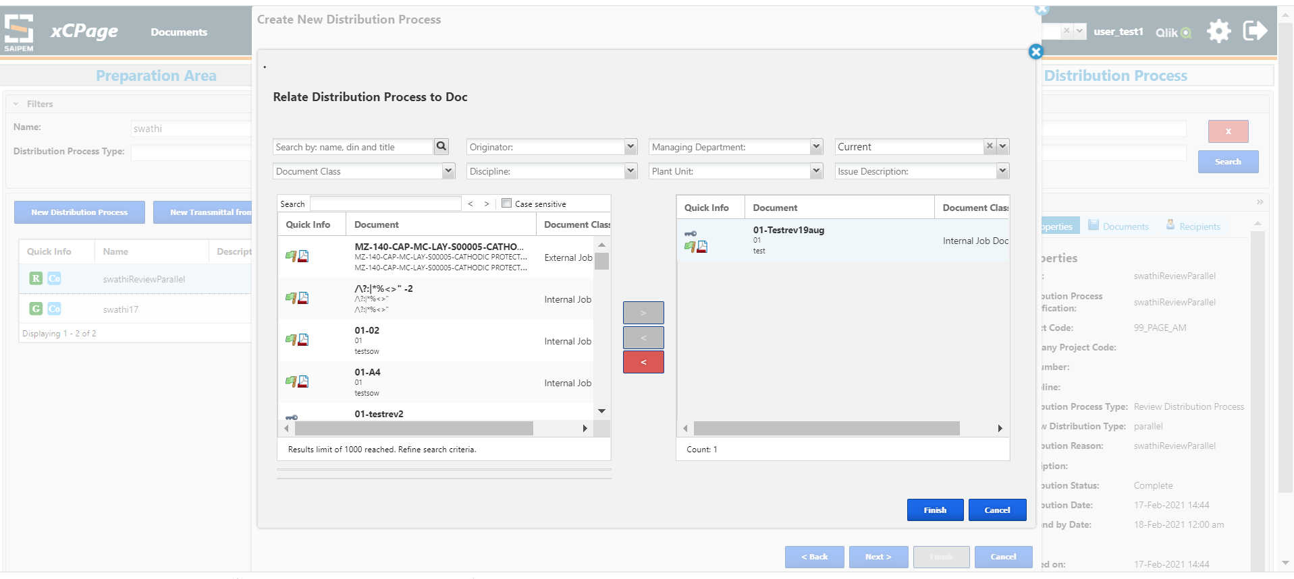
One Lead Reviewer and one or more Reviewers must be selected to proceed to the next page like below
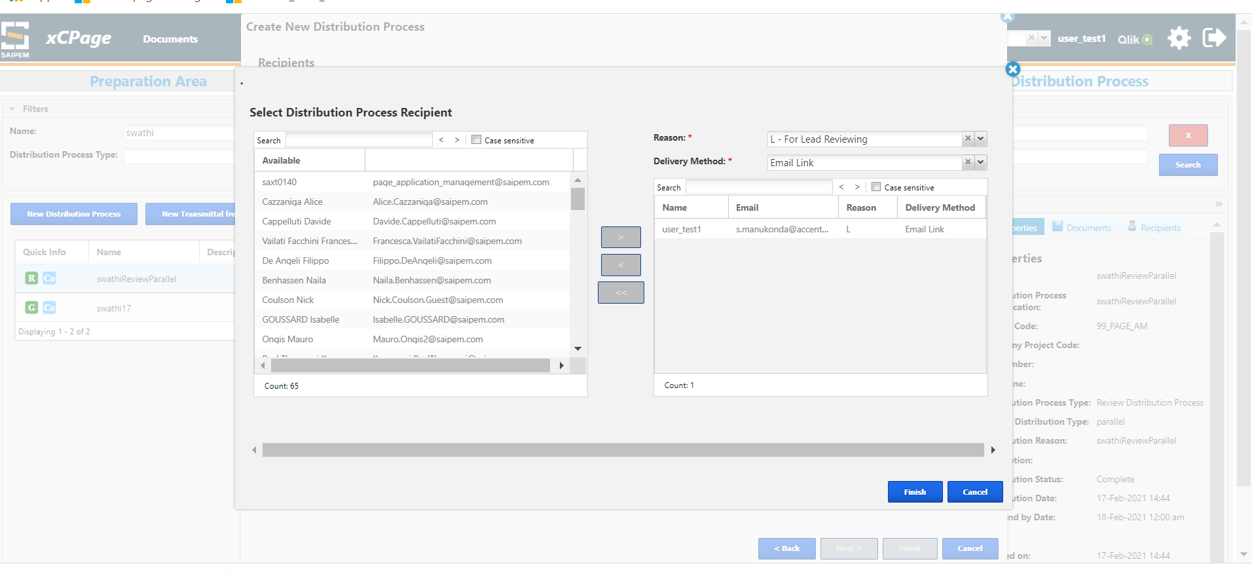
Selected 1 Lead Reviewer and 1 Reviewer
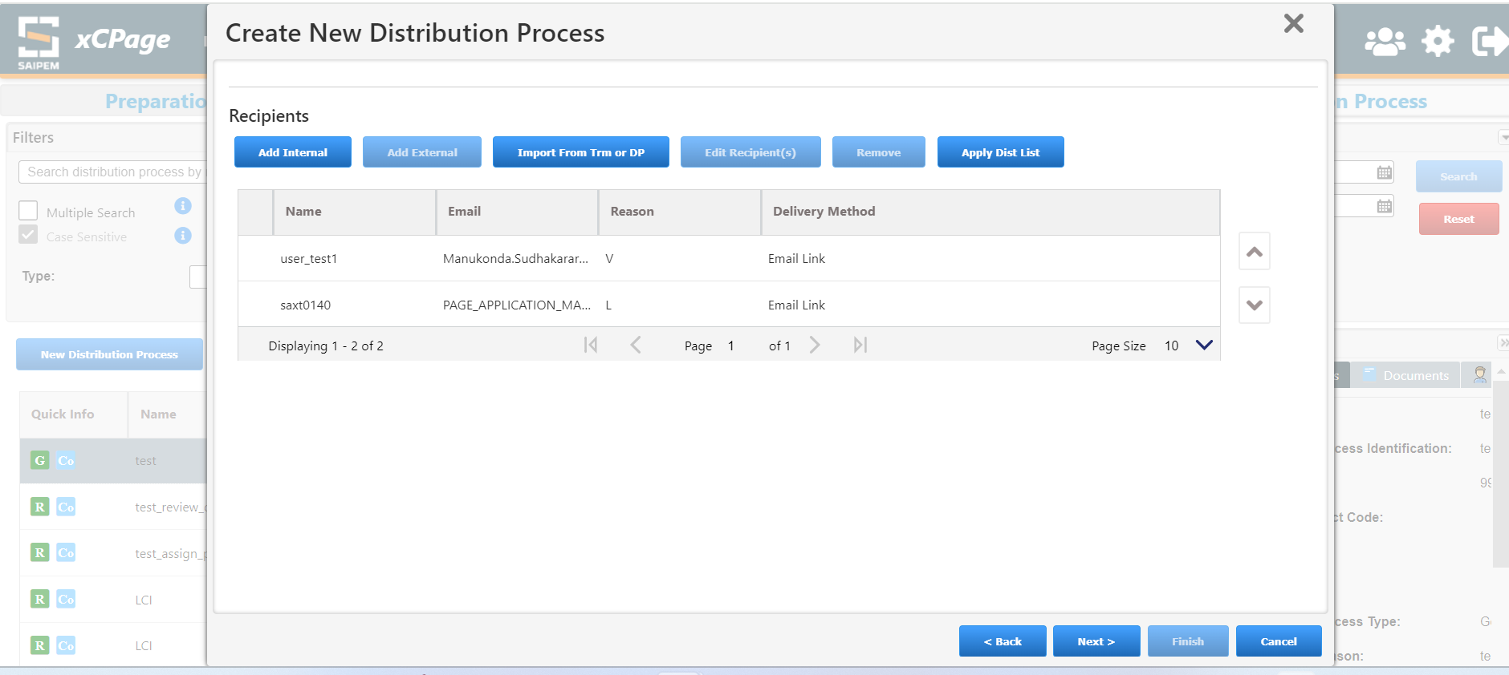
Click on finish in below screen
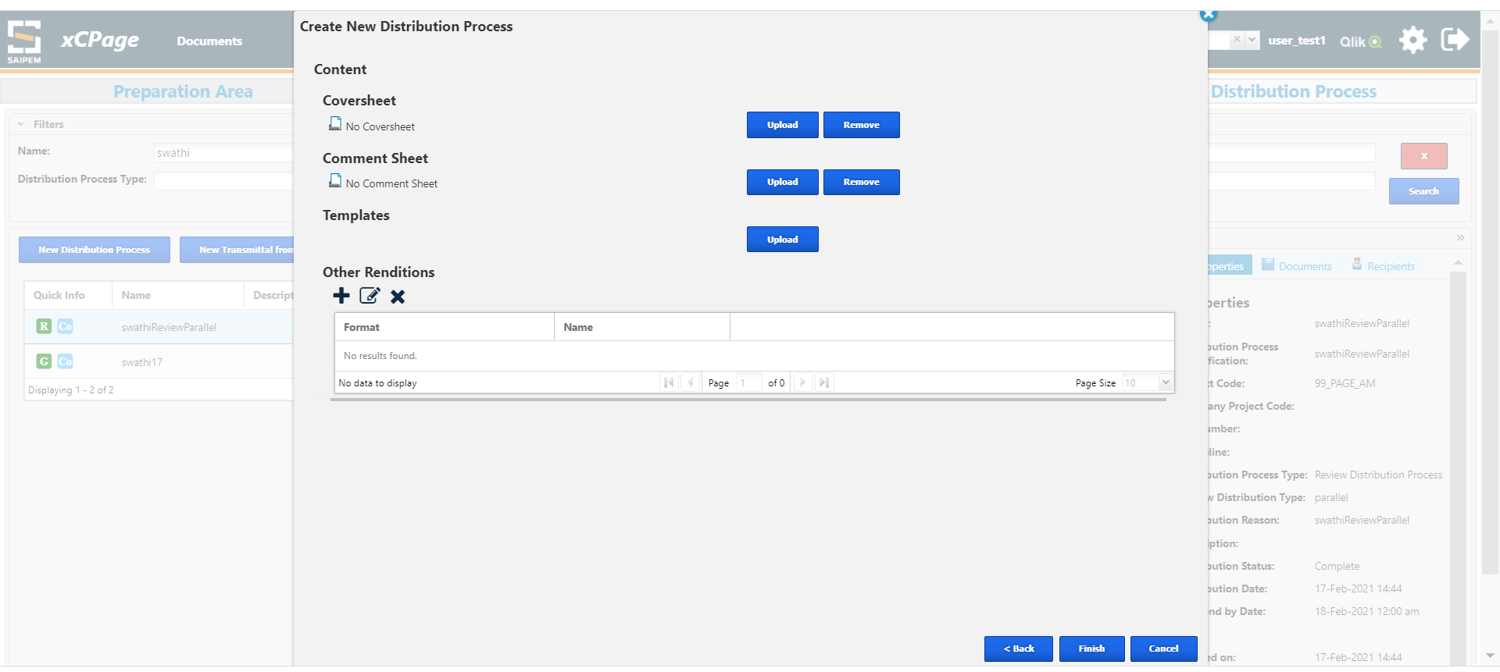
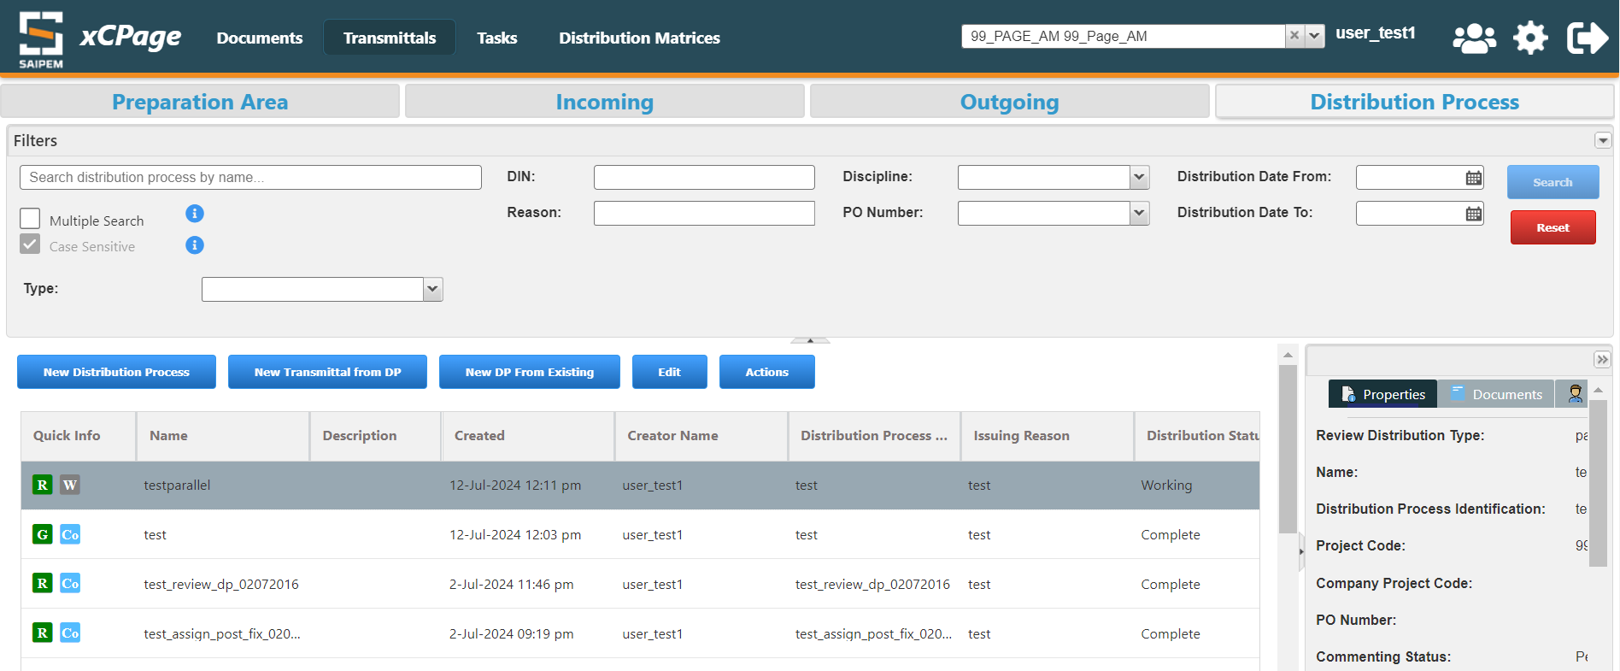
If we issue this DP tasks will be created to Lead Reviewer and Reviewer
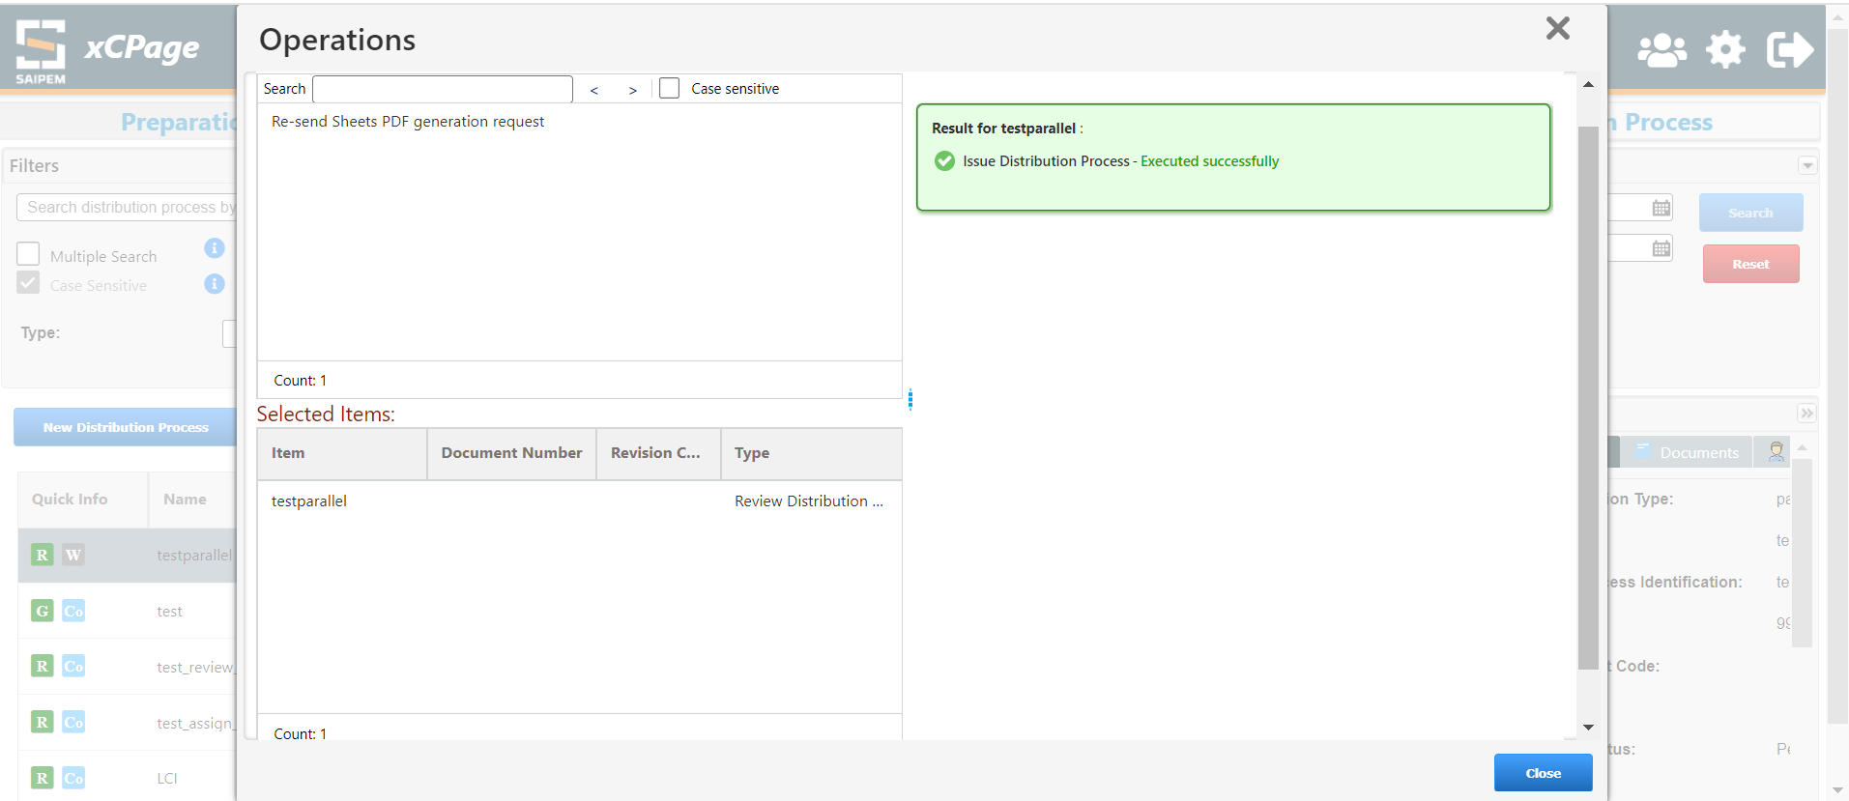
Login with Lead Reviewer and check consolidated Tasks under Tasks
Click on Accept task
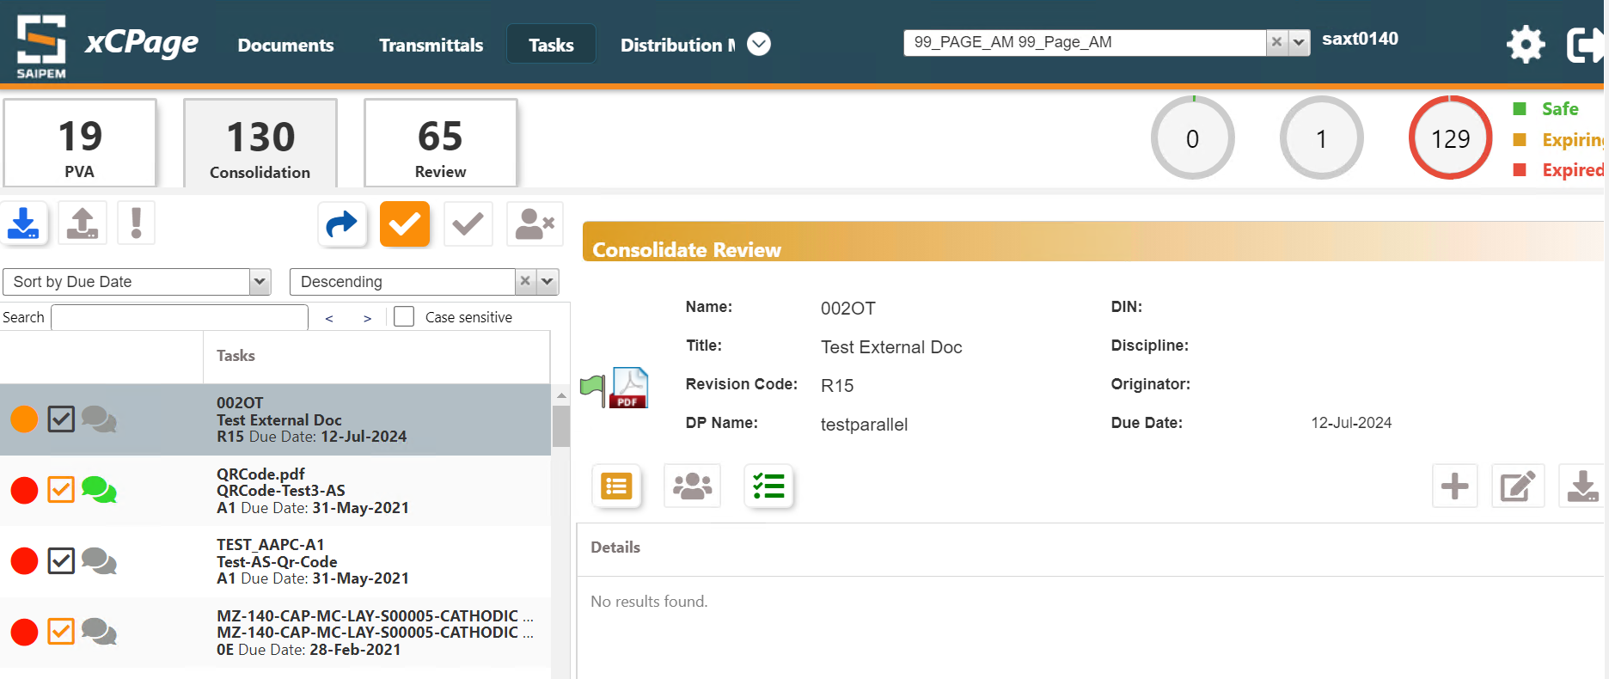
Login with Reviewer and check under Review Task and accept the task

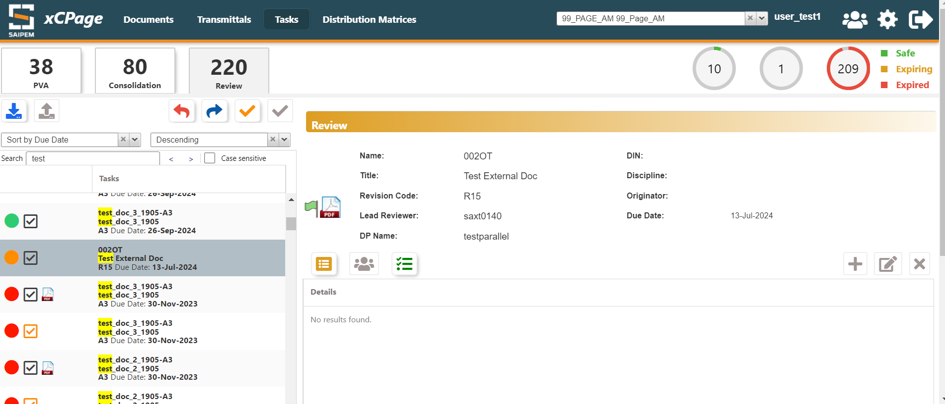

The orange Tick mark is to accept task, blue arrow mark is to delegate task
Reviewer can download the document by clicking on below highlighted icon
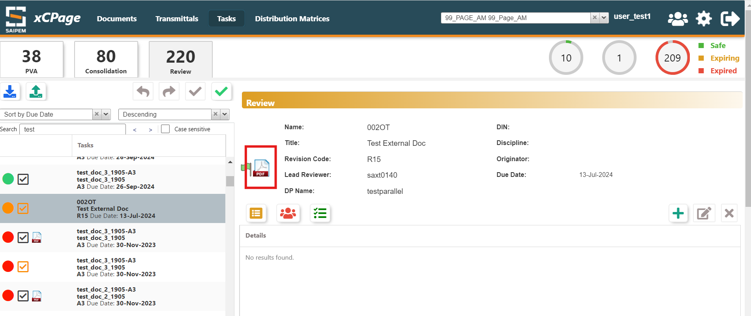
After the Reviewer clicks on Accept Task, He has an option to add comments by clicking on the + icon below
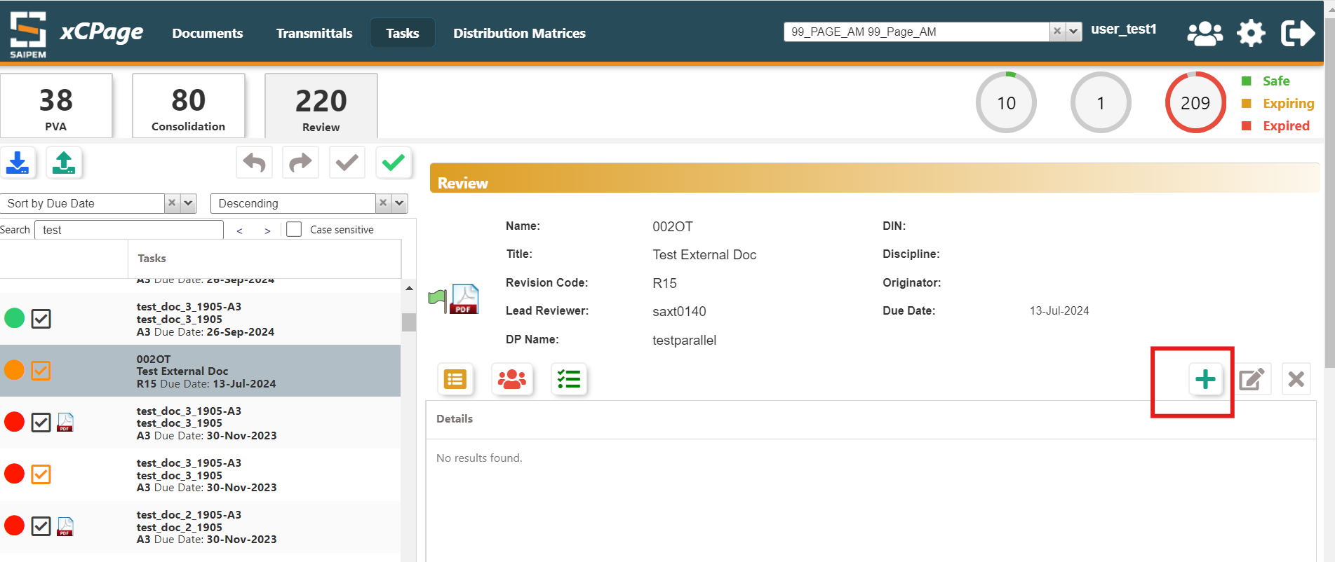
Click on + and add file
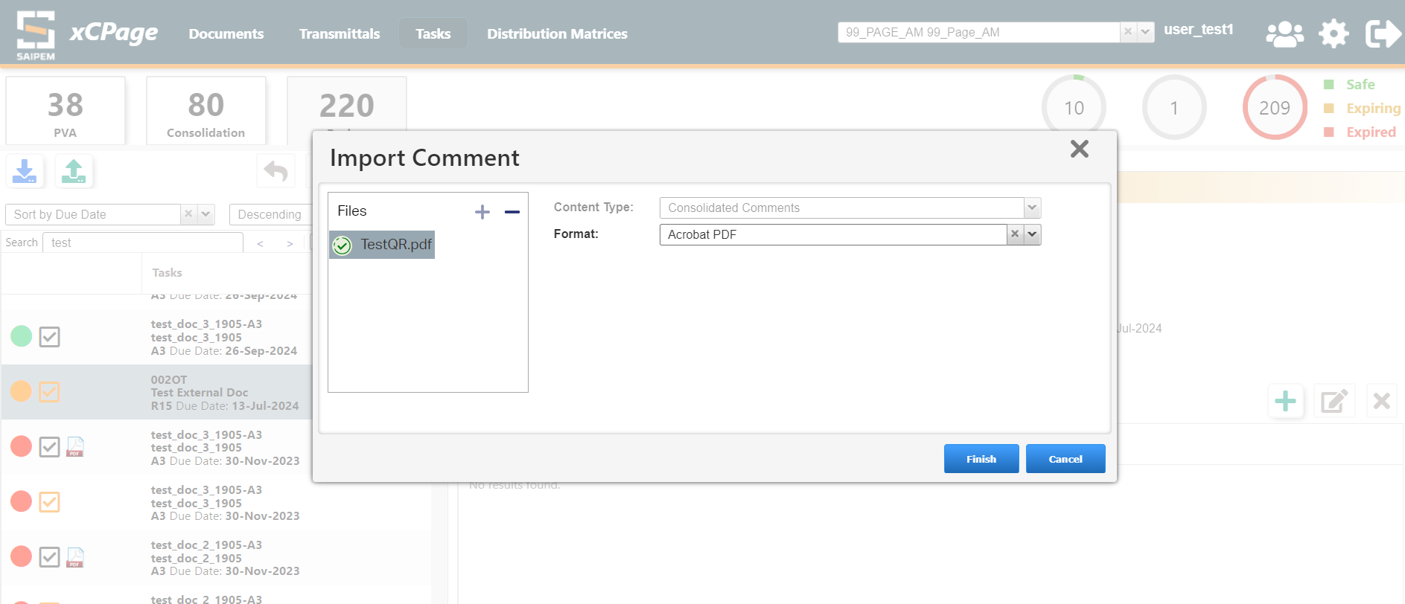
Added comment
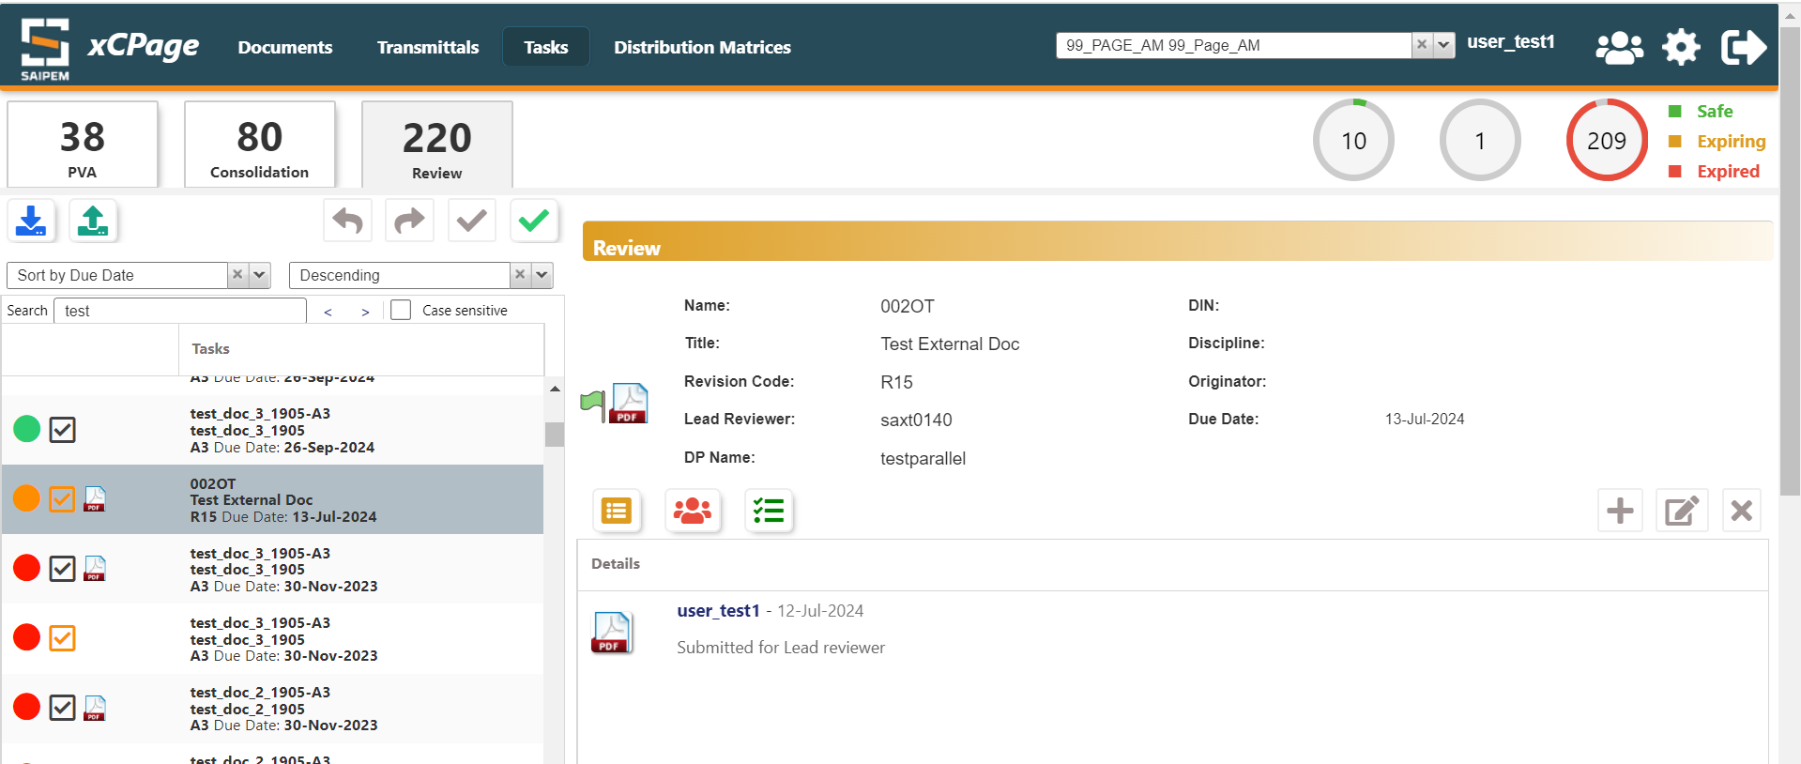
Reviewer Completes the task by clicking on the complete task option
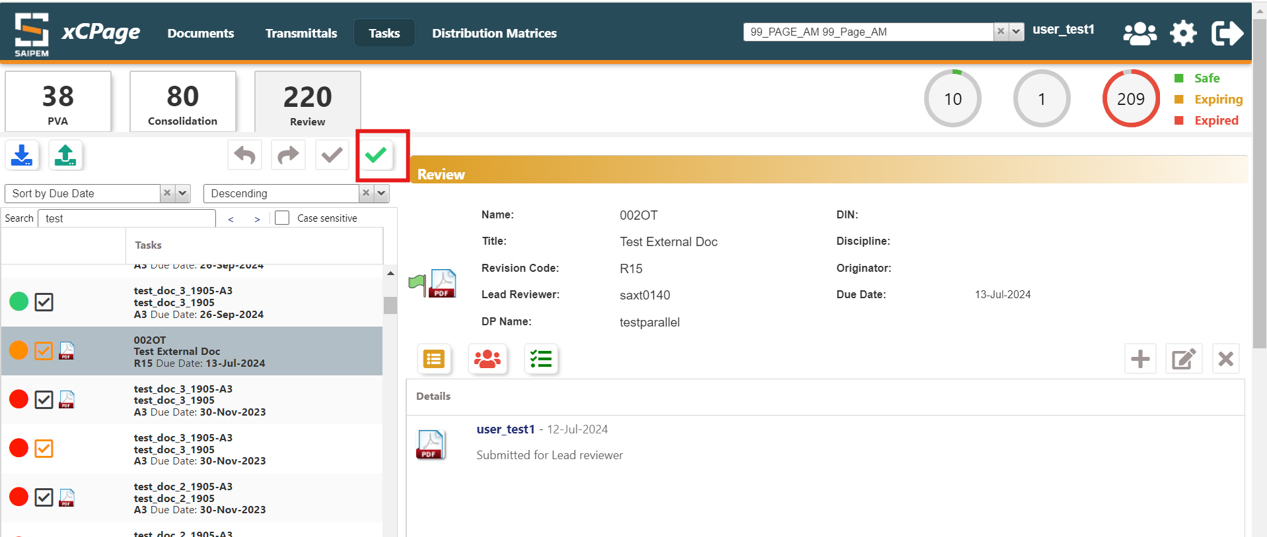
The comment doc appears for Lead Reviewer
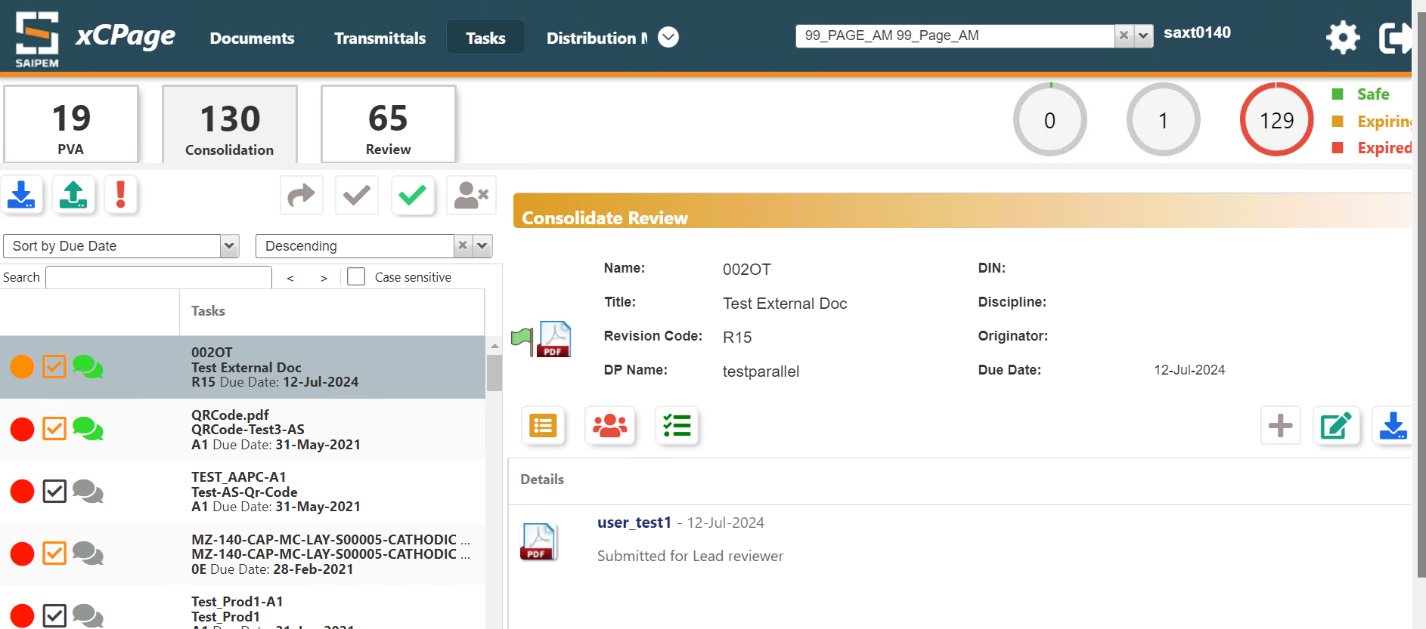
The lead Reviewer can assign document for additional commenting by clicking on highlighted icon below
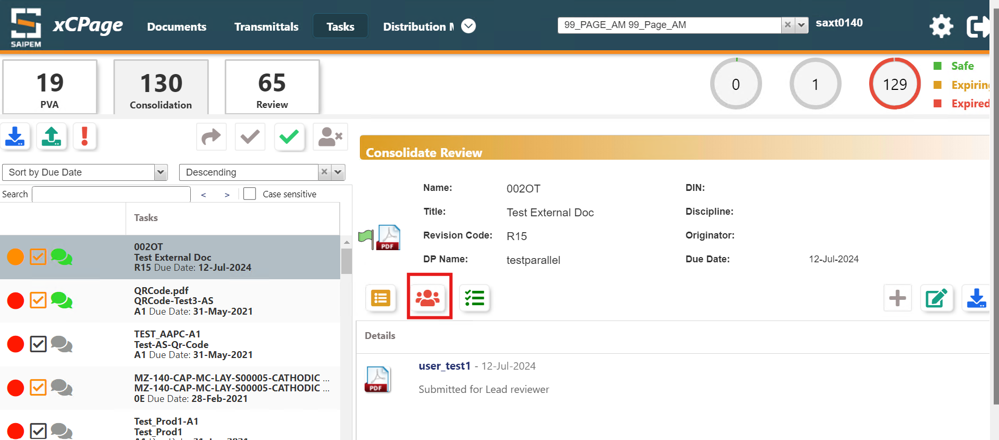

By clicking on the Green Bar icon Highlighted below, we can check the Current Assignment group, i.e who are the reviewers
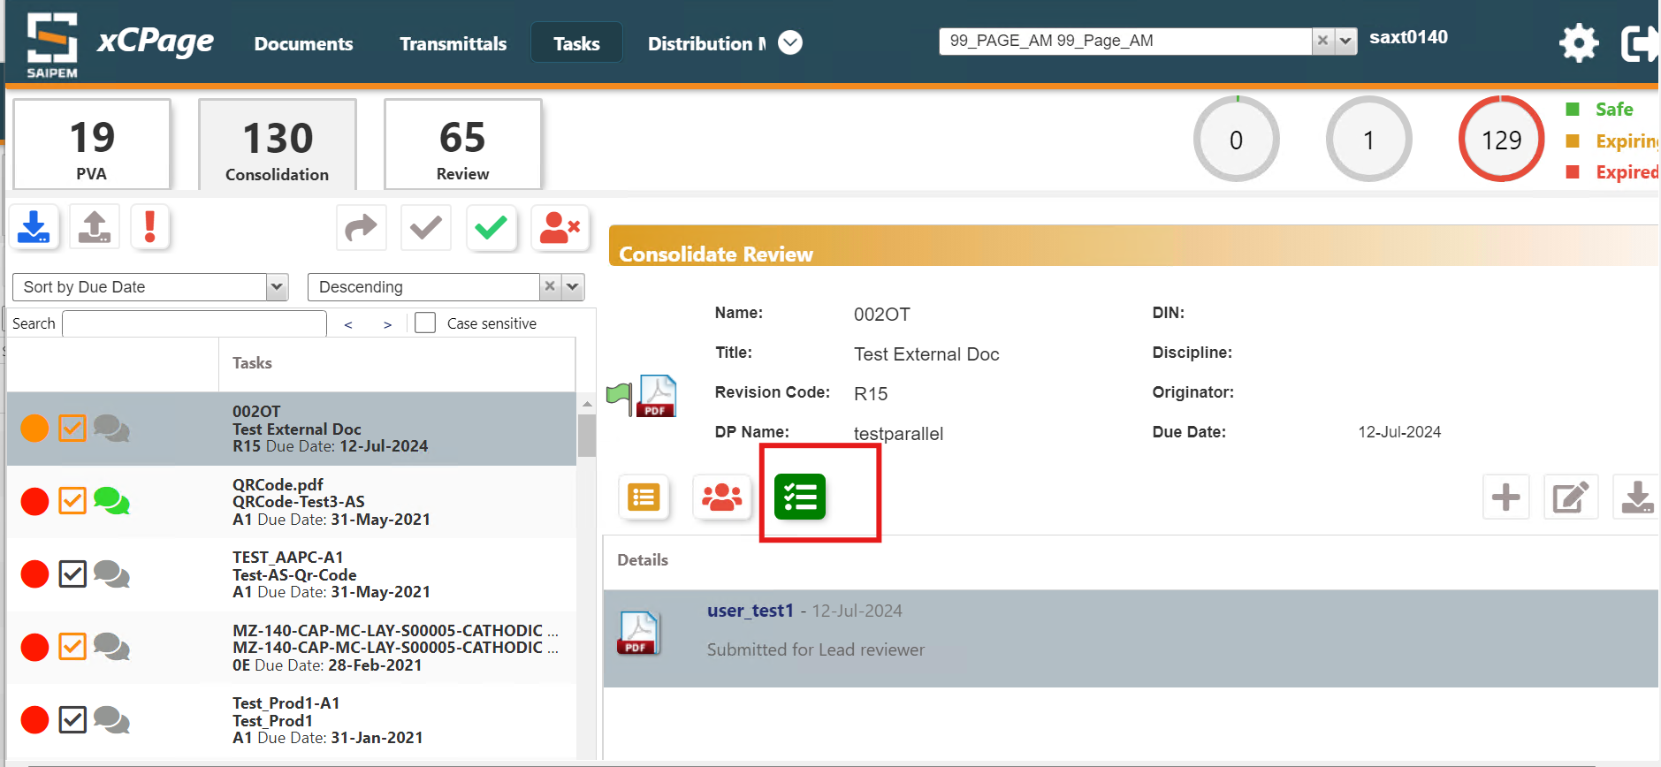
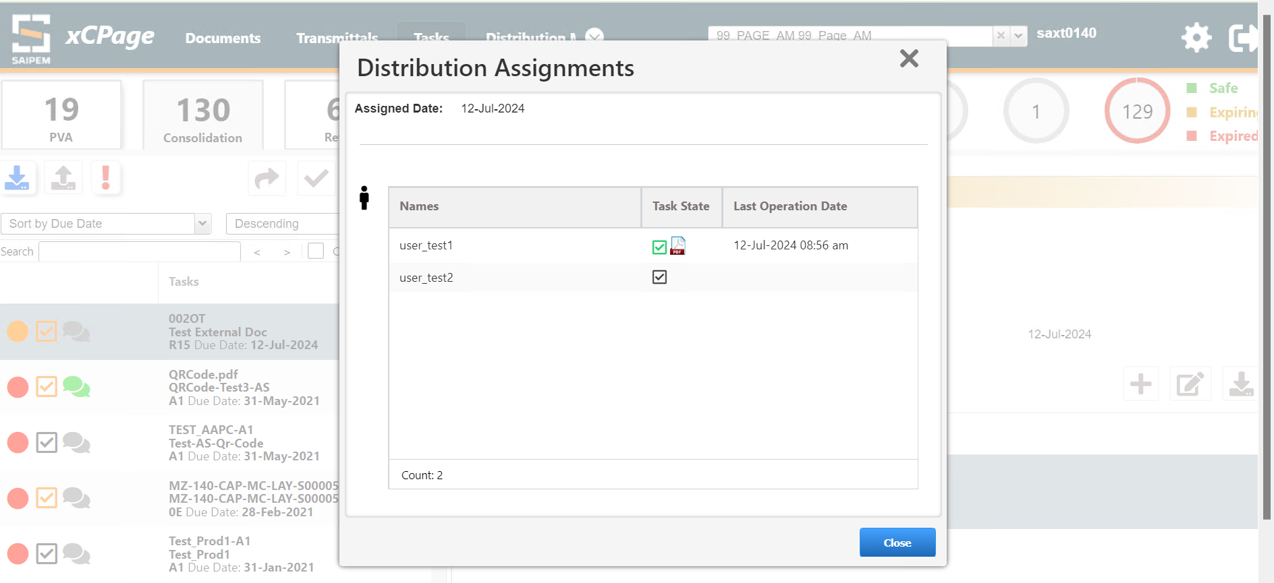

The Lead Reviewer checks all the comments added by Reviewers and also can upload comments by clicking + icon. Once he is done he can complete the task (Green tick) or even abort the task (Red cross mark)
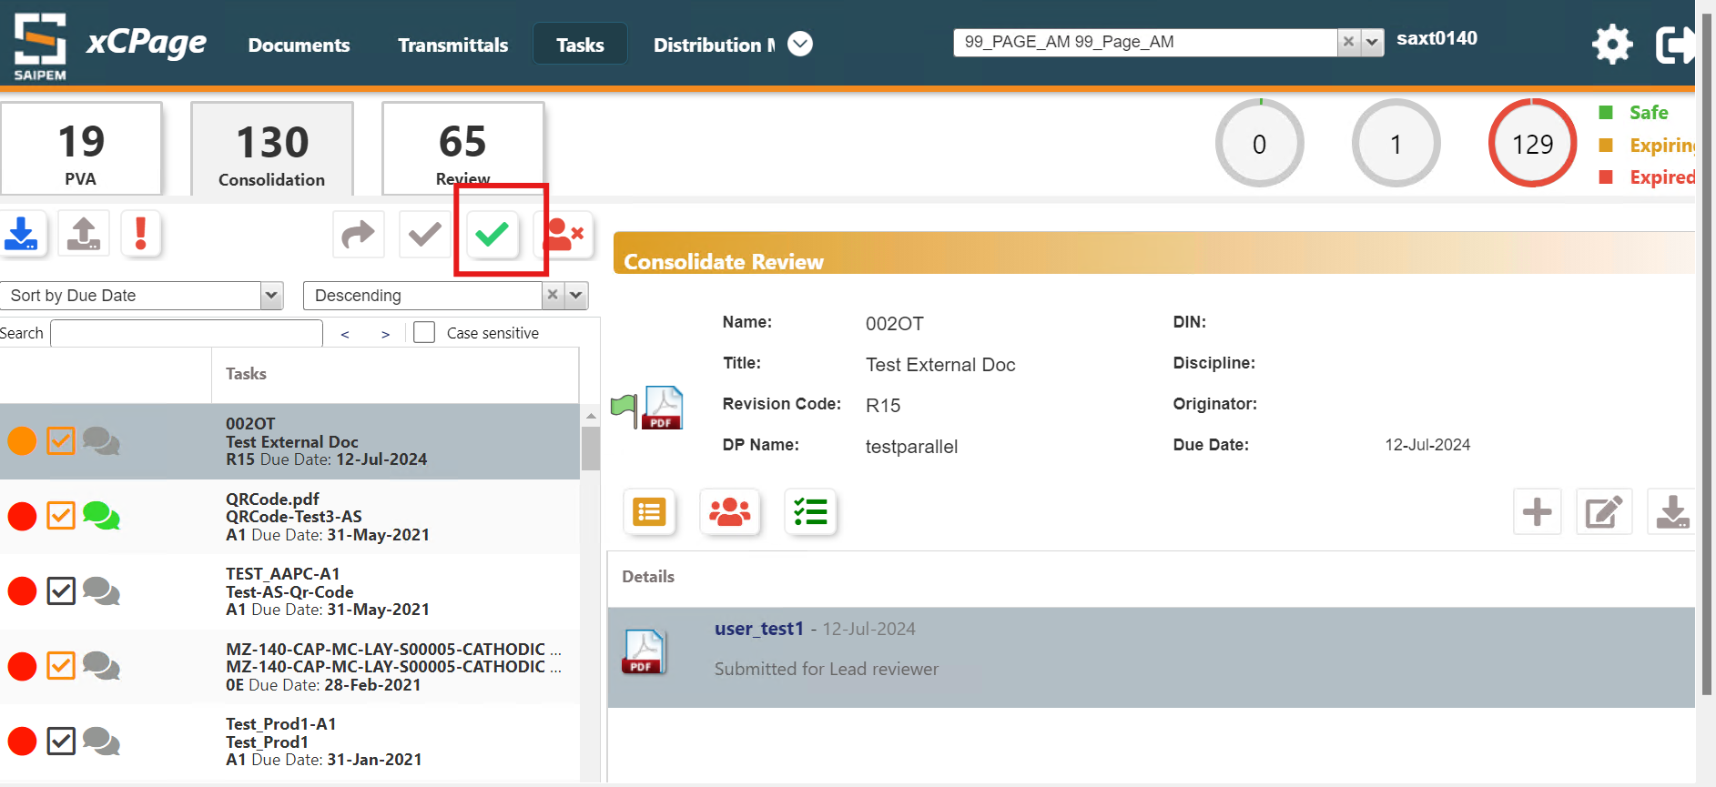

10.2.2 Serial Distribution Process
Serial Distribution Process is same like parallel distribution process except for one function i.e. all the Reviewers will not be able to see the task parallelly, but they will be able to see one by one based on the order of Reviewers selected. One a Reviewer accepts the task , the Next Reviewer will be able to see
Whereas in Parallel all the Reviewers can see the task at once.

10.3 PAGE Review Distribution Process
This is similar to PAGE Distribution Process

Structures
We can link documents which are added to clipboard to HBS Folder structures.
First add any Document to Clipboard like below
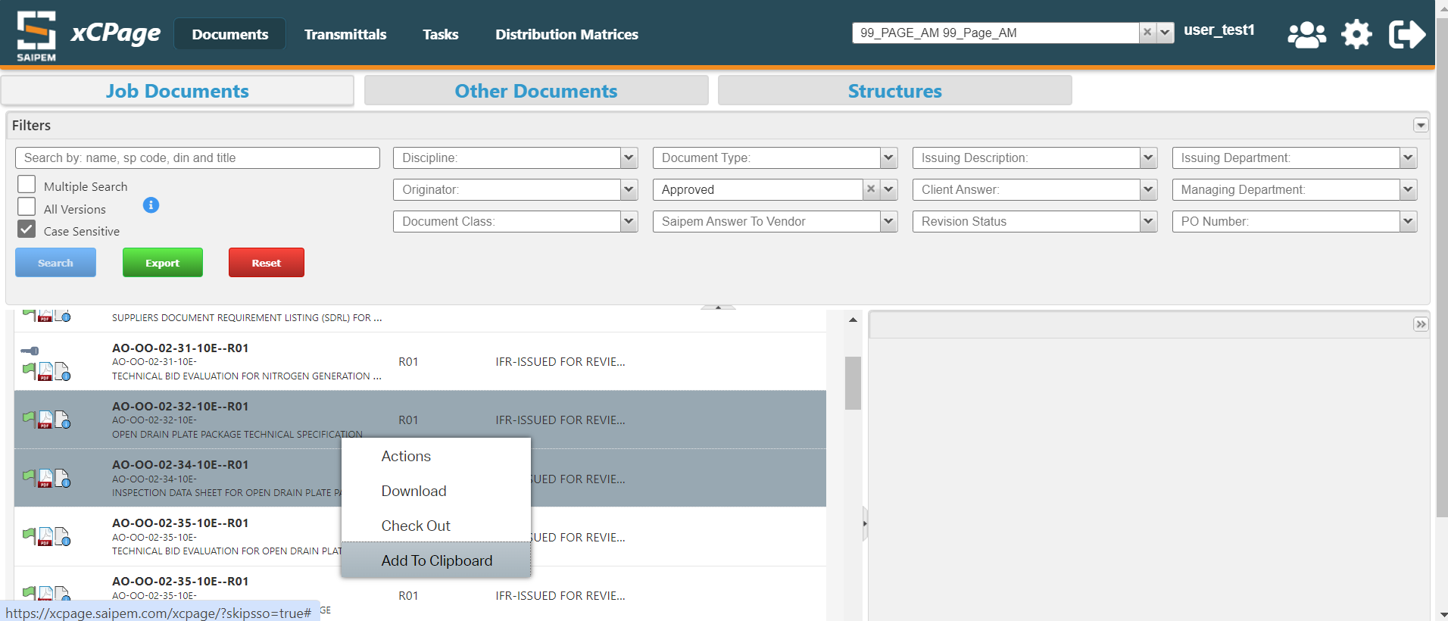
Click on structures , click on HBS and select any folder structure where we need to link the document added to clipboard.
Right side under documents we can find what all documents are already present in the folder
And under Clipboard we can see the documents which are added to clipboard
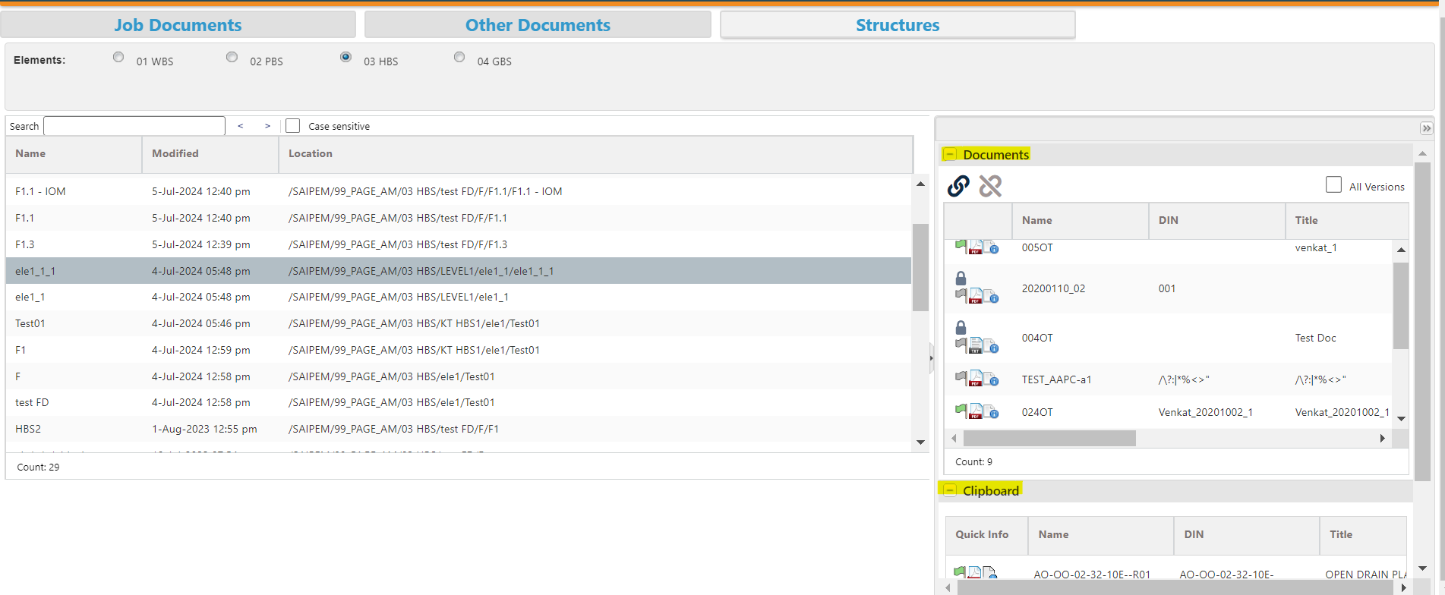
If we click on the link icon the document gets linked and we can see in the document window
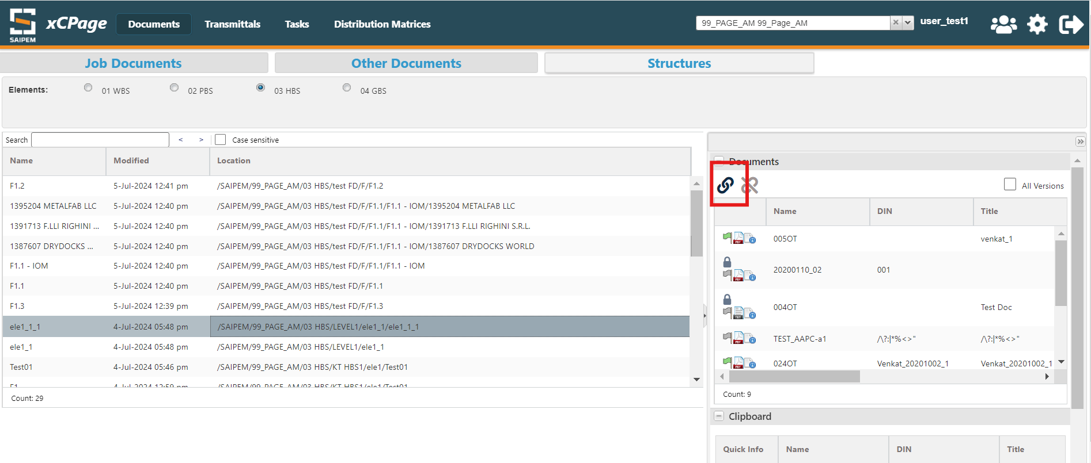

Virtual Binders
We can navigate to a Virtual Binder by clicking on the below option
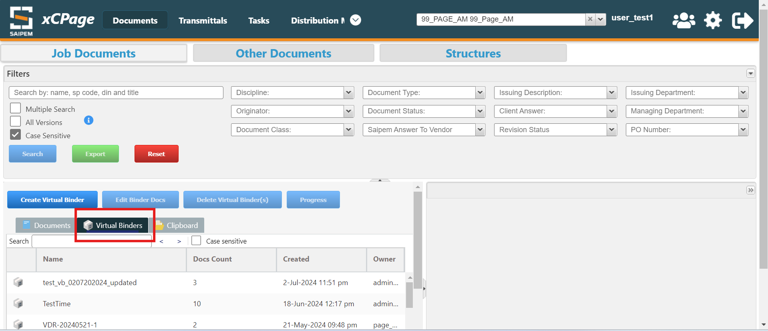
In order to create a new virtual binder select a “Create Virtual Binder” action
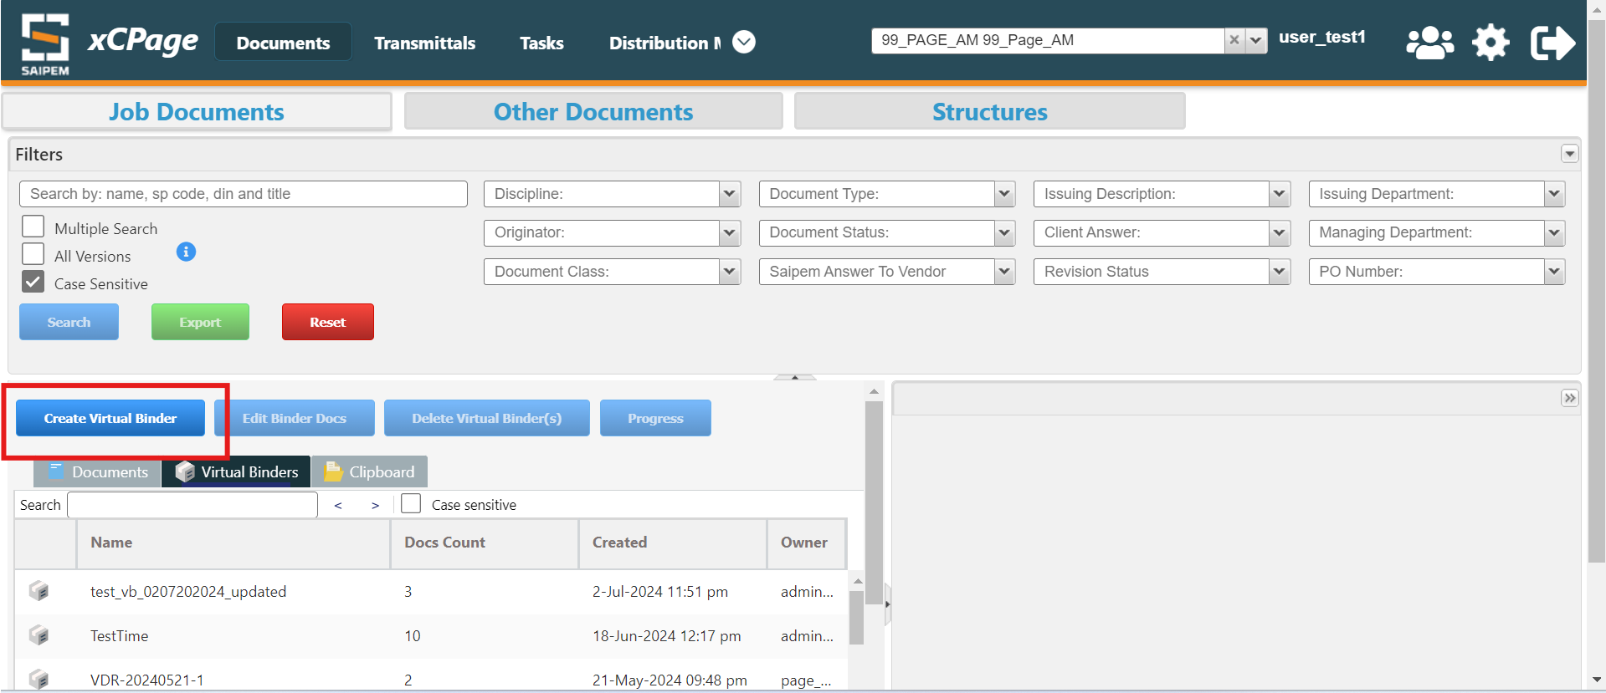

Provide the name of the virtual binder and select the documents needs to be linked to it and then click on finish
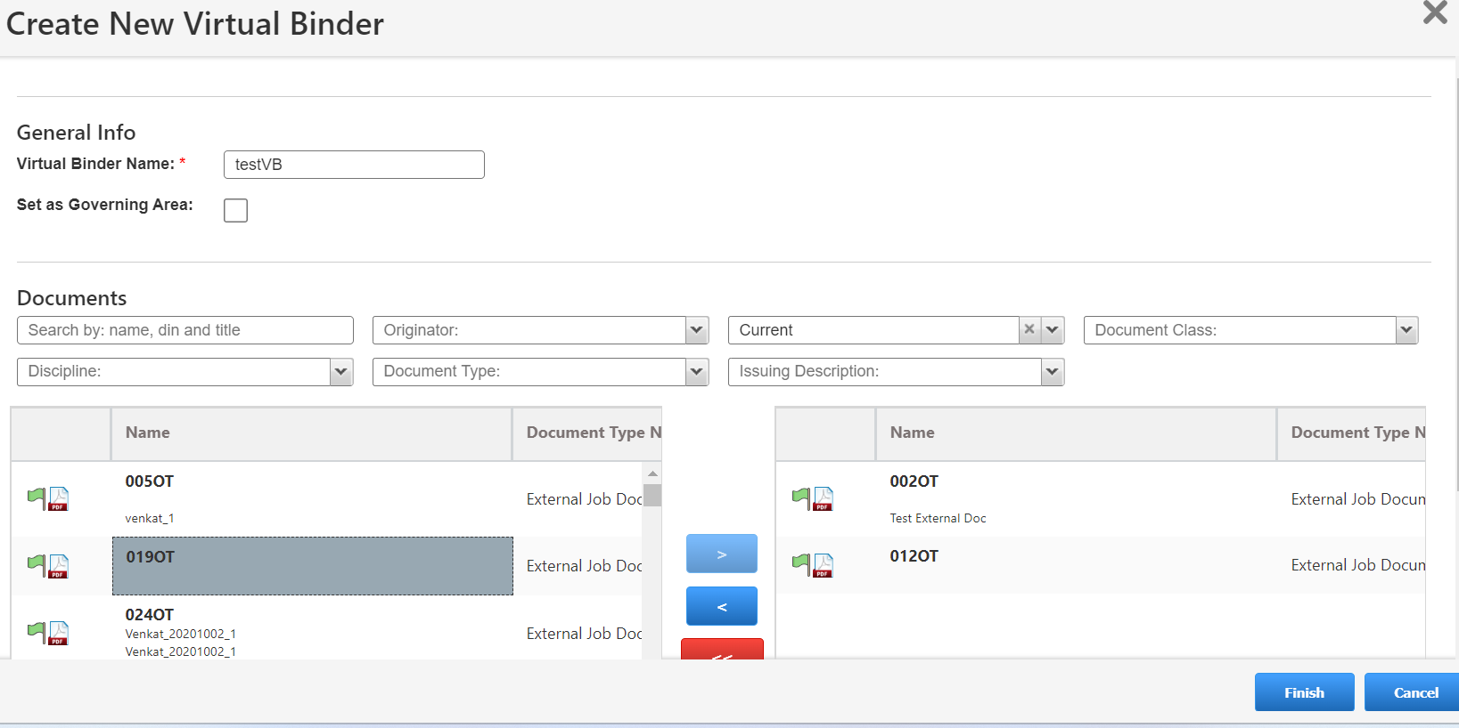
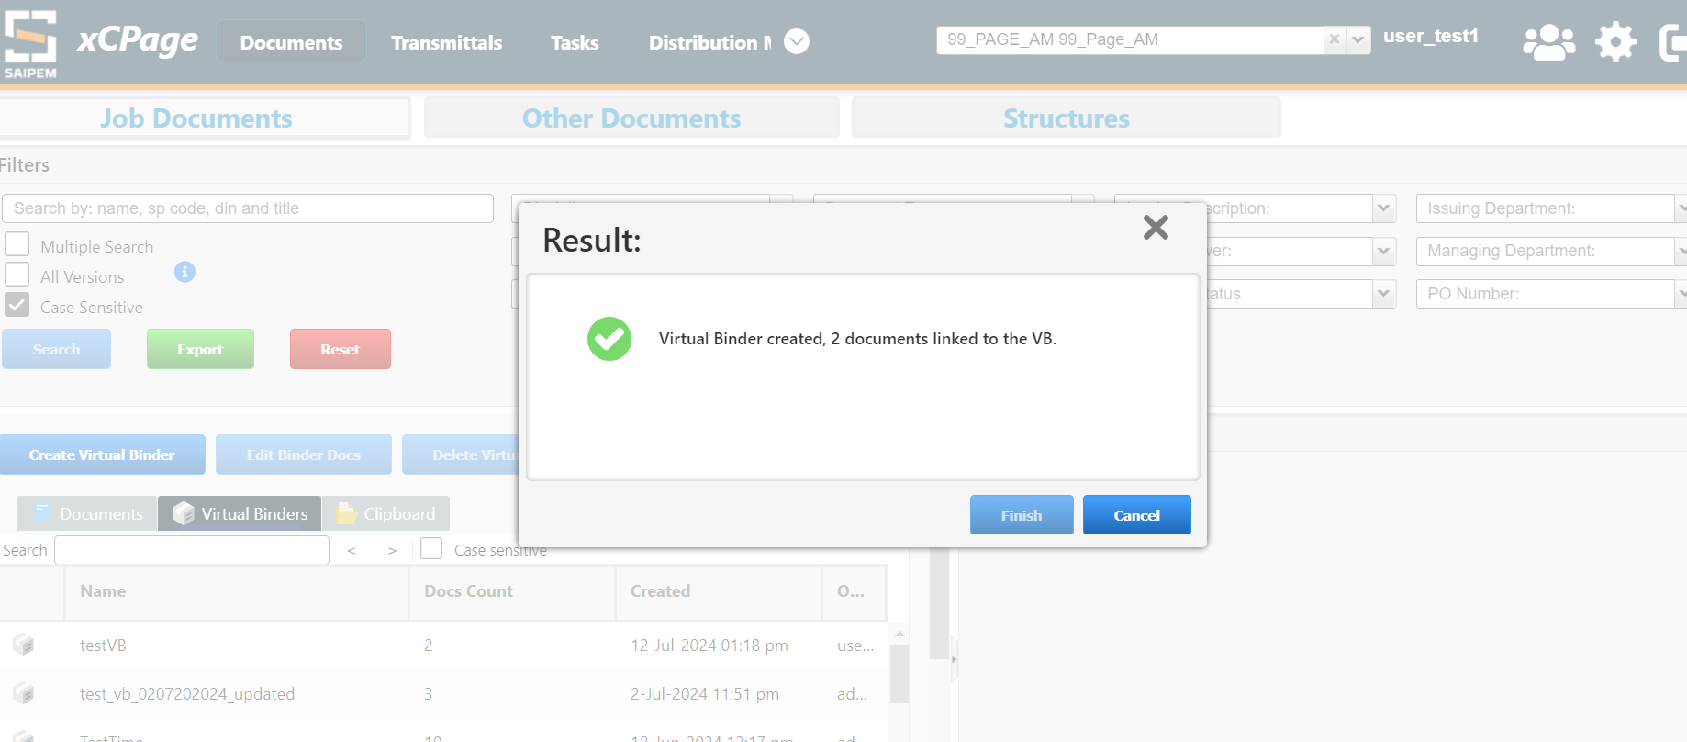
More documents can be added to a existing virtual binder by selecting Edit VB action as below
